User Manual:

Inventory / Finished Goods

| july-20 |

**Document Overview**

**Documentation Goals**

This documentation is intended to provide instruction for all ***Inventory/Finished Goods*** functions*.* It details the use of ***Warehouse Transactions, Receipts and Shipments, Transfers and Adjustments, Inventory Counting Procedures, Inventory Reporting and Reordering Practices***, and explains the use of the ***Manufactured Item Master File***.

**Documentation Disclaimers**

* Teach a user how to utilize the Finished Goods (Inventory) system.
* Provide instructions for overseeing transactions and determining inventory levels.

**Table of Contents**

**Overview of Advantzware Specific Keys and Icons** 6

Function Keys 6

Advanced Software Standard Function Keys 7

Program Icons 8

**Finished Goods Inventory Overview** 9

**Update Warehouse Transactions [IU]** 10

FG Enter/Modify Receipts [IU1] 10

Overview 10

Add/Update Receipt 13

Set Parts 19

FG Enter/Modify Transfers [IU2] 20

Transfer 20

Add/Update Transfer 21

FG Enter/Modify Adjustments [IU3] 26

Adjustment 26

Add Adjustment 27

Print Finished Goods Edit List [IU4] 32

Post to Finished Goods Files [IU5] 34

Delete Zero Qty FG Bins [IU6] 37

Move FG to Board/Misc. RM [IU7] 38

FG Consolidate Tags [IU8] 41

Transfer 41

FG Issue [IU9] 44

Issue 44

Add Issue 45

Transfer Transaction BOL [IU)] 48

**Count Finished Goods [IC]** 49

Physical Count Report [IC1] 49

Overview 49

FG Enter/Modify Physical Counts [IC2] 53

Counts 53

Add/Update Counts 54

Post Counts to Finished Goods [IC3] 58

Initialize FG Counts [IC4] 60

Analyze and Post FG Physical [IC5] 62

**Write End of Period Totals [IW]** 65

**Query Finished Goods [IQ]** 66

FG History [IQ1] 66

Scheduled Ship vs. Qty On-Hand [IQ2] 68

Overview 68

Scheduled Ship vs. Qty On-Hand Screen 69

Bin Inquiry and Update [IQ3] 70

**Reports for Finished Goods [IR]** 73

Reorder Requirements [IR1] 73

Overview 73

Multiple Warehouse Logic 74

Value/Cost by Whs/Bin/Tan [IR2] 78

Alphabetic Item List [IR3] 81

Qty/Value by Cust and Job [IR4] 84

Qty On Hand/Shpd by SMan [IR5] 87

Sales Values by Cust/Item [IR6] 90

Sales/Value by Cust and Tag [IR7] 93

[YTD Cost/Sales by Cust IR8] 96](#_Toc43475662)

Item List by Customer [IR9] 99

Status [IR)] 102

Transactions by Order [IR!] 104

Aged Inventory [IR@] 107

Next Ship Date and Value [IR#] 111

DL-Mat-GSA by Whs/Bin/Tag [IR$] 114

FG Item Value/Cost Summary [IR%] 117

**List More Reports [IL]** 120

QTY Totals by Cust/Item [IL1] 120

Unshipped FG Summary [IL2] 122

Unshipped FG Detail [IL3] 124

Scheduled Ship vs. QOH [IL4] 127

Inventory Balances [IL5] 130

FG Posting Report by Date [IL6] 132

FG Daily Activity [IL7] 135

Inventory Status by Job [IL8] 137

Reorder Advice by Ship-To [IL9] 140

Shipment by Customer Part [IL)] 143

FG Packing Detail [IL!] 146

Customer Inventory [IL@] 149

Sales Venue by Salesman by Customer [IL#] 151

Warehouse Item Audit List [IL$] 154

Inventory by Warehouse 154

Aged Inventory w/ WIP [IL%] 157

FG Executive Summary [IL^] 160

**File Maintenance for Items [IF]** 162

Finished Good Item [IF1] 162

Overview 162

Add/Update Item 166

Print Spec Card 180

Inventory Overview 181

Update Inventory 183

Totals/CP# 187

Update Totals/CP # 188

Bin/Jobs 190

Colors 191

Add/Update Color 192

Vend Cost 194

Add/Update Vend Cost 195

History 196

Image 198

Update Image File 199

POs 199

UOM 200

Add/Update UOM 201

Finished Goods Control [IF2] 203

Finished Goods Categories [IF3] 204

Add/Update Finished Good Category 206

Warehouse / Bin Locations [IF4] 209

Browse Location 209

View Location 210

Add/Update Warehouse/Bin Location 211

F/G/ Bins 215

Add/Update Finished Good Bin 216

R/M/ Bins 217

Add/Update Raw Material Bin 218

WIP Bins 219

Add/Update Work in Process Bins 220

Set Maintenance [IF5] 221

Browse Items 221

Set Parts 222

Add/Update Set Part 223

Global FG Price Change [IF6] 225

Freight Class [IF7] 226

Add Freight Class 228

Translations 229

Add Translation 230

Adjustment Reason Code [IF8] 231

View Reasons 232

Add/Update Reason 233

Inventory Status [IF9] 234

View 236

Add/Update Inventory Status 237

# **Overview of Advantzware Specific Keys and Icons**

## Function Keys

|  |  |
| --- | --- |
| BRWS | The browser, which is a list of records in this file. This is functionally equivalent to the Find option of our standard package. |
| VIEW | View record provides the ability to ADD, CHANGE, DELETE, and UPDATE an individual record. |
| SORT BY | The selections at the bottom of the browser, which will sort the list alphabetic order. |
|  |  |
| Update | Update the current record. |
| Reset | Reset the current record. |
| Add | Add a record. |
| Copy | This will copy the existing record. |
| Delete | Delete the current record displayed on the screen. |
| Cancel | Cancel the information that was entered. |
| Save | Save the record. |
|  |  |
|  | Takes the user to the first current record. |
|  | Moves backward one record. |
|  | Moves forward one record. |
|  | Takes the user to the last current record. |
|  |  |
| F1 | Miscellaneous Fields |
| F3 | Search |
| F3 | List |
| F4 | Notes |
| F6 | Browse |
| F7 | Viewer |
| F12 | Exit |

## Advanced Software Standard Function Keys

|  |  |
| --- | --- |
| Next | Shows the next sequential record. |
| Prev | Shows the previous record. |
| Add | Add a record. |
| Change | Change the current record displayed on the screen. |
| Delete | Delete the current record displayed on the screen. |
| Find | Find a record by searching by description. |
| “1”, “2” | Number 1 or 2 to go the first or second page of this record. |
| Esc | Escape from the current transaction without updating. |
| Q | Quit from the current transaction without updating. |
| F1 | Save |
| F3 | Help information is available on every data field. Simply place the cursor on a field and press F3 to display documentation regarding this particular field. |
| F3 | To insert additional data in a data field without erasing the information currently displayed. |
| F4 | Notes – General |
| F1 | Field Lookup is available on every data field which is maintained in a separate file. Place the cursor on a field and press ***“F1”*** to search for the code by description or to advance a screen of records by pressing the next key. Place the cursor next to the desired record and press enter to transfer the record to the data entry screen. See ***“Page Up”*** / ***“Page Down”*** keys below as an alternative |
| F7 | Delete |
| F8 | Notes – File Specific |
| Enter | Advances the cursor to the next field |
| Page Up | Will skim forward through each record in a data file in sequential order |
| Page Down | Will skim backward through each record in a data file in sequential order |
|  |  |

## Program Icons

|  |  |  |
| --- | --- | --- |
|  | Job Notes |  |
|  | Customer Attachments | Attach files (such as Word/Excel/Images) for this specific customer order. |
|  | Change Move/Set Column Mode |  |
|  | Print Acknowledgement |  |
|  | Export to Excel |  |
|  | Add |  |
|  | Attachments | Attachments for this Estimate. Will transfer to all future repeat orders for this estimate. |
|  | Notes |  |
|  | Spec Notes | Notes for specific finished goods items. |
|  | Utility Application |  |
|  | Help |  |
|  | UDF Viewer |  |
|  | Commissions |  |
|  | Exit |  |
|  |  |  |
|  |  |  |

# **Finished Goods Inventory Overview**

Finished goods inventory provides perpetual inventory control with updated costs and customer inventory reporting available upon request. Finished goods inventory integrates with cost estimating, order processing, bills of lading, production control and job costing.

For Stock boxes, finished goods items must exist before creating an order. The selling price may be defined by Lot, Case, Each or per Thousand. In addition, stock boxes may have a pricing matrix defined in the order processing module for special pricing by customer number, customer type, product category, item or a combination of these criteria.

For custom boxes, the system will create an item automatically as a result of entering the estimate number during order entry. Pertinent information such as customer name, quantity ordered, purchase order number, selling price, product category and standard costs automatically updates the finished goods file, saving data entry time.

Many look-ups, inquires and reports are available, using the information in the item file. Sales service and inventory look-up features are available by item number, item description, job number, customer's part number, customers purchase order number, customer name, customer number and estimate number. Additionally, a user defined production control field can be used for further user defined reporting purposes.

Warehouse transactions provide the ins and outs of inventory control via receipts, transfers, shipments and adjustments. Inventory levels by warehouse, bin, pallet and case are maintained automatically via order entry, production posting, receipts, bills of lading and invoicing.

Production posting tracks the quantity printed, cut, glued and produced. Receipts to inventory automatically updates quantity on hand and transfers work in process costs from job costing. The quantity shipped via bill of lading posting updates invoicing without further data entry. To better control physical inventory counting, cycle counting prints inventory worksheets for counting and adjusting actual quantities. The worksheet prints by range of cycle count codes, thereby allowing inventory checks weekly by a small group of items.

Multiple finished goods categories may be defined for sales and profit reporting. The description and general ledger numbers are defined in the file so that only the category code is entered in the item file. Many look-ups, inquires and reports are available via product category. The product category field is linked to estimating, sales history, job costing and general ledger providing many sales analyses as well as profit and loss reporting. The standard cost per thousand for material, labor and overhead generated via cost estimating is transferred to the item file.

When finished goods receipts are posted, the standard cost is transferred from work in process in job cost for the general ledger account numbers defined for the finished goods product category.

# **Update Warehouse Transactions [IU]**

## FG Enter/Modify Receipts [IU1]

### Overview

Finished goods should be received into a particular warehouse and bin location before the item can be shipped and invoiced to customers. Items may be received for each warehouse location.

The system tracks inventory by cases per pallet/tag numbered by bins by jobs within a warehouse. The quantity of an item posted in production posting on the last machine operation of a job will transfer automatically to the finished goods transaction file.

If the production software module is not in use, the quantity of items produced may be manually entered as a receipt via warehouse transactions. The edit list should be printed to check for data entry errors. Once reviewed, and corrections applied, post the transactions to the quantity on hand for the item. Once posted, the posting register automatically prints.

All standard costs for material, labor and overhead will be transferred from work in process into the finished goods asset counts as defined in the product category file. Once on hand, this item may be transferred from one warehouse to another and/or from one bin to another.

### Receipts

The browser screen shows all the existing PO numbers, receipt dates, item numbers and job numbers in the system starting with the most recent and descending to the oldest. To view the first/last, press the ***“End”*** key or ***“Home”*** key or click the icon with the circling arrows to sort ascending, then descending.

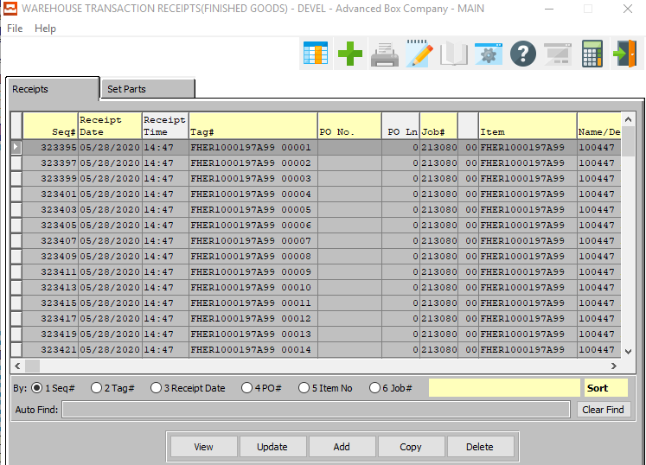

#### VIEW

Click the ***“View”*** button to view detailed information about the currently selected receipt.

#### UPDATE

Click the ***“Update”*** button to update the currently selected receipt.

#### ADD

Click the ***“Add”*** button to add a new receipt. Alternatively, click the ***“Green + Icon”*** at the top of the page.

#### COPY

Click the ***“Copy”*** button to copy information from the currently selected receipt.

#### DELETE

Click the ***“Delete”*** button to delete the currently selected receipt.

### View Receipt Details

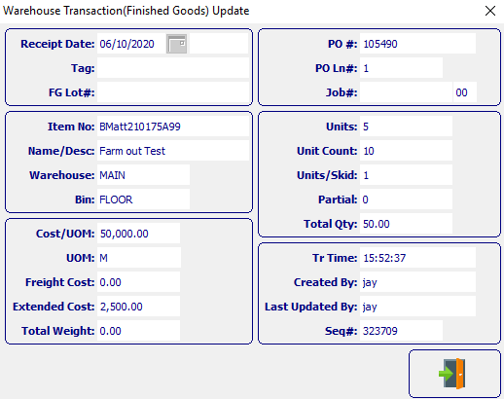

#### EXIT

Click the ***“Exit Door Icon”*** to exit the Receipt Details screen.

### Add/Update Receipt

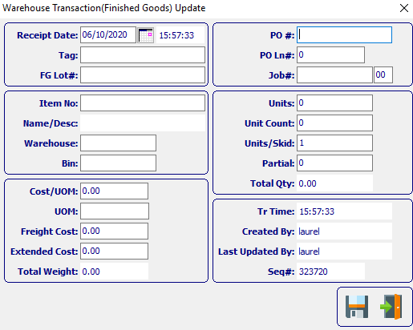

#### SAVE

Click the ***“Floppy Disc Icon”*** to save all changes to the Receipt screen.

#### EXIT

Click the ***“Exit Door Icon”*** to exit the Receipt popup screen.

### Add/Update Receipt Field Definitions

#### Receipt Date

Enter the date that the item was received, defaults to system date. This field automatically defaults to today’s date, but may be modified by the user. The user may press the ***“F1”*** key bring up a popup calendar if needed.

#### Receipt Time

The time that the new receipt is made. This cannot be modified by the user.

#### Tag

Enter tag number or (ticket number). If the item is received by the tag number, then transfers, shipments, adjustments and cycle count processing must include the tag number. The user may enter a tag number, or press the ***“F1”*** key to select the tag number from a list of all available tag numbers.

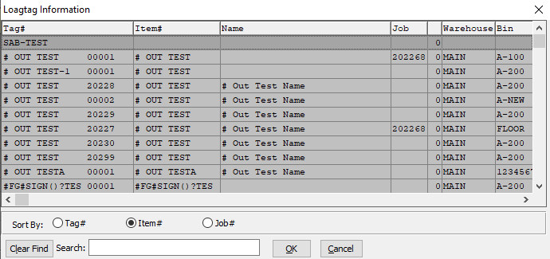

This list can be sorted by Tag Number, Item Number, or Job Number. Alternatively, the user may search for an item, job, or tag that they wish to use in order to narrow down their selection.

As soon as the user makes their selection, or finishes manually entering a valid Tag Number, many subsequent fields will automatically fill with necessary information. From the Item File.

#### FG Lot #

Enter the lot number for this Finished Good

#### Item Number

Enter the Finished Good Item Number in this field. Alternatively, the Item Number field will automatically fill when the user selects their Tag Number.

The user can also press the ***“F1”*** key to search through all available Finished Goods items.

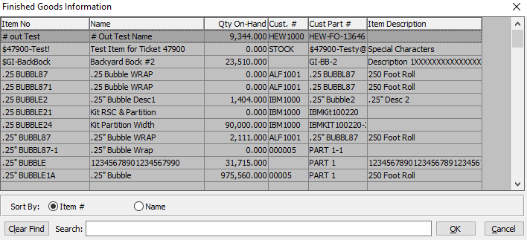

This list can be sorted by Item Number or Item Name. Alternatively, the user may search for any item that they wish to use in order to narrow down their selection.

Once an item is selected, this will automatically fill in several other fields with necessary information from the Item File.

#### Name/Description

This description name transfers from the estimate for custom boxes, however it must be entered for stock boxes. This line transfers to the job ticket, purchase order, and numerous other reports. The system also uses the Item Name for alpha-Alphanumeric searches. This field will automatically populate once the user has selected or entered the item number, and cannot be modified further.

#### Warehouse

This is the primary warehouse location for this item. The bin file will provide inventory control by warehouse, bin location and tag number. Enter the Primary Warehouse (loc). Alternatively, the user may press the ***“F1”*** key to select a warehouse from a list of available warehouses.

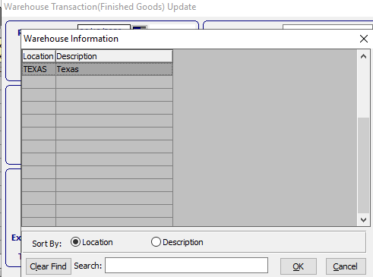

This list can be sorted by Location or Description. Alternatively, the user may search for any warehouse that they wish to use in order to narrow down their selection.

#### Bin

The bin location shows the location within the warehouse such as the aisle, bin location or floor location. Alternatively, the user may press the ***“F1”*** key to select the warehouse bin location information.

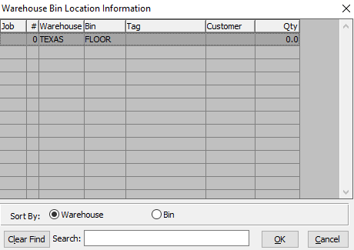

This list can be sorted by Warehouse or Bin. Alternatively, the user may search for any bin that they wish to use in order to narrow down their selection.

#### Cost/UOM

Enter the cost of the item. Three methods for determining the cost of an item exist; Standard Cost, Last Cost, and Average Cost. The company enters the costing method, that they want to use in the *F/G* Control file.

#### UOM

The sell price unit of measure defaults to M for per thousand, however this may be modified. Each unit of measure will yield a different total selling price.

Valid Units of Measure are:

|  |  |
| --- | --- |
| C | Per Hundred |
| CS | Per Case |
| EA | Per Each |
| L | Per Lot |
| M | Per Thousand |

#### Freight Cost

Enter the total freight amount for the Bill of Lading. If the weight per pallet or total Bill of Lading weight is entered in addition to the freight cost per hundred weight, the total freight cost is calculated.

#### Extended Cost

The cost for this Unit of Measure defaults from Raw Material, but may be modified by the user.

#### Total Weight

The Total Weight is automatically calculated by the system using the Cost/UOM and UOM fields. This field is not directly modifiable by the user, but it will update if the user changes the information in either of the ‘Cost/UOM’ or ‘UOM’ fields.

#### PO #

This field is for the Order Number of Purchased Finished Goods only. The number entered must be a valid PO# from the ASI Purchasing Module. The user may enter a PO Number, or press the ***“F1”*** key to select the PO # from a list of all available Purchase Orders.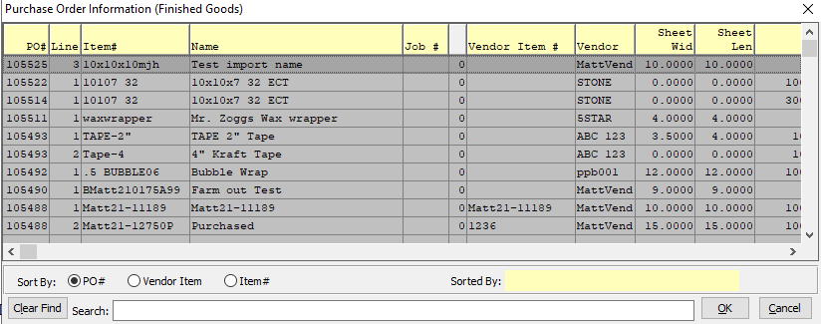

This list can be sorted by PO Number, Vendor Item, or Item Number. Alternatively, the user may search for a PO #, Vendor Item, or Item # that they wish to use in order to narrow down their selection.

#### PO Line #

This field will automatically populate once the user has selected or entered the purchase order number, but can be modified by the user.

#### Job #

The job number defaults to the estimate number, but may be modified. The Job Factory Ticket will print by job number. Repeat jobs for an item will add a suffix to the original job number.

For example, a repeat job number could be Job number 88888-01 where 88888 is the original job and the 01 is the first repeat for that item.

All costs including, standard (estimated) labor, material and overhead, work in process, actual costs and variances are maintained by job number.

#### Job #: 00

Repeat jobs for an item will add a suffix to the original job number.

#### Units

Enter the number of units received of the item into this bin in this warehouse.

#### Units/Skid

Enter the number of units per skid.

#### Partial

Enter a partial quantity.

#### Total Qty

The Total Quantity is automatically calculated by the system using the Units, Unit Count, and Units/Skid fields. This field is not directly modifiable by the user, but it will update if the user changes the information in any of the aforementioned fields.

#### Tr Time

The Transfer Time is automatically entered by the system. It is not modifiable by the user.

#### Created By

The username of the original user that created this receipt in the system.

#### Last Updated By

The username of the last user to have updated this receipt in the system.

#### Sequence #

The Sequence Number is automatically given by the system. It is not modifiable by the user.

### Set Parts

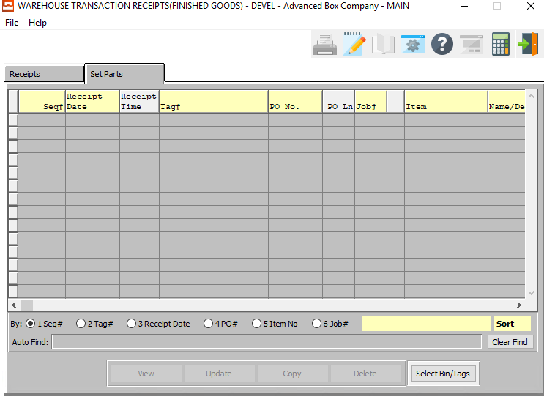

#### SELECT BIN/TAGS

Click the ***“Bins/Tags”*** button to select bins for all set parts.

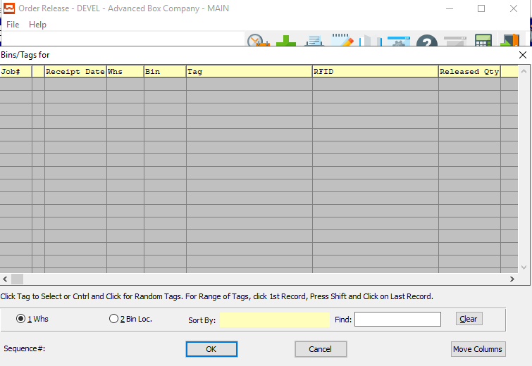

## FG Enter/Modify Transfers [IU2]

F/G Transfer allows for a user to transfer FG from one location to another in the system.

This inventory function is used when inventory is transferred from one warehouse, and/or bin to another. Inventory controls as well as history functions are maintained. *F/G* transfers subtracts the quantity shipped from the quantity on hand, and updates the quantity on hand in the receiving warehouse/bin. An item can't be transferred between jobs or tags. The system tracks the item by Job number, by Warehouse, by Bin number, by tag, as well as by Item number.

### Transfer

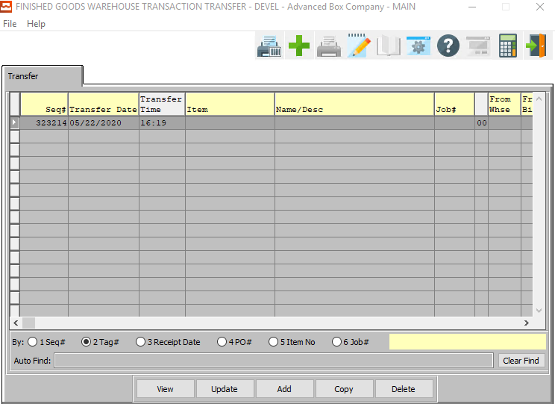

#### VIEW

Click the ***“View”*** button to view detailed information about the currently selected transfer.

#### UPDATE

Click the ***“Update”*** button to update the currently selected transfer.

#### ADD

Click the ***“Add”*** button to add a new transfer. Alternatively, click the ***“Green + Icon”*** at the top of the page.

#### COPY

Click the ***“Copy”*** button to copy information from the currently selected transfer.

#### DELETE

Click the ***“Delete”*** button to delete the currently selected transfer.

### Add/Update Transfer

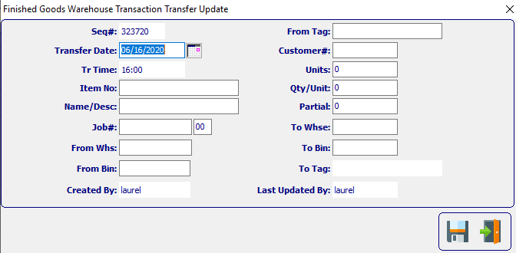

#### SAVE

Click the ***“Floppy Disc Icon”*** to save all changes to the transfer screen.

#### EXIT

Click the ***“Exit Door Icon”*** to exit the transfer popup screen.

### Add/Update Transfer Field Definitions

#### Sequence #

The Sequence Number is automatically given by the system. It is not modifiable by the user.

#### Transfer Date

Enter the date that the item was transferred. This automatically defaults to the current date, but may be modified by the user.

#### Tr Time

The Transfer Time is automatically entered by the system. It is not modifiable by the user.

#### Item Name/Description

This description name transfers from the item file, however it must be entered for stock boxes. This line transfers to the job ticket, purchase order, and numerous other reports. The system also uses the Item Name for alpha-Alphanumeric searches. This field will automatically populate once the user has selected or entered the item number, and cannot be modified further.

#### Item Number

Enter valid item number from Finished Goods file. Optionally, press “***F1”*** to search, or the ***“Page Up”*** / ***“Page Down”*** keys to scroll through the Item file. Press the “***Enter***” key to accept the Item displayed on the screen. When choosing an item number, the customer number associated with the item (in the item file) is displayed on the screen.

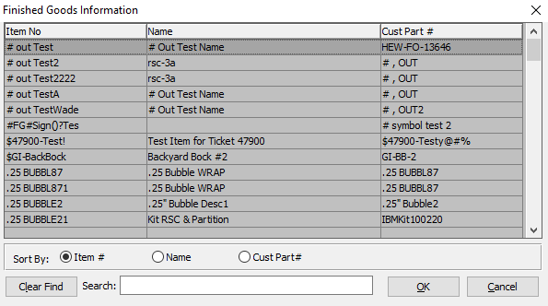

This list can be sorted by Item #, Name, or Customer Part #. Alternatively, the user may search for the Item Number, Name, or Part Number that they wish to use in order to narrow down their selection.

#### Job Number

Enter the job number, from which to transfer the item. press “***F1”*** to search, or the ***“Page Up”*** / ***“Page Down”*** keys to scroll through the Job file. Press the “***Enter***” key to accept the Job displayed on the screen.

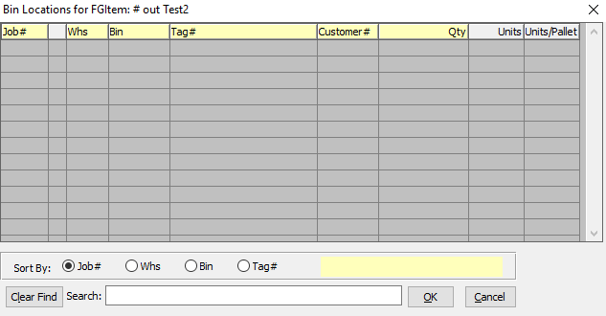

This list can be sorted by Job #, Warehouse, Bin, or Tag #. Alternatively, the user may search for the job number, warehouse, bin, or tag number that they wish to use in order to narrow down their selection.

#### Job #: 00

Repeat jobs for an item will add a suffix to the original job number.

#### From Warehouse / To Warehouse

The "From Warehouse" is the warehouse that is sending the item. The system transfers the quantity of #-CASES multiplied by QTY-PER-CASE plus PARTIAL. This quantity in the From Warehouse, from Bin, and from tag job is transferred to the To Warehouse, to Bin, and to Tag for the Item and Job entered above.

The 'To Warehouse is the warehouse receiving the item transferred. The system transfers the quantity of #-CASES multiplied by QTY-PER-CASE plus PARTIAL. This quantity in the to Warehouse, to Bin, and to tag job is increased by the quantity received from the from Warehouse, from Bin, and from Tag for the Item and Job entered above.

Enter a valid Warehouse code from the Warehouse file. Optionally, press “***F1”*** to search, or the ***“Page Up”*** / ***“Page Down”*** keys to scroll through the Warehouse file. Press the “***Enter***” key to accept the Warehouse displayed on the screen.

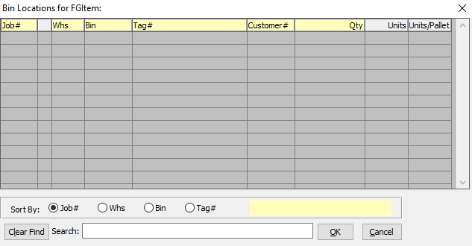

This list can be sorted by Job #, Warehouse, Bin, or Tag #. Alternatively, the user may search for the job number, warehouse, bin, or tag number that they wish to use in order to narrow down their selection.

#### From Bin / To Bin

The 'From Bin' is the bin located in the warehouse that is sending the item. The system transfers the quantity of #-CASES multiplied by QTY-PER-CASE plus PARTIAL. This quantity in the from Warehouse, from Bin, and from tag job is transferred to the To Warehouse, to Bin, and to Tag for the Item and Job entered above.

The 'To Bin' is the Bin in the warehouse receiving the item transferred. The system transfers the quantity of #-CASES multiplied by QTY-PER-CASE plus PARTIAL. This quantity in the To Warehouse, to Bin, and to tag job is increased by the quantity received from the from Warehouse, from Bin, and from Tag for the Item and Job entered above.

Enter valid Bin from Bin file. Optionally, press “***F1”*** to search, or the ***“Page Up”*** / ***“Page Down”*** keys to scroll through the Bin file. Press the “***Enter***” key to accept the Bin displayed on the screen.

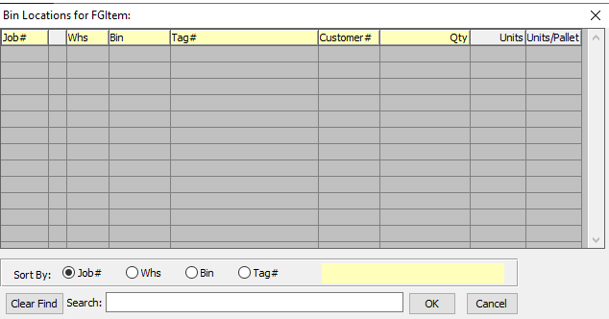

This list can be sorted by Job #, Warehouse, Bin, or Tag #. Alternatively, the user may search for the job number, warehouse, bin, or tag number that they wish to use in order to narrow down their selection.

#### From Tag / To Tag

The 'From Tag' is the Tag number of the item, located in the bin and warehouse that is sending the item. The system transfers the quantity of #-CASES multiplied by QTY-PER-CASE plus PARTIAL. This quantity in the from Warehouse, from Bin, and from tag job is transferred to the to Warehouse, to Bin, and to Tag for the Item and Job entered above.

The 'To Tag' is the Tag number in the bin of the warehouse receiving the item transferred. The system transfers the quantity of #-CASES multiplied by QTY-PER-CASE plus PARTIAL. This quantity in the to Warehouse, to Bin, and to tag job is increased by the quantity received from the from Warehouse, from Bin, and from Tag for the Item and Job entered above.

Enter tag number or (ticket number). If the item is received by the tag number, then transfers, shipments, adjustments and cycle count processing must include the tag number.

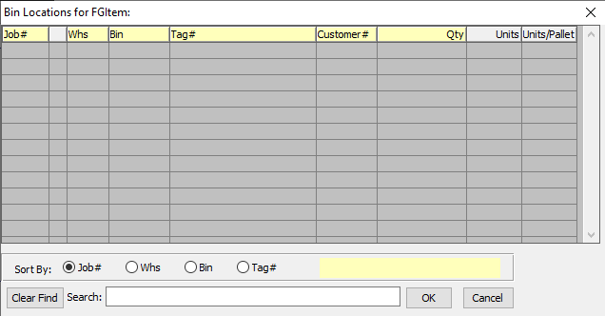

This list can be sorted by Job #, Warehouse, Bin, or Tag #. Alternatively, the user may search for the job number, warehouse, bin, or tag number that they wish to use in order to narrow down their selection.

#### Customer #

The Customer Number will transfer from the Warehouse/Bin/Tag file.

#### Units

This is the total number of units in the currently selected From location.

#### Qty/Unit

Enter the number of units you wish to transfer to the new location.

#### Partial

Enter the partial amount received of the item into this bin in this warehouse.

#### Created By

The username of the original user that created this receipt in the system.

#### Last Updated By

The username of the last user to have updated this receipt in the system.

## FG Enter/Modify Adjustments [IU3]

This inventory function is used when inventory need to be adjusted (in either quantity and/or cost). Inventory controls as well as history functions are maintained. *F/G* shipping adjusts the quantity and the associated costs. The system tracks the item by Job number, by Warehouse, by Bin number, by tag, as well as by Item number.

### Adjustment

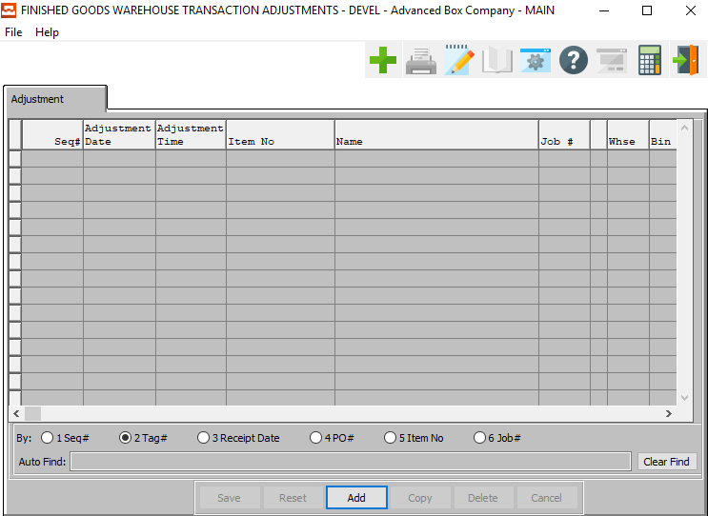

#### ADD

Click the ***“Add”*** button to add a new adjustment. Alternatively, click the ***“Green + Icon”*** at the top of the page.

### Add Adjustment

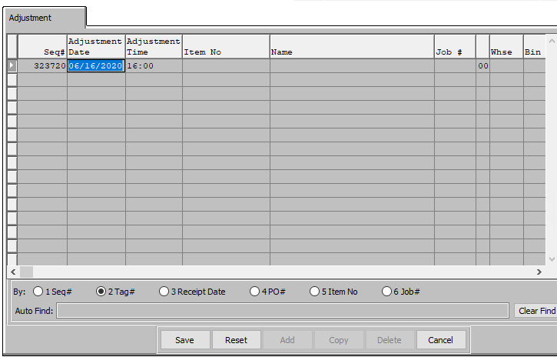

#### SAVE

Click the “***Save***” button to save the current adjustment.

#### RESET

Click the “***Reset***” button to reset all changes to the adjustment.

#### CANCEL

Click the “***Cancel***” button to cancel the adjustment without saving changes.

### Add Adjustment Field Definitions

#### Sequence #

The Sequence Number is automatically given by the system. It is not modifiable by the user.

#### Adjustment Date

Enter the date that the item was adjusted, defaults to system date.

#### Adjustment Time

The time that the new adjustment was made. This is not modifiable by the user.

#### Item Name

This description name transfers from item file, however it must be entered for stock boxes. This line transfers to the job ticket, purchase order, and numerous other reports. The system also uses the Item Name for alpha-Alphanumeric searches. This field will automatically populate once the user has selected or entered the item number, and cannot be modified further.

#### Item Number

Enter a valid item number from Finished Goods file. Optionally, press “***F1”*** to search, or the ***“Page Up”*** / ***“Page Down”*** keys to scroll through the Item file. Press the “***Enter***” key to accept the Item displayed on the screen.

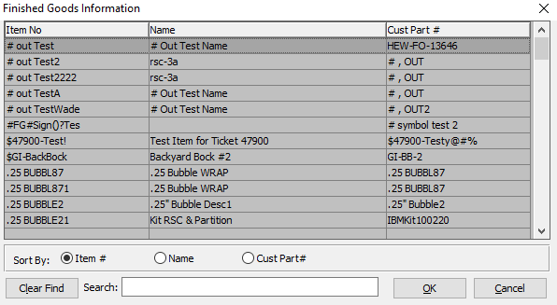

This list can be sorted by Item Number, Name, or Customer Part Number. Alternatively, the user may search for what they wish to use in order to narrow down their selection.

As soon as the user makes their selection, or finishes manually entering a valid Item Number, many subsequent fields will automatically fill with necessary information.

#### Job Number

Enter the job number for the adjustment of this item. Optionally, press “***F1”*** to search, or the ***“Page Up”*** / ***“Page Down”*** keys to scroll through the Job file. Press the “***Enter***” key to accept the Job displayed on the screen.

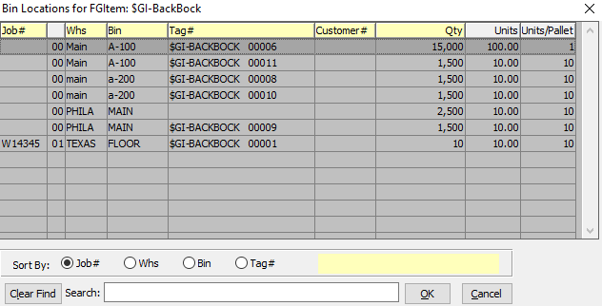

This list can be sorted by Job Number, Warehouse, Bin, or Tag Number. Alternatively, the user may search for what they wish to use in order to narrow down their selection.

As soon as the user makes their selection, or finishes manually entering a valid Bin Location, many subsequent fields will automatically fill with necessary information.

#### Warehouse

This field will automatically fill as soon as the user chooses or enters an item number.

The 'From Warehouse is the warehouse that is sending the item. The system transfers the quantity of #-CASES multiplied by QTY-PER-CASE plus PARTIAL. This quantity in the from Warehouse, from Bin, and from tag job is transferred to the To Warehouse, to Bin, and to Tag for the Item and Job entered above.

Enter a valid Warehouse code from the Warehouse file. Optionally, press “***F1”*** to search, or the ***“Page Up”*** / ***“Page Down”*** keys to scroll through the Warehouse file. Press the “***Enter***” key to accept the Warehouse displayed on the screen.



This list can be sorted by Job Number, Warehouse, Bin, or Tag Number. Alternatively, the user may search for what they wish to use in order to narrow down their selection.

As soon as the user makes their selection, or finishes manually entering a valid Bin Location, many subsequent fields will automatically fill with necessary information.

#### Bin

This field will automatically fill as soon as the user chooses or enters an item number.

The 'From Bin' is the bin located in the warehouse that is sending the item. The system transfers the quantity of #-CASES multiplied by QTY-PER-CASE plus PARTIAL. This quantity in the from Whse, from Bin, and from tag job is transferred to the to Whse, to Bin, and to Tag for the Item and Job entered above.

Enter valid Bin from Bin file. press “***F1”*** to search, or the ***“Page Up”*** / ***“Page Down”*** keys to scroll through the Bin file. Press the “***Enter***” key to accept the Bin displayed on the screen.



This list can be sorted by Job Number, Warehouse, Bin, or Tag Number. Alternatively, the user may search for what they wish to use in order to narrow down their selection.

As soon as the user makes their selection, or finishes manually entering a valid Bin Location, many subsequent fields will automatically fill with necessary information.

#### Created By

The username of the user who first created this adjustment. The system automatically fills this in, and it cannot be modified by the user.

#### Last Update

The username of the user who has last updated information on this adjustment. The system automatically fills this in, and it cannot be modified by the user.

#### Reason

The user may select their chosen reason for the adjustment using a drop-down menu in the Reason field. If the user does not see their reason listed, new reasons may be defined by the user in the File Maintenance section of the Inventory/Finished Goods menu.

#### Tag

The 'From Tag' is the Tag number of the item, located in the bin and warehouse that is sending the item. The system adjusts the quantity by the net adding +QTY and subtracting -QTY. Likewise, costs are adjusted by adding +COST and subtracting -COST. If the item is received by tag number, then transfers, shipments, adjustments and cycle count processing must include the tag number.



This list can be sorted by Job Number, Warehouse, Bin, or Tag Number. Alternatively, the user may search for what they wish to use in order to narrow down their selection.

As soon as the user makes their selection, or finishes manually entering a valid Bin Location, many subsequent fields will automatically fill with necessary information.

#### Customer #

This field will automatically fill as soon as the user chooses a Bin location. However, it can be modified by the user.

#### Units

Enter the number of units for the adjustment.

#### Qty/Unit

This number will automatically fill as soon as the use selects or enters an item number.

#### Partial

Alternatively, enter the number of partial units for the adjustment.

#### Total Qty

The total quantity is automatically filled in by the system to show the total quantity of units after the adjustment is completed.

#### Cost

The total cost is automatically calculated by the system, and cannot be modified by the user.

## Print Finished Goods Edit List [IU4]

This inventory function is used to print *F/G* transactions that have not been posted.

Finished Goods edit list should be printed before posting warehouse transactions. The edit list sorts by Date, location, item and transaction type. Review the edit list to catch data input errors. Once found, the corrections should be made to the transaction where the error occurred by displaying the Entry on the screen and press ***"C"*** for change; then type in the correct information. Once corrected, the posting program can run correctly, updating all quantity fields in the finished goods file.

### Selection Parameters

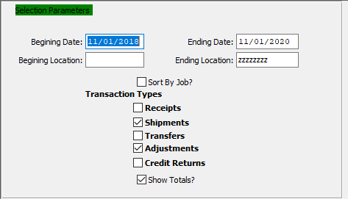

#### Beginning Date / Ending Date

Enter a starting and ending date.

#### Beginning Location / Ending Location

Enter a starting and ending location.

#### Sort by Job? – Toggle Box

To sort the edit list by job, make sure that the Sort by Job toggle box is checked.

#### Transaction Type – Receipts – Toggle Box

To include Receipts in the edit list, make sure that the Receipts toggle box is checked.

#### Transaction Type – Shipments – Toggle Box

To include Shipments in the edit list, make sure that the Shipments toggle box is checked.

#### Transaction Type – Transfers – Toggle Box

To include Transfers in the edit list, make sure that the Transfers toggle box is checked.

#### Transaction Type – Adjustments – Toggle Box

To include Adjustments in the edit list, make sure that the Adjustments toggle box is checked.

#### Transaction Type – Credit Returns – Toggle Box

To include Credit Returns in the edit list, make sure that the Credit Returns toggle box is checked.

#### Show Totals? -Toggle Box

To show totals in the edit list, make sure that the Show Totals toggle box is checked.

### Output Destination

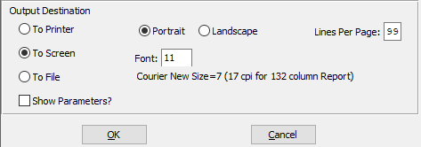

#### Destination Choice

To choose the destination where the document should be printed, please make sure that desired output destination choice bubble is toggled.

#### Layout Choice

To choose the preferred layout of Landscape vs. Portrait, please make sure the desired option choice bubbled is toggled.

#### Lines Per Page

Lines per page on the report when printing.

#### Font

Enter the font number to use with this report (Font 11 is default).

#### Show Parameters? – Toggle Box

To show parameters, make sure that the toggle box is ‘ticked’ with a checkmark.

## Post to Finished Goods Files [IU5]

This process updates all of the related item files as to quantity, and cost. Current transactions are moved to the history file for an audit trail, and the *F/G* transaction file is cleared of all current receipts, Shipments, Adjustments, and Transfers.

### Selection Parameters

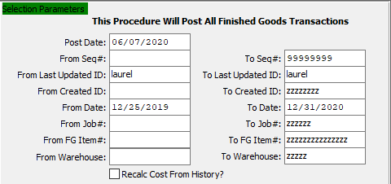

#### Post Date

Enter the post date of the Finished Items Goods file. This defaults as today’s date, but may be modified.

#### From Sequence # / To Sequence #

Enter the starting and ending sequence number for the Finished Goods file.

#### From Last Updated ID / To Last Updated ID

Enter the starting and ending username for the Finished Goods file.

#### From Created ID / To Created ID

Enter the starting and ending created ID for the Finished Goods file.

#### From Date / To Date

Enter a starting and ending date.

#### From Job # / To Job #

Enter the starting and ending job number.

#### From FG Item # / To FG Item #

Enter the starting and ending finished goods item number.

#### From Warehouse / To Warehouse

Enter the starting and ending warehouse.

#### Recalc Cost From History? – Toggle Box

To recalculate the cost of the finished goods transaction from history, make sure that this toggle box is checked.

### Parameter Options

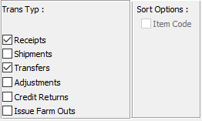

#### Transaction Type – Receipts – Toggle Box

To include Receipts in the edit list, make sure that the Receipts toggle box is checked.

#### Transaction Type – Shipments – Toggle Box

To include Shipments in the edit list, make sure that the Shipments toggle box is checked.

#### Transaction Type – Transfers – Toggle Box

To include Transfers in the edit list, make sure that the Transfers toggle box is checked.

#### Transaction Type – Adjustments – Toggle Box

To include Adjustments in the edit list, make sure that the Adjustments toggle box is checked.

#### Transaction Type – Credit Returns – Toggle Box

To include Credit Returns in the edit list, make sure that the Credit Returns toggle box is checked.

#### Transaction Type – Issue Farm Outs – Toggle Box

To include Farm Outs in the edit list, make sure that the Issue Farm Outs toggle box is checked.

#### Sort Options – Item Code – Toggle Box

To Sort transactions by their item code, the user must enter int the starting and beginning Finished Good Item Numbers in the selection parameters above, then make sure that the Item Code toggle box is checked.

### Print Options

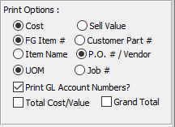

The user may choose the options that they wish to print using this list. All options where the desired option choice bubble is toggled will post to the Finished Goods file, and print on the subsequent report.

#### Print GL Account Numbers – Toggle Box

To print General Ledger account numbers on the report, make sure that this toggle box is checked.

#### Total Cost/Value – Toggle Box

To print the total cost and value on the report, make sure that the Total Cost/Value toggle box is checked.

#### Grand Total – Toggle Box

To print the grand total on the report, make sure that the Grand Total toggle box is checked.

### Output Destination

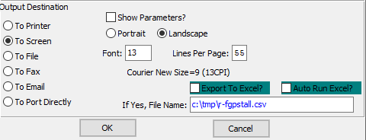

#### Destination Choice

To choose the destination where the document should be printed, please make sure that desired output destination choice bubble is toggled.

#### Layout Choice

To choose the preferred layout of Landscape vs. Portrait, please make sure the desired option choice bubbled is toggled.

#### Lines Per Page

Lines per page on the report when printing.

#### Font

Enter the font number to use with this report (Font 11 is default).

#### Show Parameters? – Toggle Box

To show parameters, make sure that the toggle box is ‘ticked’ with a checkmark.

#### Export to Excel? – Toggle Box

To export the printed file to an excel document, make sure that the Export to Excel toggle box is checked.

#### Auto Run Excel? – Toggle Box

To automatically open the new excel document, make sure that the Auto Run Excel toggle box is checked.

#### If Yes, File Name

If exporting the file to Excel, enter the desired file name.

## Delete Zero Qty FG Bins [IU6]

This process deletes all Bins / Jobs that are no longer is use by the system. It can be used at any time, but it is beneficial to use only when the inventory system becomes noticeably slower.

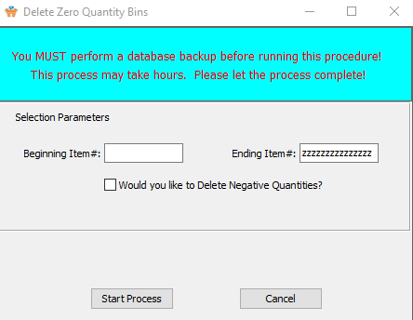

#### Beginning Item # / Ending Item #

Enter the starting and ending item number.

#### Would you like to Delete Negative Quantities?

To delete all negative quantity items, as well as items that have a quantity of zero, make sure that this toggle box is checked.

## Move FG to Board/Misc. RM [IU7]

Updating the FG Item code is not updating the FG item code in the Load tag and Case Tag files. The tag number would remain the same, however the FG Item code in the Load tag file must be updated.

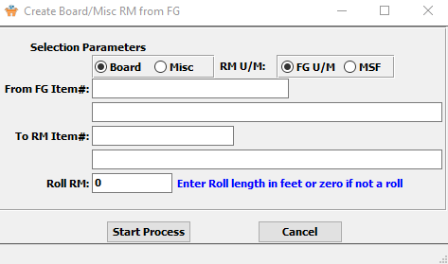

#### Item Type (Choice)

To choose the preferred Item Type of Board vs. Miscellaneous, please make sure the desired option choice bubble is toggled.

#### RM U/M (Choice)

To choose the preferred Raw Material Unit of Measure of Finished Good Unit of Measure vs. MSF, please make sure the desired option choice bubble is toggled.

#### FG Item Name

This field will automatically fill as soon as the user enters or chooses a valid Finished Good Item Number. However, it can be modified by the user.

#### From FG Item #

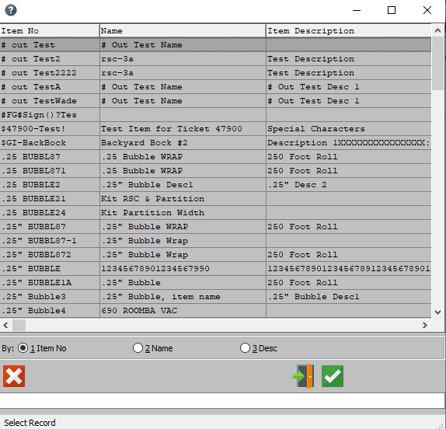

This list can be sorted by Item Number, Name, or Description. As soon as the user makes their selection, or finishes manually entering a valid Item, many subsequent fields will automatically fill with necessary information.

#### To RM Item #

This field will automatically fill in as soon as the user enters or chooses a valid Finished Good Item Number. However, a new Raw Material Item Number can be entered or chosen by pressing the ***“F1”*** button.

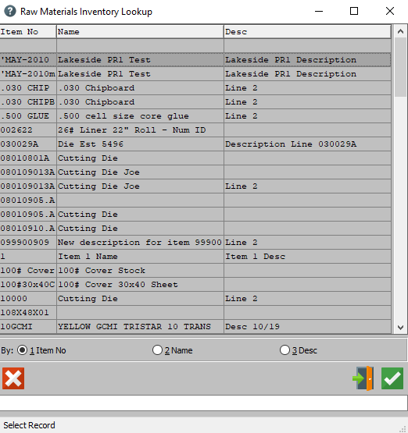

This list can be sorted by Item Number, Name, or Description. As soon as the user makes their selection, or finishes manually entering a valid Item, many subsequent fields will automatically fill with necessary information.

#### Raw Material Name

This field will automatically fill as soon as the user enters or chooses a valid Raw Material Item Number. However, it can be modified by the user.

#### Roll RM

Enter the Roll Length (In feet) for the Raw Material Item. If the Raw Material is not a roll, this field should be set to 0.

## FG Consolidate Tags [IU8]

### Transfer

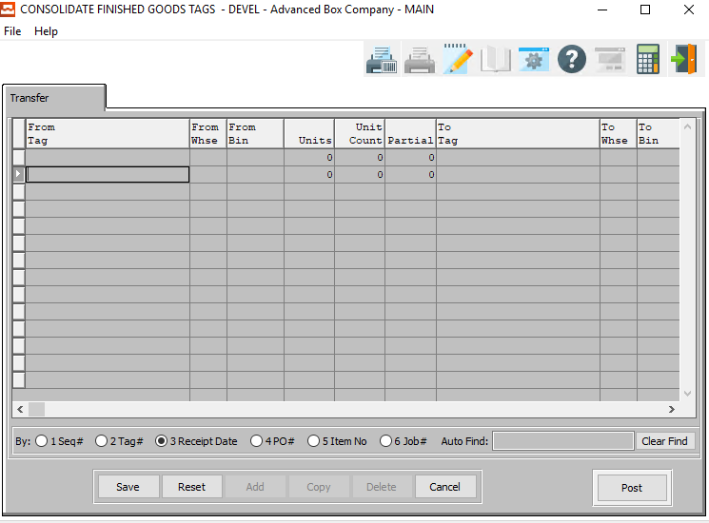

#### SAVE

Click the “***Save***” button to save the current transfer.

#### RESET

Click the “***Reset***” button to reset all changes to the transfer.

#### CANCEL

Click the “***Cancel***” button to cancel the transfer without saving changes.

#### POST

Click the “***Post***” button to post the transfer.

### Transfer Field Definitions

#### From Tag / To Tag

Enter the Tag # of both the To and From Fields for the transfer. Alternatively, the user may press the ***“F1”*** key to select a Tag # from a list of available tag numbers.

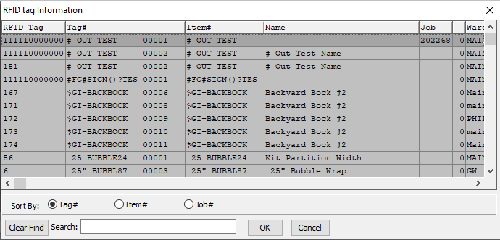

This list can be sorted by Tag Number, Item Number, or Job Number. Alternatively, the user may search for the number that they wish to use in order to narrow down their selection.

As soon as the user makes their selection, or finishes manually entering a valid Tag Number, many subsequent fields will automatically fill with necessary information.

Please Note: Both of the From Tag and To Tag must be the same.

#### From Warehouse / To Warehouse

The From Warehouse will automatically fill as soon as the user enters or chooses a valid From Tag Number.

The To Warehouse will automatically fill as soon as the user enters or chooses a valid To Tag Number.

#### From Bin / To Bin

The From Bin will automatically fill as soon as the user enters or chooses a valid From Tag Number.

The To Bin will automatically fill as soon as the user enters or chooses a valid To Tag Number.

#### Units

The number of units in the From Bin will automatically fill in as soon as the user enters or chooses a valid Tag Number.

#### Partial

The number of partial units of this Tag Number.

#### Customer #

The Customer Number field will automatically fill in as soon as the user enters or chooses a valid Tag Number.

#### Item #

The Item Number field will automatically fill in as soon as the user enters or chooses a valid Tag Number.

#### Item Name

The Item Name field will automatically fill in as soon as the user enters or chooses a valid Tag Number.

#### User Created

The username of the original user to create this transfer. It cannot be modified.

#### User Update

The date that this transfer was first made. It cannot be modified.

#### Transfer Date

The username of the last user to update information within this transfer. It cannot be modified.

#### Transfer Time

The date that this transfer was last updated. It cannot be modified.

## FG Issue [IU9]

### Issue

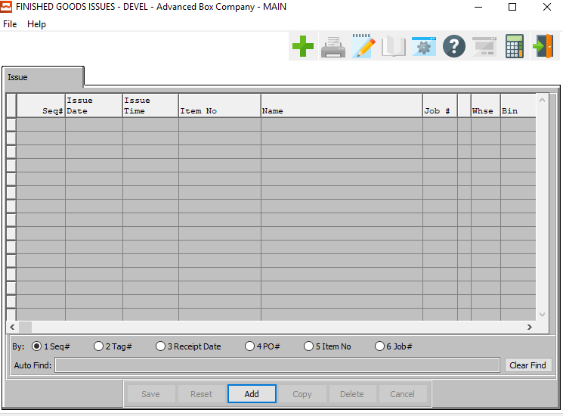

#### ADD

Click the ***“Add”*** button to add a new issue. Alternatively, click the ***“Green + Icon”*** at the top of the page.

### Add Issue

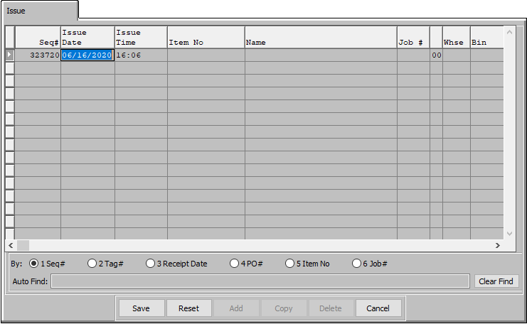

#### SAVE

Click the “***Save***” button to save the current issue.

#### RESET

Click the “***Reset***” button to reset all changes to the issue.

#### CANCEL

Click the “***Cancel***” button to cancel the issue without saving changes.

### Add Issue Field Definitions

#### Sequence #

The Sequence Number is automatically given by the system. It is not modifiable by the user.

#### Issue Date

Enter the date that the item was issued, defaults to system date. This field automatically defaults to today’s date, but may be modified by the user.

#### Issue Time

The time that the new issue is made. This cannot be modified by the user.

#### Item Name

Enter the Finished Good Item Name on this line. This line transfers to the job ticket, purchase order, and numerous other reports. The system also uses the Item Name for alpha-Alphanumeric searches. This field will automatically populate once the user has selected or entered the item number, and cannot be modified further.

#### Item Number

Enter the Finished Good Item Number for this field. Alternatively, the user may press the ***“F1”*** key to select an Item Number from a list of available Finished Good Items.

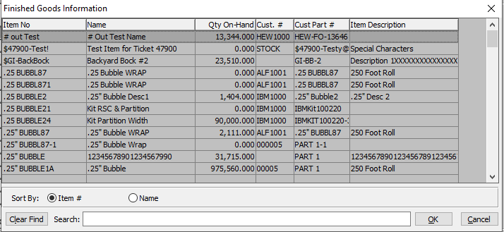

This list can be sorted by Item Number or Item Name. Alternatively, the user may search for what they wish to use in order to narrow down their selection.

As soon as the user makes their selection, or finishes manually entering a valid Item Number, many subsequent fields will automatically fill with necessary information.

#### Job #

This is the Job Number for the current Issue. The user may enter a job number, or press the ***“F1”*** key to select the job number from a list of all available open Jobs.

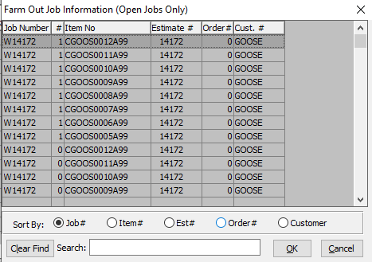

This list can be sorted by Job Number, Item Number, Estimate Number, Order Number, or Customer Number. Alternatively, the user may search for number that they wish to use in order to narrow down their selection.

As soon as the user makes their selection, or finishes manually entering a valid Job Number, the subsequent job number field will automatically fill with necessary information.

#### Warehouse

The Warehouse code will automatically populate once the user enters or chooses a valid Tag Number.

#### Bin

The Bin code will automatically populate once the user enters or chooses a valid Tag Number.

#### Tag

This is the Tag Number for the current Issue. The user may enter a known Tag Number, or press the ***“F1”*** key to select the number from a list of all available Tag Numbers.

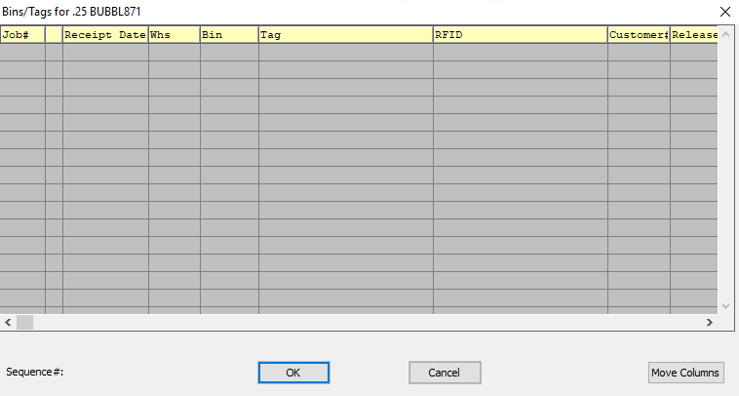

As soon as the user makes their selection, or finishes manually entering a valid Tag Number, many subsequent fields will automatically fill with necessary information.

#### Partial

The user may enter a partial quantity for the current item.

#### Total Qty

This is the total quantity for the current issue.

#### Cost

This is the cost of the currently selected item. This field will automatically populate as soon as the user enters of chooses a valid item number.

#### Created By

The username of the user who first created this issue. This cannot be modified.

#### Last Update

This is the username of the last user that made changes to this issue. This cannot be modified.

## Transfer Transaction BOL [IU)]

The *Transfer Transaction BOL* screen allows the user to easily create and print a Bill of Lading document for a transfer.

### Transfer Bill of Lading Creation

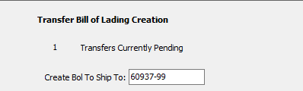

#### Create BOL to Ship To:

This is the Ship-To ID Code to create a Bill of Lading for. The user may enter a Ship-To code, or press the ***“F1”*** key to select the code from a list of all available Ship-To ID Codes.

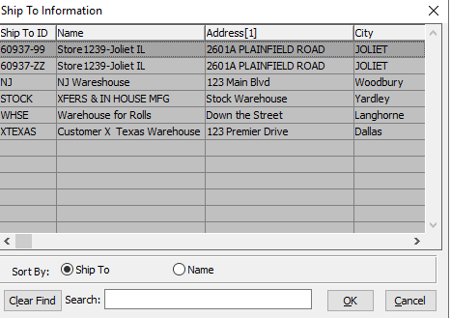

This list can be sorted by the Ship-To Code or the Warehouse Name. Alternatively, the user may search for what they wish to use in order to narrow down their selection.

### Output Options

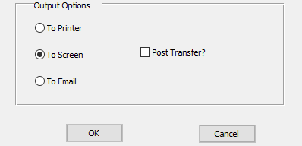

#### Destination Choice

To choose the destination where the document should be printed, please make sure that desired output destination choice bubble is toggled.

#### Post Transfer? – Toggle Box

To post the transfer as well as print the report, make sure that the Post Transfer toggle box is checked.

# **Count Finished Goods [IC]**

This menu provides the Finished Goods options that available under the Cycle Count (Physical) Inventory subsystem. The Cycle Count report is based, primarily, upon the cycle count code entered in the Item file. In a cycle, items are physically counted; the result is entered into and compared by the F/G module. If correct, results can then be posted. The user defines this code when entering item numbers. No separate maintenance is necessary when a new code is entered; the system reads the Cycle Count Processing on the fly.

## Physical Count Report [IC1]

### Overview

Physical Counting of Finished Goods may be processed as often as required. More critical items such as board should be counted every month, whereas glue or pallets may be counted semi-annually.

Whatever your company’s inventory control methodology, the physical count processing provides a more routine and accurate method to control inventory. To facilitate this process, each item is given a CYCLE COUNT Code in the Finished Goods file; similar items should be given the same cycle count code so that the cycle count worksheet prints only that group of items.

Once the worksheet is printed, and the actual inventory noted on the worksheet, the data entry process of posting the actual count must be entered. Once entered, an edit list should be printed and, then finally, the transactions should be posted and then the cycle count register printed.

The important issue regarding this program; the quantity posted replaces the previous quantity on hand for each bin, warehouse, job and tag number. This varies from warehouse transactions that either add or reduce from the original on hand quantity.

Once entered into the Finished Goods, physical counts to Finished goods inventory may be added, deleted or changed for each job, warehouse, bin and tag number.

### Selection Parameters

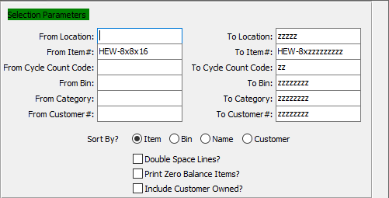

#### From Location / To Location

Enter a starting and ending location.

#### From Item # / To Item #

Enter the starting and ending item number.

#### From Cycle Count Code / To Cycle Count Code

Enter the starting and ending cycle count code.

#### From Bin / To Bin

Enter the starting and ending bin.

#### From Category / To Category

Enter the starting and ending category.

#### From Customer # / To Customer #

Enter the starting and ending customer number.

#### Sort By? (Choice)

To choose the preferred sort method of Item vs. Bin vs. Name vs. Customer, please make sure the desired option choice bubble is toggled.

#### Double Space Lines? – Toggle Box

To double space all lines in the report, make sure that the Double Space Lines toggle box is checked.

#### Print Zero Balance Items? – Toggle Box

To print items that have a balance of zero on the report, make sure that the Print Zero Balance Items toggle box is checked.

#### Include Customer Owned? – Toggle Box

To include the quantity owned by the customer with the quantity on hand, please make sure that this toggle box is checked.

### Available and Selected Columns

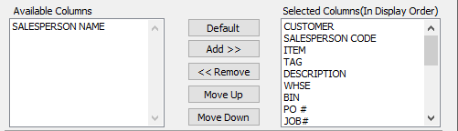

#### Available Columns

The user may choose which columns they wish to have on the report printout. As the user selects their choices, they will appear on the ‘*Selected Columns’* list.

#### Selected Columns (In Display Order)

The columns that the user has chosen from the ‘*Available Columns’* list. The order that these columns are displayed in here is the order in which they will print on the report.

#### Default

Click the ***“Default****”* button to sort the ‘*Selected Columns’* list by the default system parameters.

#### Add >>

Click on the selected item from the ‘*Available Columns’* list to highlight it, then click the ***“Add”*** button to add the selected column to the ‘*Selected Columns’* list.

#### << Remove

Click on the selected item from the ‘*Selected Columns’* list to highlight it, then click the ***“Remove”*** button to remove the selected column to the ‘*Selected Columns’* list.

#### Move Up

Within the ‘*Selected Columns’* list, the user may choose the order they wish the selected columns to print in. In order to change the order of the columns, the user can click on a selection to highlight it. By then clicking the ***“Move Up***” button, the user can change its position on the report.

#### Move Down

Within the ‘*Selected Columns’* list, the user may choose the order they wish the selected columns to print in. In order to change the order of the columns, the user can click on a selection to highlight it. By then clicking the ***“Move Down***” button, the user can change its position on the report.

### Output Destination

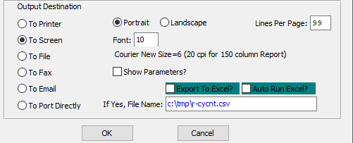

#### Destination Choice

To choose the destination where the document should be printed, please make sure that desired output destination choice bubble is toggled.

#### Layout Choice

To choose the preferred layout of Landscape vs. Portrait, please make sure the desired option choice bubbled is toggled.

#### Lines Per Page

Lines per page on the report when printing.

#### Font

Enter the font number to use with this report (Font 11 is default).

#### Show Parameters? – Toggle Box

To show parameters, make sure that the toggle box is ‘ticked’ with a checkmark.

#### Export to Excel? – Toggle Box

To export the printed file to an excel document, make sure that the Export to Excel toggle box is checked.

#### Auto Run Excel? – Toggle Box

To automatically open the new excel document, make sure that the Auto Run Excel toggle box is checked.

#### If Yes, File Name

If exporting the file to Excel, enter the desired file name.

## FG Enter/Modify Physical Counts [IC2]

### Counts

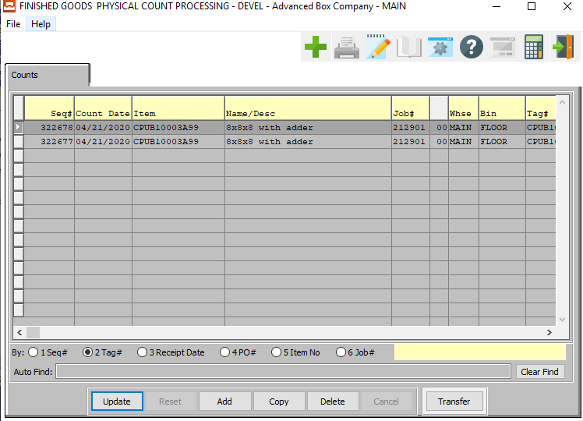

#### UPDATE

Click the ***“Update”*** button to update the currently selected physical count.

#### ADD

Click the ***“Add”*** button to add a new physical count. Alternatively, click the ***“Green + Icon”*** at the top of the page.

#### COPY

Click the ***“Copy”*** button to copy information from the currently selected physical count.

#### DELETE

Click the ***“Delete”*** button to delete the currently selected physical count.

#### TRANSFER

Click the ***“Transfer”*** button to quickly transfer the selected physical count from warehouse to another.

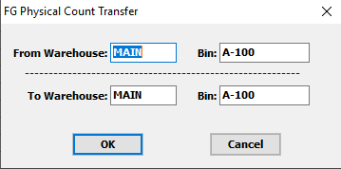

### Add/Update Counts

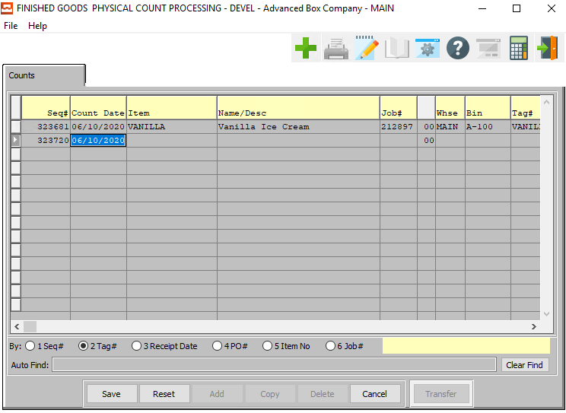

#### SAVE

Click the “***Save***” button to save the current count.

#### RESET

Click the “***Reset***” button to reset all changes to the count.

#### CANCEL

Click the “***Cancel***” button to cancel the count without saving changes.

### Add/Update Counts Field Definitions

#### Sequence #

The Sequence Number is automatically given by the system. It is not modifiable by the user.

#### Count Date

Enter the date that physical count way made, defaults to system date. This field automatically defaults to today’s date, but may be modified by the user.

#### Item Name/Description

The Item Name/Description field will automatically populate as soon as the user enters or chooses a valid item number.

#### Item

Enter valid item number from Finished Goods file. Optionally, press “***F1”*** to search, or the ***“Page Up”*** / ***“Page Down”*** keys to scroll through the Item file. Press the “***Enter***” key to accept the Item displayed on the screen.

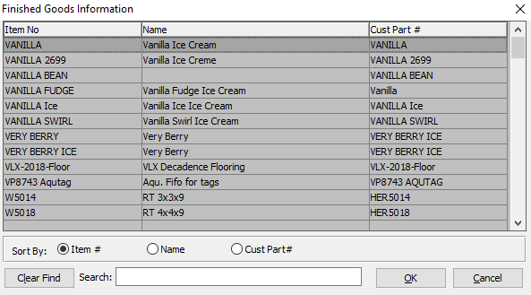

This list can be sorted by Item Number, Item Name, or Customer Part Number. Alternatively, the user may search for a number that they wish to use in order to narrow down their selection.

As soon as the user makes their selection, or finishes manually entering a valid Item Number, many subsequent fields will automatically fill with necessary information.

#### Job #

Enter the job number for the Physical Count of this item. Optionally, press “***F1”*** to search, or the ***“Page Up”*** / ***“Page Down”*** keys to scroll through the Job file. Press the “***Enter***” key to accept the Job displayed on the screen.

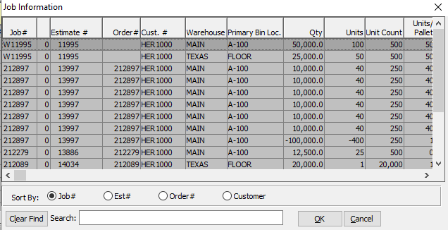

This list can be sorted by Job Number, Estimate Number, Order Number, or Customer Number. Alternatively, the user may search for a number that they wish to use in order to narrow down their selection.

As soon as the user makes their selection, or finishes manually entering a valid Job Number, many subsequent fields will automatically fill with necessary information.

#### Warehouse

Enter valid Warehouse from Warehouse file. Optionally, press “***F1”*** to search, or the ***“Page Up”*** / ***“Page Down”*** keys to scroll through the Warehouse file. Press the “***Enter***” key to accept the warehouse displayed on the screen.

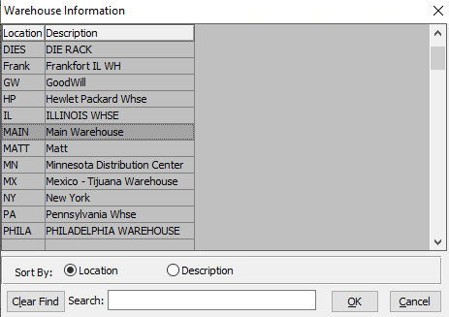

This list can be sorted by Warehouse Location or Warehouse Description. Alternatively, the user may search for what they wish to use in order to narrow down their selection.

As soon as the user makes their selection, or finishes manually entering a valid Warehouse Location Code, many subsequent fields will automatically fill with necessary information.

#### Bin

Enter valid Bin from Bin file. Optionally, press “***F1”*** to search, or the ***“Page Up”*** / ***“Page Down”*** keys to scroll through the Bin file. Press the “***Enter***” key to accept the Bin displayed on the screen.

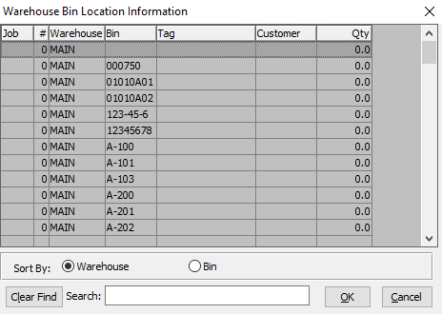

This list can be sorted by Warehouse Code or Bin Number. Alternatively, the user may search for what they wish to use in order to narrow down their selection.

As soon as the user makes their selection, or finishes manually entering a valid Bin Number, many subsequent fields will automatically fill with necessary information.

#### Tag #

Enter the Tag Number (Or Ticket Number) for this item. Alternatively, the user may press the ***“F1”*** key to select a Tag Number from a list of available Tags.

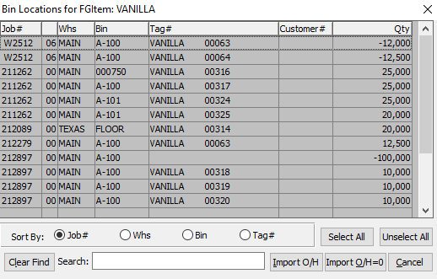

This list can be sorted by Job Number, Warehouse Code, Bin Number, or Tag Number. Alternatively, the user may search for what they wish to use in order to narrow down their selection.

As soon as the user makes their selection, or finishes manually entering a valid Tag Number, many subsequent fields will automatically fill with necessary information.

#### Customer #

The customer number will default from the Bin Location if the Warehouse item is Customer-Owned. If it is not, this field will remain blank. This field is not modifiable.

#### Quantity

Enter the quantity in this warehouse, bin, and tag for the item with this job number.

#### Created By

The username of the original user that created this inventory count.

#### Last Update

The username of the last user that made changes to this inventory count.

## Post Counts to Finished Goods [IC3]

### Selection Parameters

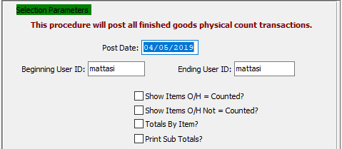

#### Post Date

Enter date for posting.

#### Beginning User ID / Ending User ID

Enter the starting and ending user ID.

#### Show Items O/H = Counted? – Toggle Box

To show items where the count is not different between the physical count and the current inventory count, make sure that this toggle box is checked.

#### Show Items O/H Not = Counted? – Toggle Box

To show items where the count is different between the physical count and the current inventory count, make sure that this toggle box is checked.

#### Totals by Item? – Toggle Box

To show totals by the item, make sure that the Totals by Item toggle box is checked.

#### Print Sub Totals? – Toggle Box

To print sub totals, make sure that the Print Cub Totals toggle box is checked.

### Available and Selected Columns

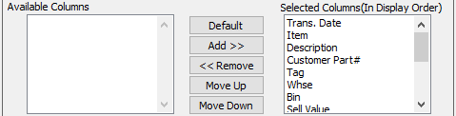

#### Available Columns

The user may choose which columns they wish to have on the report printout. As the user selects their choices, they will appear on the ‘*Selected Columns’* list.

#### Selected Columns (In Display Order)

The columns that the user has chosen from the ‘*Available Columns’* list. The order that these columns are displayed in here is the order in which they will print on the report.

#### Default

Click the ***“Default****”* button to sort the ‘*Selected Columns’* list by the default system parameters.

#### Add >>

Click on the selected item from the ‘*Available Columns’* list to highlight it, then click the ***“Add”*** button to add the selected column to the ‘*Selected Columns’* list.

#### << Remove

Click on the selected item from the ‘*Selected Columns’* list to highlight it, then click the ***“Remove”*** button to remove the selected column to the ‘*Selected Columns’* list.

#### Move Up

Within the ‘*Selected Columns’* list, the user may choose the order they wish the selected columns to print in. In order to change the order of the columns, the user can click on a selection to highlight it. By then clicking the ***“Move Up***” button, the user can change its position on the report.

#### Move Down

Within the ‘*Selected Columns’* list, the user may choose the order they wish the selected columns to print in. In order to change the order of the columns, the user can click on a selection to highlight it. By then clicking the ***“Move Down***” button, the user can change its position on the report.

### Output Destination

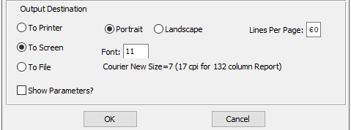

#### Destination Choice

To choose the destination where the document should be printed, please make sure that desired output destination choice bubble is toggled.

#### Layout Choice

To choose the preferred layout of Landscape vs. Portrait, please make sure the desired option choice bubbled is toggled.

#### Lines Per Page

Lines per page on the report when printing.

#### Font

Enter the font number to use with this report (Font 11 is default).

#### Show Parameters? – Toggle Box

To show parameters, make sure that the toggle box is ‘ticked’ with a checkmark.

## Initialize FG Counts [IC4]

### Selection Parameters

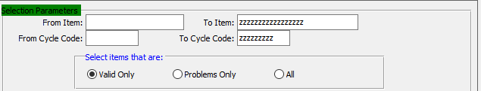

#### From Item / To Item

Enter the starting and ending item.

#### From Cycle Code / To Cycle Code

Enter the starting and ending cycle code.

#### Select Items That Are: (Choice)

To choose the preferred items of Valid vs. Problems (Or All), please make sure the desired option choice bubble is toggled.

### Warehouse Limit



#### Warehouse List

The user may enter multiple warehouses manually, as long as each warehouse code is separated by a comma. Alternatively, the user may press the ***“F1”*** button to bring up a list of all available warehouses.

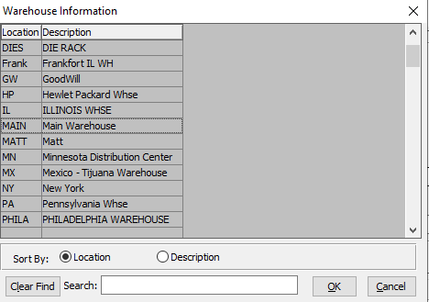

The user may choose multiple warehouses from this list by using the ***“Control – Click”*** method. Choosing multiple locations this way will automatically separate those chosen by the needed commas.

This list can be sorted by Warehouse Location or Warehouse Description. Alternatively, the user may search for what they wish to use in order to narrow down their selection.

### Snapshot Description

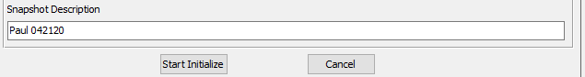

#### Snapshot Description

The user may enter any description that they wish in this field.

## Analyze and Post FG Physical [IC5]

### Selection Parameters

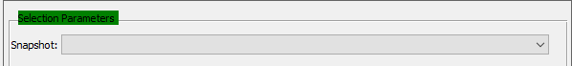

#### Snapshot

The user may choose the Finished Good count description from a drop down menu of all available Snapshots.

### Posting Options

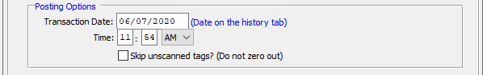

#### Transaction Date

This is the date of posting the transaction. It defaults to the current date, but may be modified by the user.

#### Time

This is the time of posting the transaction. It defaults to the current time, but may be modified by the user.

#### Skip Unscanned Tags? – Toggle Box

To skip all unscanned tags, make sure that this toggle box is checked.

Please Note: This will not zero out tags that have not been scanned during the physical count. It will only show counted tags on the current report.

### Item Selections

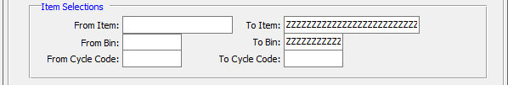

#### From Item / To Item

Enter the starting and ending item.

#### From Bin / To Bin

Enter the starting and ending bin.

#### From Cycle Code / To Cycle Code

Enter the starting and ending cycle code.

### Warehouse List



#### Warehouse List

The user may enter multiple warehouses manually, as long as each warehouse code is separated by a comma. Alternatively, the user may press the ***“F1”*** button to bring up a list of all available warehouses.



The user may choose multiple warehouses from this list by using the ***“Control – Click”*** method. Choosing multiple locations this way will automatically separate those chosen by the needed commas.

This list can be sorted by Warehouse Location or Warehouse Description. Alternatively, the user may search for what they wish to use in order to narrow down their selection.

### Choose Full Report or Just Exceptions

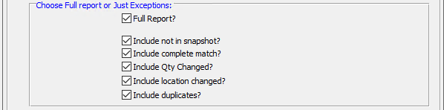

#### Full Report? – Toggle Box

To print a full inventory report, make sure that the Full Report toggle box is checked. If the user does not wish to print a full inventory report, make sure that this toggle box is not checked.

#### Include Not in Snapshot? – Toggle Box

To include items that are not in the snapshot, make sure that this toggle box is checked.

#### Include Complete Match? – Toggle Box

To include matches that are a complete match for the selected parameters, make sure that the Include Complete Match toggle box is checked.

#### Include Qty Changed? – Toggle Box

To include items where the quantity is different between the physical count and the known inventory, make sure that the Include Qty Changed toggle box is checked.

#### Include Location Changed? – Toggle Box

To include items where the location has changed between the physical count location and the known inventory location, make sure that this toggle box is checked.

#### Include Duplicates? – Toggle Box

To include items that are duplicated multiple times, make sure that the Include Duplicates toggle box is checked.

### Output Destination

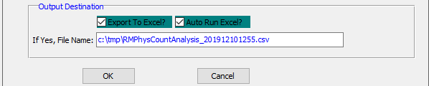

#### Export to Excel? – Toggle Box

To export the printed file to an excel document, make sure that the Export to Excel toggle box is checked.

#### Auto Run Excel? – Toggle Box

To automatically open the new excel document, make sure that the Auto Run Excel toggle box is checked.

#### If Yes, File Name

If exporting the file to Excel, enter the desired file name.

# **Write End of Period Totals [IW]**

The *Write End of Period Totals* screen will clear all monthly and period to date quantities from the system. These quantities are captured in the Year-To-Date totals reports.

Please Note: This process should be run on the last day of the period in order to keep all system information accurate.

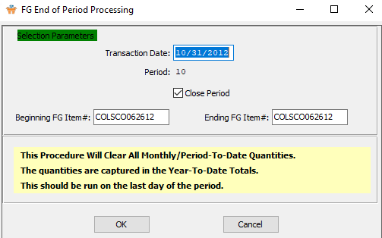

#### Transaction Date

The user may enter the date of the last day of the period that they wish to close.

#### Close Period – Toggle Box

To close the period once the report has printed, make sure that the Close Period toggle box is checked.

#### Beginning FG Item # / Ending FG Item #

Enter the starting and ending Finished Good item number.

# **Query Finished Goods [IQ]**

## FG History [IQ1]

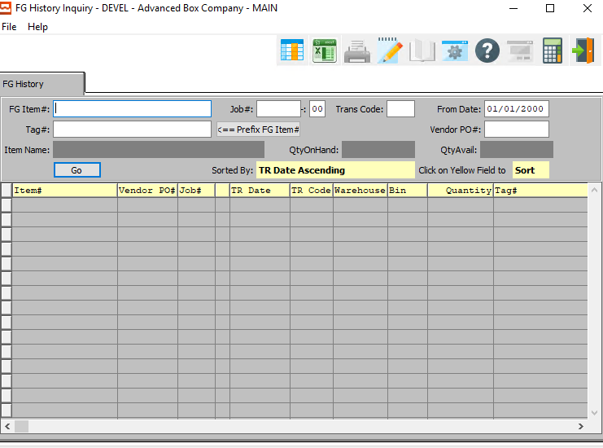

#### FG Item #

Enter the FG item number or you may use the ***“F1”*** look-up. A partial description may be typed into any field or data may be entered into multiple fields followed by pressing the ***“Go”*** button to sort the fields by the criteria that was entered. Once the data is presented on the screen, the YELLOW column heading may be clicked to sort that specific column in ascending or descending order.

#### Tag #

Enter a tag number to search for.

#### Job #

Enter the job number or you can do a ***“F1”*** look-up from list. A partial description may be typed into any field or data may be entered into multiple fields followed by pressing the ***“Go”*** button to sort the fields by the criteria that was entered. Once the data is presented on the screen, the YELLOW column heading may be clicked to sort that specific column in ascending or descending order.

#### Job #: 00

Enter the 2-digit extension of the job number, if applicable. If the user does not know if the job has multiple sequences, or is unsure of which subsequent number to use, they may leave this field blank and all of the subsequent jobs for this Job number will be listed in the browse field.

#### Trans Code

The valid codes are as follows:

|  |  |
| --- | --- |
| A | Adjustments |
| C | Physical Count |
| E | Returns |
| R | Receipts |
| S | Shipments |

#### From Date

Enter the invoice date for the vendor.

#### Vendor PO #

Enter the PO number for a look-up of a customer or you may use the ***“F1”*** key to find the customer. A partial description may be typed into any field or data may be entered into multiple fields followed by pressing the ***“Go”*** button to sort the fields by the criteria that was entered. Once the data is presented on the screen, the YELLOW column heading may be clicked to sort that specific column in ascending or descending order.

## Scheduled Ship vs. Qty On-Hand [IQ2]

### Overview

This inventory function is used when inventory is shipped to a customer. Inventory controls as well as history functions are maintained. *F/G* shipping subtracts the quantity shipped from the quantity on hand, update the quantity shipped, and tracks the item by Job Number, by Warehouse, by Bin Number, by Tag, as well as by Item Number.

The Finished Goods Warehouse Shipping Screen is utilized only when the Bill of Lading module is not in use. This is indicated by the Ship From flag located in the Order Entry Control File. The Flag will be set to either “***FG”*** for Finished Goods for ***“BOL”*** for Bill of Lading.

Finished goods may be shipped by cases per pallet/tag number and by bins within a warehouse. The quantity of an item shipped will reduce the quantity on hand. An edit list should be printed to check for data entry errors. Once reviewed and corrections applied, the transactions should be posted to the quantity on hand for the item. Once posted, a register is printed automatically.

If the customer order processing module is in use, the bill of lading program will be used to ship items and transfer the quantities shipped to the invoice file for billing. Any changes required to the quantity or cost, after the warehouse transactions have been posted, may be adjusted with the adjustment program.

### Scheduled Ship vs. Qty On-Hand Screen

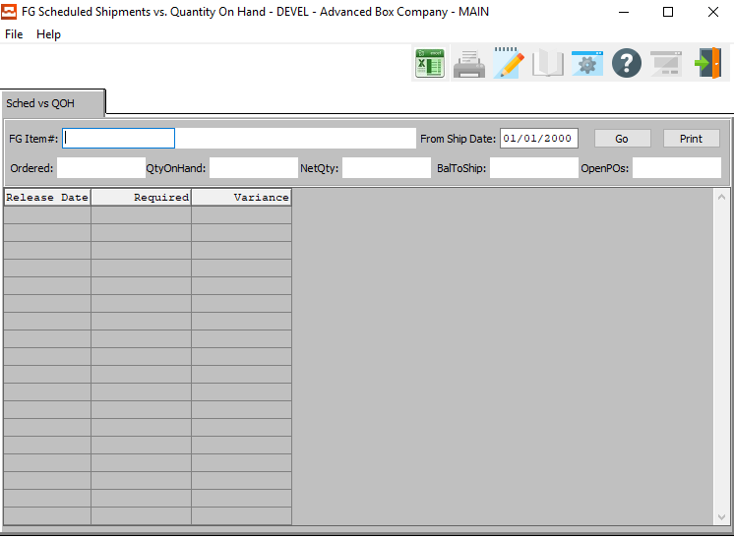

#### FG Item #

Enter the FG item number or you may use the ***“F1”*** look-up. A partial description may be typed into any field or data may be entered into multiple fields followed by pressing the ***“Go”*** button to sort the fields by the criteria that was entered. Once the data is presented on the screen, the YELLOW column heading may be clicked to sort that specific column in ascending or descending order.

#### Item Name

The Item Name will automatically fill as soon as the user enters of chooses a valid Item Number.

#### From Ship Date

Enter the invoice date for the vendor.

## Bin Inquiry and Update [IQ3]

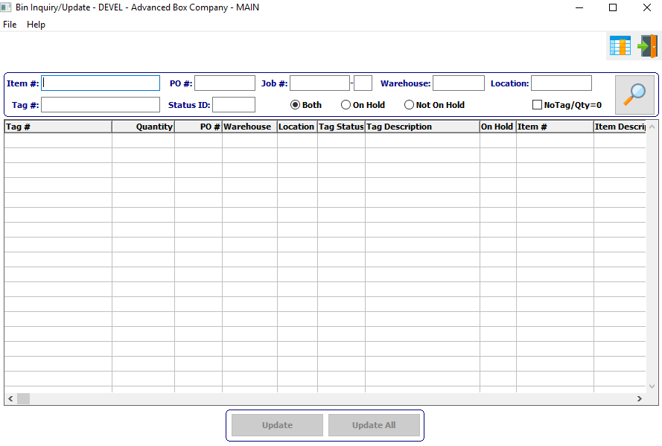

#### Item #

Enter an Item Number to search for. Alternatively, the user may press the ***“F1”*** key to select an item from a list of available Finished Good Items.

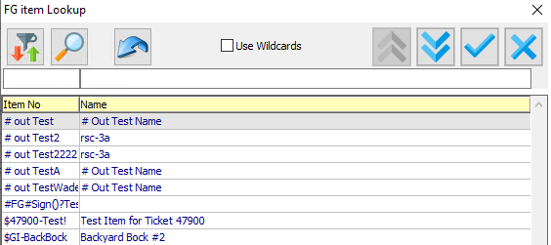

#### Tag #

Enter a Tag Number to search for.

#### PO #

Enter a Purchase Order Number to search for. Alternatively, the user may press the ***“F1”*** key to select an order from a list of available Purchase Orders.

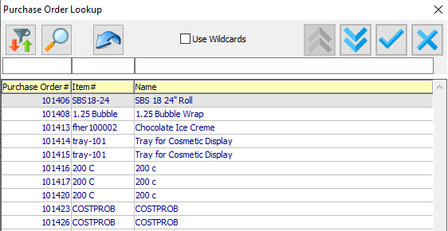

#### Status ID

Enter a Status ID to search for. Alternatively, the user may press the ***“F1”*** key to select a Inventory Status ID from a list of available Inventories.

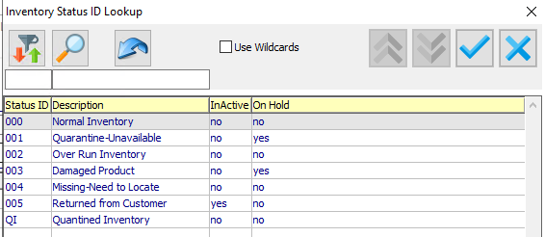

#### Job #

Enter a Job Number to search for. Alternatively, the user may press the ***“F1”*** key to select a number from a list of available Jobs.

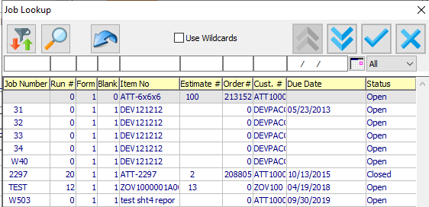

#### Job #: 00

Enter the 2-digit extension of the job number, if applicable. If the user does not know if the job has multiple sequences, or is unsure of which subsequent number to use, they may leave this field blank and all of the subsequent jobs for this Job number will be listed in the browse field.

#### Warehouse

Enter an Warehouse to search for. Alternatively, the user may press the ***“F1”*** key to select a warehouse from a list of available Warehouses.

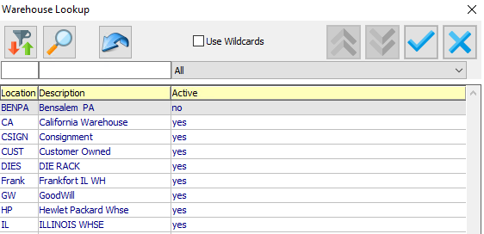

#### Status (Choice)

To choose the preferred Hold Status of On Hold vs. Not On Hold (Or All), please make sure the desired option choice bubble is toggled.

#### No Tag / Qty = 0 – Toggle Box

To include bin that have no tag, or have an inventory quantity of zero, make sure that this toggle box is checked.

# **Reports for Finished Goods [IR]**

## Reorder Requirements [IR1]

### Overview

The finished goods report I-R-1, called reorder advice report, will show all items that fall below the Reorder Level. The report will print by customer range and can select specific item types such as manufactured, purchased, the reorder policy type and more.

The warehouse manager has the option to calculate the quantity available by excluding or including the quantity on order from a purchase order for purchased items or on order awaiting the job to be finished. When quantity available is less than the reorder level, the item will print on the report. Therefore, only the hot items or exceptions that need immediate attention will print on the report. Therefore, the item should be produced immediately to provide enough finished goods inventory just in time to supply the customer on demand requests.

The tricky question is what level to set the reorder level. It may be best to think of the reorder quantity as a safety stock level that is the quantity of goods to supplier the customer for a period of time such as one week, two weeks or one month. Inventory history transaction reports may be analyzed to help to determine the reorder level quantity. Items that are sold during specific periods of the year as known as cyclical items and many need the reorder level updated on a monthly or quarterly basis.

In the end, the economic job quantity will consider the cost of buying material, setting up jobs and warehousing costs compared to the customer’s average quantity of consuming the inventory.

The inventory folder for each item should be defined for the best results when running the reorder advice report.

### Multiple Warehouse Logic

The I-R-1 Reorder Advise report has the ability to sort by warehouse. This report is intended to print only the finished goods items that are below the reorder level when selecting to print Items below the reorder Level. When the toggle box called (ReOrder Level by Whse?) is unchecked, the program will calculate the inventory available based on the grand total of all warehouses and print the items that are below the reorder level.

When checking the toggle box (ReOrder Level by Whse?), the program will calculate the inventory requirement for each warehouse. In other words, each item’s available quantity is compared to the reorder level for each warehouse, whereby one warehouse may require replenishment and another warehouse may not need more inventory.

In order for this report to work properly, each item must have preset quantities defined for reorder level by warehouse.

#### N-K-1 Reports – View Form

The I-R-1 Reorder Advise Report has an option to allow the user to select what fields will be printed or output to excel. Under the menu keys N-K-1, Reports parameter the user will define how the use selects the columns. For the reorder advise report, the business form must be set to IR1. If the logical value is unchecked, the user will select the fields from the report options above and the report will print as programmed by ASI. If the toggle box is checked, then the user can select what fields to print from the original report columns and the sequence of how the columns should print.

Each user can select what fields to print from the originally programmed report columns and the sequence of how the columns should print. First, the user clicks the Select Columns button, then selects the fields in the box highlighted in green and click ***“Add”*** to move the fields to the box on the right highlighted in red.

Once the desired fields have been moved to the box on the right, the user can move the columns up or down until they have their desired sequence. Only the fields they the user wants to print will print or output to excel. Please note, the print selection ranges and other toggle boxes to presort the items prior to printing will remain the same.

### Selection Parameters

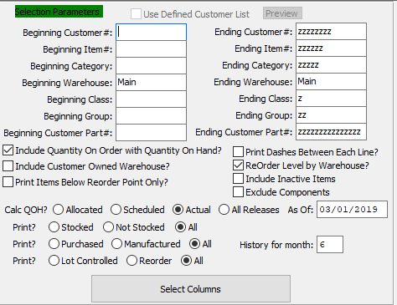

#### Beginning Customer # / Ending Customer #

Enter the starting and ending customer number.

#### Beginning Item # / Ending Item #

Enter the starting and ending item number.

#### Beginning Category / Ending Category

Enter the starting and ending category.

#### Beginning Warehouse / Ending Warehouse

Enter the starting and ending warehouse.

#### Beginning Class / Ending Class

Enter the starting and ending class.

#### Beginning Group / Ending Group

Enter the starting and ending group.

#### Beginning Customer Part # / Ending Customer Part #

Enter the starting and ending customer part number.

#### Include Quantity On Order with Quantity On Hand? – Toggle Box

Please make sure that this toggle box is checked in order to include the quantity on order from Purchasing or Shop Orders to be added to the on-hand quantity. If the cumulative quantity total is less than the reorder level quantity, then the item will print on the reorder advice report so that the product may be manufactured or purchased.

#### Include Customer Owned Warehouse? – Toggle Box

To include the quantity owned by the customer with the quantity on hand, please make sure that this toggle box is checked.

#### Print Items Below Reorder Point Only? – Toggle Box

To only print items that the system deems at a low enough quantity to need a reorder, make sure that this toggle box is checked.

#### Print Dashes Between Each Line? – Toggle Box

To print dashes between each line in order to make the report easier to read, make sure that this toggle box is checked.

#### Reorder Level by Warehouse? – Toggle Box

To print the reorder level by warehouse location on the report, make sure that this toggle box is checked.

#### Include Inactive Items – Toggle Box

To include inactive items in the report, make sure that the Include Inactive Items toggle box is checked.

#### Exclude Components – Toggle Box

To exclude individual components from the report, make sure that the Exclude Components toggle box is checked.

#### Calc QOH? (Choice)

To choose the preferred Quantity On Hand Calculation, please make sure the desired option choice bubble is toggled.

#### As Of

Enter a date for the start of this report. Any items within the selected parameters after this date will be reported.

#### History for Month

Enter a number between 1 and 12 to print a history for that month. The number corresponds to a month of the year.

#### Print? (Stocked)

To choose the preferred Print Option of Stocked vs. Not Stocked (Or All), please make sure the desired option choice bubble is toggled.

#### Print? (Item Type)

To choose the preferred Print Option of Manufactured Items vs. Manufactured Item (Or All Items), please make sure the desired option choice bubble is toggled.

#### Print? (Controlled vs Reorder)

To choose the preferred Print Option of Lot Controlled vs. Reorder (Or All), please make sure the desired option choice bubble is toggled.

### Output Destination

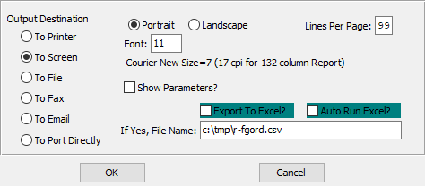

#### Destination Choice

To choose the destination where the document should be printed, please make sure that desired output destination choice bubble is toggled.

#### Layout Choice

To choose the preferred layout of Landscape vs. Portrait, please make sure the desired option choice bubbled is toggled.

#### Lines Per Page

Lines per page on the report when printing.

#### Font

Enter the font number to use with this report (Font 11 is default).

#### Show Parameters? – Toggle Box

To show parameters, make sure that the toggle box is ‘ticked’ with a checkmark.

#### Export to Excel? – Toggle Box

To export the printed file to an excel document, make sure that the Export to Excel toggle box is checked.

#### Auto Run Excel? – Toggle Box

To automatically open the new excel document, make sure that the Auto Run Excel toggle box is checked.

#### If Yes, File Name

If exporting the file to Excel, enter the desired file name.

## Value/Cost by Whs/Bin/Tan [IR2]

### Selection Parameters

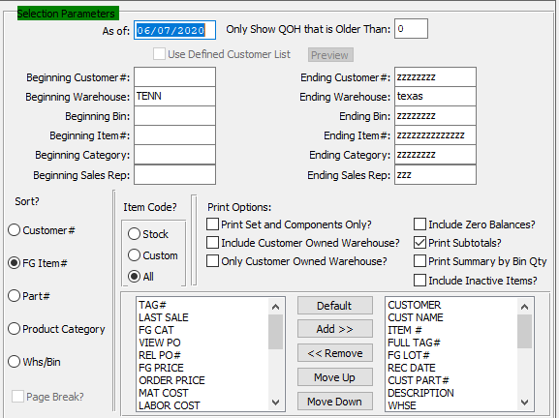

#### As Of

Enter a date for the start of this report. Any items within the selected parameters after this date will be reported.

#### Only Show QOH that is Older Than

Enter a number of months in this field.

For example, if the user enters 4, the report will only show quantity on hand that is older than 4 months.

#### Beginning Customer # / Ending Customer #

Enter the starting and ending customer number.

#### Beginning Warehouse / Ending Warehouse

Enter the starting and ending warehouse.

#### Beginning Bin / Ending Bin

Enter the starting and ending bin.

#### Beginning Item # / Ending Item #

Enter the starting and ending item number.

#### Beginning Category / Ending Category

Enter the starting and ending category.

#### Beginning Sales Rep / Ending Sales Rep

Enter the starting and ending sales representative.

#### Sort? (Choice)

To choose the preferred Sort Method fort he report, please make sure the desired option choice bubble is toggled.

#### Item Code? (Choice)

To choose the preferred Item Code of Stock vs. Customer (Or All), please make sure the desired option choice bubble is toggled.

#### Print Set and Components Only? – Toggle Box

To only print the set and components of an item, make sure that this toggle box is checked.

#### Include Customer Owned Warehouse? – Toggle Box

To include the quantity owned by the customer with the quantity on hand, please make sure that this toggle box is checked.

#### Only Customer Owned Warehouse? – Toggle Box

To only print customer owned warehouse items in the report, make sure that this toggle box is checked.

#### Include Zero Balances? – Toggle Box

To include all items with zero quantity balances, make sure that the Include Zero Balances toggle box is checked.

#### Print Subtotals? – Toggle Box

To print subtotals of items on the report, make sure that the Print Subtotals toggle box is checked.

#### Print Summary by Bin Qty? – Toggle Box

To print summaries by the quantities with the selected bins on the report, make sure that the Print Summary by Bin Qty toggle box is checked.

#### Include Inactive Items? – Toggle Box

To include inactive items in the report, make sure that the Include Inactive Items toggle box is checked.

#### Available Columns

The user may choose which columns they wish to have on the report printout. As the user selects their choices, they will appear on the ‘*Selected Columns’* list.

#### Selected Columns (In Display Order)

The columns that the user has chosen from the ‘*Available Columns’* list. The order that these columns are displayed in here is the order in which they will print on the report.

#### Default

Click the ***“Default****”* button to sort the ‘*Selected Columns’* list by the default system parameters.

#### Add >>

Click on the selected item from the ‘*Available Columns’* list to highlight it, then click the ***“Add”*** button to add the selected column to the ‘*Selected Columns’* list.

#### << Remove

Click on the selected item from the ‘*Selected Columns’* list to highlight it, then click the ***“Remove”*** button to remove the selected column to the ‘*Selected Columns’* list.

#### Move Up

Within the ‘*Selected Columns’* list, the user may choose the order they wish the selected columns to print in. In order to change the order of the columns, the user can click on a selection to highlight it. By then clicking the ***“Move Up***” button, the user can change its position on the report.

#### Move Down

Within the ‘*Selected Columns’* list, the user may choose the order they wish the selected columns to print in. In order to change the order of the columns, the user can click on a selection to highlight it. By then clicking the ***“Move Down***” button, the user can change its position on the report.

### Output Destination

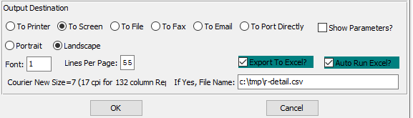

#### Destination Choice

To choose the destination where the document should be printed, please make sure that desired output destination choice bubble is toggled.

#### Layout Choice

To choose the preferred layout of Landscape vs. Portrait, please make sure the desired option choice bubbled is toggled.

#### Lines Per Page

Lines per page on the report when printing.

#### Font

Enter the font number to use with this report (Font 11 is default).

#### Show Parameters? – Toggle Box

To show parameters, make sure that the toggle box is ‘ticked’ with a checkmark.

#### Export to Excel? – Toggle Box

To export the printed file to an excel document, make sure that the Export to Excel toggle box is checked.

#### Auto Run Excel? – Toggle Box

To automatically open the new excel document, make sure that the Auto Run Excel toggle box is checked.

#### If Yes, File Name

If exporting the file to Excel, enter the desired file name.

## Alphabetic Item List [IR3]

### Selection Parameters

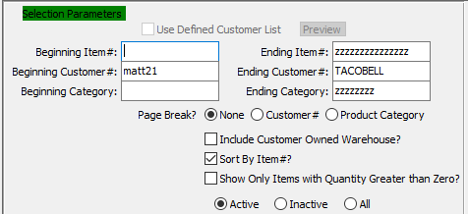

#### Beginning Item # / Ending Item #

Enter the starting and ending item number.

#### Beginning Customer # / Ending Customer #

Enter the starting and ending customer number.

#### Beginning Category / Ending Category

Enter the starting and ending category.

#### Page Break? (Choice)

To choose the preferred Page Break Option of By Customer Number vs. By Product Category (Or None), please make sure the desired option choice bubble is toggled.

#### Include Customer Owned Warehouse? – Toggle Box

To include the quantity owned by the customer with the quantity on hand, please make sure that this toggle box is checked.

#### Sort by Item #? – Toggle Box

To sort the report by the item numbers, make sure that the Sort By Item # toggle box is checked.

#### Show Only Items with Quantity Greater Than Zero? – Toggle Box

To only show items that have a positive quantity in the current inventory count, make sure that this toggle box is checked.

#### Status (Choice)

To choose the preferred Status of Active vs. Inactive (Or All), please make sure the desired option choice bubble is toggled.

### Available and Selected Columns

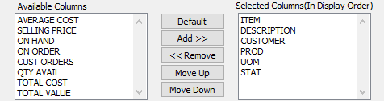

#### Available Columns

The user may choose which columns they wish to have on the report printout. As the user selects their choices, they will appear on the ‘*Selected Columns’* list.

#### Selected Columns (In Display Order)

The columns that the user has chosen from the ‘*Available Columns’* list. The order that these columns are displayed in here is the order in which they will print on the report.

#### Default

Click the ***“Default****”* button to sort the ‘*Selected Columns’* list by the default system parameters.

#### Add >>

Click on the selected item from the ‘*Available Columns’* list to highlight it, then click the ***“Add”*** button to add the selected column to the ‘*Selected Columns’* list.

#### << Remove

Click on the selected item from the ‘*Selected Columns’* list to highlight it, then click the ***“Remove”*** button to remove the selected column to the ‘*Selected Columns’* list.

#### Move Up

Within the ‘*Selected Columns’* list, the user may choose the order they wish the selected columns to print in. In order to change the order of the columns, the user can click on a selection to highlight it. By then clicking the ***“Move Up***” button, the user can change its position on the report.

#### Move Down

Within the ‘*Selected Columns’* list, the user may choose the order they wish the selected columns to print in. In order to change the order of the columns, the user can click on a selection to highlight it. By then clicking the ***“Move Down***” button, the user can change its position on the report.

### Output Destination

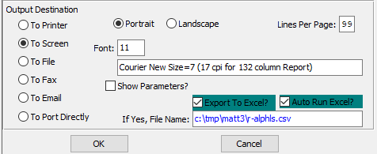

#### Destination Choice

To choose the destination where the document should be printed, please make sure that desired output destination choice bubble is toggled.

#### Layout Choice

To choose the preferred layout of Landscape vs. Portrait, please make sure the desired option choice bubbled is toggled.

#### Lines Per Page

Lines per page on the report when printing.

#### Font

Enter the font number to use with this report (Font 11 is default).

#### Show Parameters? – Toggle Box

To show parameters, make sure that the toggle box is ‘ticked’ with a checkmark.

#### Export to Excel? – Toggle Box

To export the printed file to an excel document, make sure that the Export to Excel toggle box is checked.

#### Auto Run Excel? – Toggle Box

To automatically open the new excel document, make sure that the Auto Run Excel toggle box is checked.

#### If Yes, File Name

If exporting the file to Excel, enter the desired file name.

## Qty/Value by Cust and Job [IR4]

This detail customer report by item by warehouse by bin by job provides total quantity on hand, selling price per Unit of Measure, and total selling price. Totals are provided by customer, and a grand total is printed.

### Selection Parameters

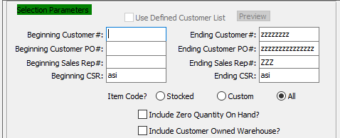

#### Beginning Customer # / Ending Customer #

Enter the starting and ending customer number.

#### Beginning Customer PO # / Ending Customer PO #

Enter the starting and ending customer purchase order number.

#### Beginning Sales Rep # / Ending Sales Rep #

Enter the starting and ending sales representative number.

#### Beginning CSR / Ending CSR

Enter the starting and ending CSR.

#### Item Code? (Choice)

To choose the preferred Item Code of Stocked vs. Custom (Or All), please make sure the desired option choice bubble is toggled.

#### Include Zero Quantity On Hand? – Toggle Box

To include all items with zero quantity balances, make sure that this toggle box is checked.

#### Include Customer Owned Warehouse? – Toggle Box

To include the quantity owned by the customer with the quantity on hand, please make sure that this toggle box is checked.

### Available and Selected Columns

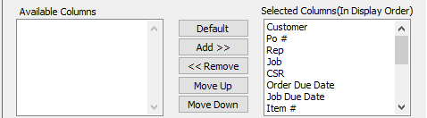

#### Available Columns

The user may choose which columns they wish to have on the report printout. As the user selects their choices, they will appear on the ‘*Selected Columns’* list.

#### Selected Columns (In Display Order)

The columns that the user has chosen from the ‘*Available Columns’* list. The order that these columns are displayed in here is the order in which they will print on the report.

#### Default

Click the ***“Default****”* button to sort the ‘*Selected Columns’* list by the default system parameters.

#### Add >>

Click on the selected item from the ‘*Available Columns’* list to highlight it, then click the ***“Add”*** button to add the selected column to the ‘*Selected Columns’* list.

#### << Remove

Click on the selected item from the ‘*Selected Columns’* list to highlight it, then click the ***“Remove”*** button to remove the selected column to the ‘*Selected Columns’* list.

#### Move Up

Within the ‘*Selected Columns’* list, the user may choose the order they wish the selected columns to print in. In order to change the order of the columns, the user can click on a selection to highlight it. By then clicking the ***“Move Up***” button, the user can change its position on the report.

#### Move Down

Within the ‘*Selected Columns’* list, the user may choose the order they wish the selected columns to print in. In order to change the order of the columns, the user can click on a selection to highlight it. By then clicking the ***“Move Down***” button, the user can change its position on the report.

### Output Destination

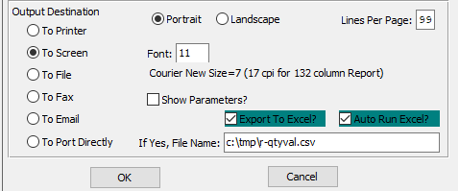

#### Destination Choice

To choose the destination where the document should be printed, please make sure that desired output destination choice bubble is toggled.

#### Layout Choice

To choose the preferred layout of Landscape vs. Portrait, please make sure the desired option choice bubbled is toggled.

#### Lines Per Page

Lines per page on the report when printing.

#### Font

Enter the font number to use with this report (Font 11 is default).

#### Show Parameters? – Toggle Box

To show parameters, make sure that the toggle box is ‘ticked’ with a checkmark.

#### Export to Excel? – Toggle Box

To export the printed file to an excel document, make sure that the Export to Excel toggle box is checked.

#### Auto Run Excel? – Toggle Box

To automatically open the new excel document, make sure that the Auto Run Excel toggle box is checked.

#### If Yes, File Name

If exporting the file to Excel, enter the desired file name.

## Qty On Hand/Shpd by SMan [IR5]

This salesman's report provides a customer breakdown by salesman. Within each salesman, and customer is a summary by item number. Included in this report are quantity produced, quantity shipped, quantity on hand, standard cost, and total cost. This report provides totals by Customer.

### Selection Parameters

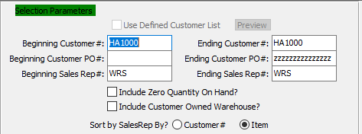

#### Beginning Customer # / Ending Customer #

Enter the starting and ending customer number.

#### Beginning Customer PO # / Ending Customer PO #

Enter the starting and ending purchase order number.

#### Beginning Sales Rep # / Ending Sales Rep #

Enter the starting and ending sales representative number.

#### Include Zero Quantity On Hand? – Toggle Box

To include all items with zero quantity balances, make sure that this toggle box is checked.

#### Include Customer Owned Warehouse? – Toggle Box

To include the quantity owned by the customer with the quantity on hand, please make sure that this toggle box is checked.

#### Sort by Sales Rep By? (Choice)

To choose the preferred Sorting Method of Customer Number vs. Item, please make sure the desired option choice bubble is toggled.

### Available and Selected Columns

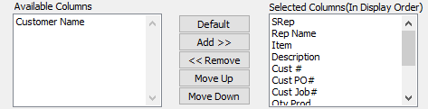

#### Available Columns

The user may choose which columns they wish to have on the report printout. As the user selects their choices, they will appear on the ‘*Selected Columns’* list.

#### Selected Columns (In Display Order)

The columns that the user has chosen from the ‘*Available Columns’* list. The order that these columns are displayed in here is the order in which they will print on the report.

#### Default

Click the ***“Default****”* button to sort the ‘*Selected Columns’* list by the default system parameters.

#### Add >>

Click on the selected item from the ‘*Available Columns’* list to highlight it, then click the ***“Add”*** button to add the selected column to the ‘*Selected Columns’* list.

#### << Remove

Click on the selected item from the ‘*Selected Columns’* list to highlight it, then click the ***“Remove”*** button to remove the selected column to the ‘*Selected Columns’* list.

#### Move Up

Within the ‘*Selected Columns’* list, the user may choose the order they wish the selected columns to print in. In order to change the order of the columns, the user can click on a selection to highlight it. By then clicking the ***“Move Up***” button, the user can change its position on the report.

#### Move Down

Within the ‘*Selected Columns’* list, the user may choose the order they wish the selected columns to print in. In order to change the order of the columns, the user can click on a selection to highlight it. By then clicking the ***“Move Down***” button, the user can change its position on the report.

### Output Destination

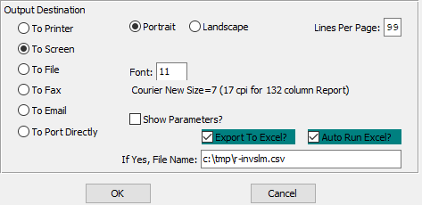

#### Destination Choice

To choose the destination where the document should be printed, please make sure that desired output destination choice bubble is toggled.

#### Layout Choice

To choose the preferred layout of Landscape vs. Portrait, please make sure the desired option choice bubbled is toggled.

#### Lines Per Page

Lines per page on the report when printing.

#### Font

Enter the font number to use with this report (Font 11 is default).

#### Show Parameters? – Toggle Box

To show parameters, make sure that the toggle box is ‘ticked’ with a checkmark.

#### Export to Excel? – Toggle Box

To export the printed file to an excel document, make sure that the Export to Excel toggle box is checked.

#### Auto Run Excel? – Toggle Box

To automatically open the new excel document, make sure that the Auto Run Excel toggle box is checked.

#### If Yes, File Name

If exporting the file to Excel, enter the desired file name.

## Sales Values by Cust/Item [IR6]

### Selection Parameters

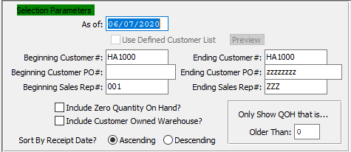

#### As Of

Enter a date for the start of this report. Any items within the selected parameters after this date will be reported.

#### Beginning Customer # / Ending Customer #

Enter the starting and ending customer number.

#### Beginning Customer PO # / Ending Customer PO #

Enter the starting and ending customer purchase order number.

#### Beginning Sales Rep # / Ending Sales Rep #

Enter the starting and ending sales representative number.

#### Include Zero Quantity On Hand? – Toggle Box

To include all items with zero quantity balances, make sure that this toggle box is checked.

#### Include Customer Owned Warehouse? – Toggle Box

To include the quantity owned by the customer with the quantity on hand, please make sure that this toggle box is checked.

#### Sort by Receipt Date? (Choice)

To choose the preferred Sorting Option of Ascending vs. Descending, please make sure the desired option choice bubble is toggled.

#### Only Show QOH that is Older Than

Enter a number of months in this field.

For example, if the user enters 4, the report will only show quantity on hand that is older than 4 months.

### Available and Selected Columns

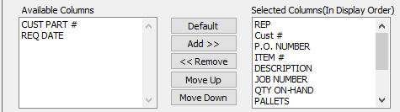

#### Available Columns

The user may choose which columns they wish to have on the report printout. As the user selects their choices, they will appear on the ‘*Selected Columns’* list.

#### Selected Columns (In Display Order)

The columns that the user has chosen from the ‘*Available Columns’* list. The order that these columns are displayed in here is the order in which they will print on the report.

#### Default

Click the ***“Default****”* button to sort the ‘*Selected Columns’* list by the default system parameters.

#### Add >>

Click on the selected item from the ‘*Available Columns’* list to highlight it, then click the ***“Add”*** button to add the selected column to the ‘*Selected Columns’* list.

#### << Remove

Click on the selected item from the ‘*Selected Columns’* list to highlight it, then click the ***“Remove”*** button to remove the selected column to the ‘*Selected Columns’* list.

#### Move Up

Within the ‘*Selected Columns’* list, the user may choose the order they wish the selected columns to print in. In order to change the order of the columns, the user can click on a selection to highlight it. By then clicking the ***“Move Up***” button, the user can change its position on the report.

#### Move Down

Within the ‘*Selected Columns’* list, the user may choose the order they wish the selected columns to print in. In order to change the order of the columns, the user can click on a selection to highlight it. By then clicking the ***“Move Down***” button, the user can change its position on the report.

### Output Destination

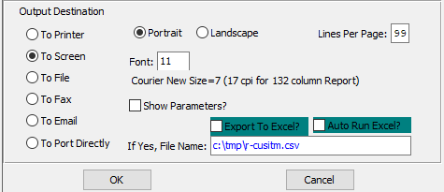

#### Destination Choice

To choose the destination where the document should be printed, please make sure that desired output destination choice bubble is toggled.

#### Layout Choice

To choose the preferred layout of Landscape vs. Portrait, please make sure the desired option choice bubbled is toggled.

#### Lines Per Page

Lines per page on the report when printing.

#### Font

Enter the font number to use with this report (Font 11 is default).

#### Show Parameters? – Toggle Box

To show parameters, make sure that the toggle box is ‘ticked’ with a checkmark.

#### Export to Excel? – Toggle Box

To export the printed file to an excel document, make sure that the Export to Excel toggle box is checked.

#### Auto Run Excel? – Toggle Box

To automatically open the new excel document, make sure that the Auto Run Excel toggle box is checked.

#### If Yes, File Name

If exporting the file to Excel, enter the desired file name.

## Sales/Value by Cust and Tag [IR7]

### Selection Parameters

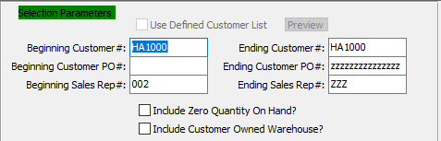

#### Beginning Customer # / Ending Customer #

Enter the starting and ending customer number.

#### Beginning Customer PO # / Ending Customer PO #

Enter the starting and ending customer purchase order number.

#### Beginning Sales Rep # / Ending Sales Rep #

Enter the starting and ending sales representative number.

#### Include Zero Quantity On Hand? – Toggle Box

To include all items with zero quantity balances, make sure that this toggle box is checked.

#### Include Customer Owned Warehouse? – Toggle Box

To include the quantity owned by the customer with the quantity on hand, please make sure that this toggle box is checked.

### Available and Selected Columns

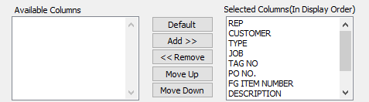

#### Available Columns

The user may choose which columns they wish to have on the report printout. As the user selects their choices, they will appear on the ‘*Selected Columns’* list.

#### Selected Columns (In Display Order)

The columns that the user has chosen from the ‘*Available Columns’* list. The order that these columns are displayed in here is the order in which they will print on the report.

#### Default

Click the ***“Default****”* button to sort the ‘*Selected Columns’* list by the default system parameters.

#### Add >>

Click on the selected item from the ‘*Available Columns’* list to highlight it, then click the ***“Add”*** button to add the selected column to the ‘*Selected Columns’* list.

#### << Remove

Click on the selected item from the ‘*Selected Columns’* list to highlight it, then click the ***“Remove”*** button to remove the selected column to the ‘*Selected Columns’* list.

#### Move Up

Within the ‘*Selected Columns’* list, the user may choose the order they wish the selected columns to print in. In order to change the order of the columns, the user can click on a selection to highlight it. By then clicking the ***“Move Up***” button, the user can change its position on the report.

#### Move Down

Within the ‘*Selected Columns’* list, the user may choose the order they wish the selected columns to print in. In order to change the order of the columns, the user can click on a selection to highlight it. By then clicking the ***“Move Down***” button, the user can change its position on the report.

### Output Destination

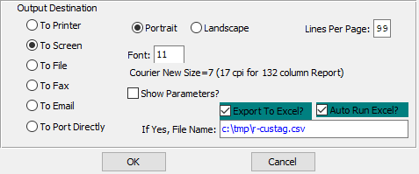

#### Destination Choice

To choose the destination where the document should be printed, please make sure that desired output destination choice bubble is toggled.

#### Layout Choice

To choose the preferred layout of Landscape vs. Portrait, please make sure the desired option choice bubbled is toggled.

#### Lines Per Page

Lines per page on the report when printing.

#### Font

Enter the font number to use with this report (Font 11 is default).

#### Show Parameters? – Toggle Box

To show parameters, make sure that the toggle box is ‘ticked’ with a checkmark.

#### Export to Excel? – Toggle Box

To export the printed file to an excel document, make sure that the Export to Excel toggle box is checked.

#### Auto Run Excel? – Toggle Box

To automatically open the new excel document, make sure that the Auto Run Excel toggle box is checked.

#### If Yes, File Name

If exporting the file to Excel, enter the desired file name.

## YTD Cost/Sales by Cust IR8]

### Selection Parameters

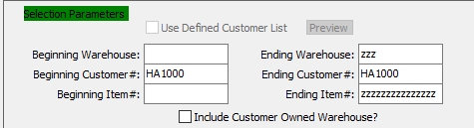

#### Beginning Warehouse / Ending Warehouse

Enter the starting and ending warehouse.

#### Beginning Customer # / Ending Customer #

Enter the starting and ending customer number.

#### Beginning Item # / Ending Item #

Enter the starting and ending item number.

#### Include Customer Owned Warehouse? – Toggle Box

To include the quantity owned by the customer with the quantity on hand, please make sure that this toggle box is checked.

### Available and Selected Columns

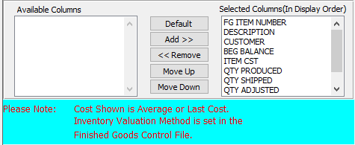

#### Available Columns

The user may choose which columns they wish to have on the report printout. As the user selects their choices, they will appear on the ‘*Selected Columns’* list.

#### Selected Columns (In Display Order)

The columns that the user has chosen from the ‘*Available Columns’* list. The order that these columns are displayed in here is the order in which they will print on the report.

#### Default

Click the ***“Default****”* button to sort the ‘*Selected Columns’* list by the default system parameters.

#### Add >>

Click on the selected item from the ‘*Available Columns’* list to highlight it, then click the ***“Add”*** button to add the selected column to the ‘*Selected Columns’* list.

#### << Remove

Click on the selected item from the ‘*Selected Columns’* list to highlight it, then click the ***“Remove”*** button to remove the selected column to the ‘*Selected Columns’* list.

#### Move Up

Within the ‘*Selected Columns’* list, the user may choose the order they wish the selected columns to print in. In order to change the order of the columns, the user can click on a selection to highlight it. By then clicking the ***“Move Up***” button, the user can change its position on the report.

#### Move Down

Within the ‘*Selected Columns’* list, the user may choose the order they wish the selected columns to print in. In order to change the order of the columns, the user can click on a selection to highlight it. By then clicking the ***“Move Down***” button, the user can change its position on the report.

### Output Destination

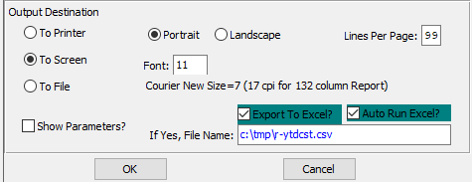

#### Destination Choice

To choose the destination where the document should be printed, please make sure that desired output destination choice bubble is toggled.

#### Layout Choice

To choose the preferred layout of Landscape vs. Portrait, please make sure the desired option choice bubbled is toggled.

#### Lines Per Page

Lines per page on the report when printing.

#### Font

Enter the font number to use with this report (Font 11 is default).

#### Show Parameters? – Toggle Box

To show parameters, make sure that the toggle box is ‘ticked’ with a checkmark.

#### Export to Excel? – Toggle Box

To export the printed file to an excel document, make sure that the Export to Excel toggle box is checked.

#### Auto Run Excel? – Toggle Box

To automatically open the new excel document, make sure that the Auto Run Excel toggle box is checked.

#### If Yes, File Name

If exporting the file to Excel, enter the desired file name.

## Item List by Customer [IR9]

### Selection Parameters

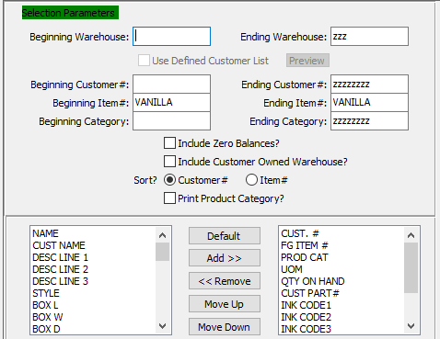

#### Beginning Warehouse / Ending Warehouse

Enter the starting and ending warehouse.

#### Beginning Customer # / Ending Customer #

Enter the starting and ending customer number.

#### Beginning Item # / Ending Item #

Enter the starting and ending item number.

#### Beginning Category / Ending Category

Enter the starting and ending category.

#### Include Zero Quantity On Hand? – Toggle Box

To include all items with zero quantity balances, make sure that this toggle box is checked.

#### Include Customer Owned Warehouse? – Toggle Box

To include the quantity owned by the customer with the quantity on hand, please make sure that this toggle box is checked.

#### Sort? (Choice)

To choose the preferred Sorting Option of Customer Number vs. Item Number, please make sure the desired option choice bubble is toggled.

#### Print Product Category? – Toggle Box

To print the product category on the report, make sure that this toggle box is checked.

#### Available Columns

The user may choose which columns they wish to have on the report printout. As the user selects their choices, they will appear on the ‘*Selected Columns’* list.

#### Selected Columns (In Display Order)

The columns that the user has chosen from the ‘*Available Columns’* list. The order that these columns are displayed in here is the order in which they will print on the report.

#### Default

Click the ***“Default****”* button to sort the ‘*Selected Columns’* list by the default system parameters.

#### Add >>

Click on the selected item from the ‘*Available Columns’* list to highlight it, then click the ***“Add”*** button to add the selected column to the ‘*Selected Columns’* list.

#### << Remove

Click on the selected item from the ‘*Selected Columns’* list to highlight it, then click the ***“Remove”*** button to remove the selected column to the ‘*Selected Columns’* list.

#### Move Up

Within the ‘*Selected Columns’* list, the user may choose the order they wish the selected columns to print in. In order to change the order of the columns, the user can click on a selection to highlight it. By then clicking the ***“Move Up***” button, the user can change its position on the report.

#### Move Down

Within the ‘*Selected Columns’* list, the user may choose the order they wish the selected columns to print in. In order to change the order of the columns, the user can click on a selection to highlight it. By then clicking the ***“Move Down***” button, the user can change its position on the report.

### Output Destination

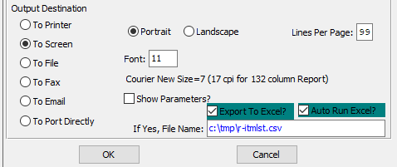

#### Destination Choice

To choose the destination where the document should be printed, please make sure that desired output destination choice bubble is toggled.

#### Layout Choice

To choose the preferred layout of Landscape vs. Portrait, please make sure the desired option choice bubbled is toggled.

#### Lines Per Page

Lines per page on the report when printing.

#### Font

Enter the font number to use with this report (Font 11 is default).

#### Show Parameters? – Toggle Box

To show parameters, make sure that the toggle box is ‘ticked’ with a checkmark.

#### Export to Excel? – Toggle Box

To export the printed file to an excel document, make sure that the Export to Excel toggle box is checked.

#### Auto Run Excel? – Toggle Box

To automatically open the new excel document, make sure that the Auto Run Excel toggle box is checked.

#### If Yes, File Name

If exporting the file to Excel, enter the desired file name.

## Status [IR)]

This summary report by customer provides year-to-date quantities (by item number) produced, shipped, adjusted, and on-hand. Also provided are the beginning balance (on hand), sales price, and a total inventory value by customer. A report total also prints.

### Selection Parameters

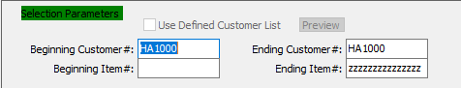

#### Beginning Customer # / Ending Customer #

Enter the starting and ending customer number.

#### Beginning Item # / Ending Item #

Enter the starting and ending item number.

### Available and Selected Columns

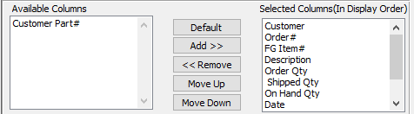

#### Available Columns

The user may choose which columns they wish to have on the report printout. As the user selects their choices, they will appear on the ‘*Selected Columns’* list.

#### Selected Columns (In Display Order)

The columns that the user has chosen from the ‘*Available Columns’* list. The order that these columns are displayed in here is the order in which they will print on the report.

#### Default

Click the ***“Default****”* button to sort the ‘*Selected Columns’* list by the default system parameters.

#### Add >>

Click on the selected item from the ‘*Available Columns’* list to highlight it, then click the ***“Add”*** button to add the selected column to the ‘*Selected Columns’* list.

#### << Remove

Click on the selected item from the ‘*Selected Columns’* list to highlight it, then click the ***“Remove”*** button to remove the selected column to the ‘*Selected Columns’* list.

#### Move Up

Within the ‘*Selected Columns’* list, the user may choose the order they wish the selected columns to print in. In order to change the order of the columns, the user can click on a selection to highlight it. By then clicking the ***“Move Up***” button, the user can change its position on the report.

#### Move Down

Within the ‘*Selected Columns’* list, the user may choose the order they wish the selected columns to print in. In order to change the order of the columns, the user can click on a selection to highlight it. By then clicking the ***“Move Down***” button, the user can change its position on the report.

### Output Destination

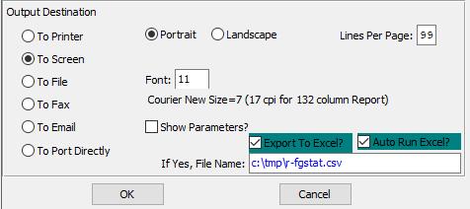

#### Destination Choice

To choose the destination where the document should be printed, please make sure that desired output destination choice bubble is toggled.

#### Layout Choice

To choose the preferred layout of Landscape vs. Portrait, please make sure the desired option choice bubbled is toggled.

#### Lines Per Page

Lines per page on the report when printing.

#### Font

Enter the font number to use with this report (Font 11 is default).

#### Show Parameters? – Toggle Box

To show parameters, make sure that the toggle box is ‘ticked’ with a checkmark.

#### Export to Excel? – Toggle Box

To export the printed file to an excel document, make sure that the Export to Excel toggle box is checked.

#### Auto Run Excel? – Toggle Box

To automatically open the new excel document, make sure that the Auto Run Excel toggle box is checked.

#### If Yes, File Name

If exporting the file to Excel, enter the desired file name.

## Transactions by Order [IR!]

### Selection Parameters

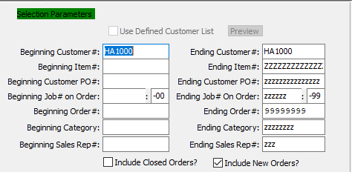

#### Beginning Customer # / Ending Customer #

Enter the starting and ending customer number.

#### Beginning Item # / Ending Item #

Enter the starting and ending item number.

#### Beginning Customer PO # / Ending Customer PO #

Enter the starting and ending customer purchase order number.

#### Beginning Job # On Order / Ending Job # On Order

Enter the starting and ending job order number.

#### Beginning Job #: 00 On Order / Ending Job #: 00 On Order

Enter the starting and ending subsequent job order number.

#### Beginning Order # / Ending Order #

Enter the starting and ending order number.

#### Beginning Category / Ending Category

Enter the starting and ending category.

#### Beginning Sales Rep # / Ending Sales Rep #

Enter the starting and ending sales representative number.

#### Include Closed Orders? – Toggle Box

To include closed order in the report, make sure that the Include Closed Orders toggle box is checked.

#### Include New Orders? – Toggle Box

To include new orders in the report, make sure that the Include New Orders toggle box is checked.

### Available and Selected Columns

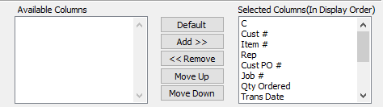

#### Available Columns

The user may choose which columns they wish to have on the report printout. As the user selects their choices, they will appear on the ‘*Selected Columns’* list.

#### Selected Columns (In Display Order)

The columns that the user has chosen from the ‘*Available Columns’* list. The order that these columns are displayed in here is the order in which they will print on the report.

#### Default

Click the ***“Default****”* button to sort the ‘*Selected Columns’* list by the default system parameters.

#### Add >>

Click on the selected item from the ‘*Available Columns’* list to highlight it, then click the ***“Add”*** button to add the selected column to the ‘*Selected Columns’* list.

#### << Remove

Click on the selected item from the ‘*Selected Columns’* list to highlight it, then click the ***“Remove”*** button to remove the selected column to the ‘*Selected Columns’* list.

#### Move Up

Within the ‘*Selected Columns’* list, the user may choose the order they wish the selected columns to print in. In order to change the order of the columns, the user can click on a selection to highlight it. By then clicking the ***“Move Up***” button, the user can change its position on the report.

#### Move Down

Within the ‘*Selected Columns’* list, the user may choose the order they wish the selected columns to print in. In order to change the order of the columns, the user can click on a selection to highlight it. By then clicking the ***“Move Down***” button, the user can change its position on the report.

### Output Destination

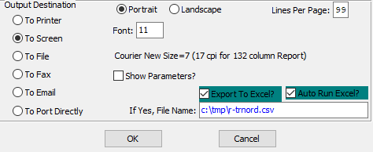

#### Destination Choice

To choose the destination where the document should be printed, please make sure that desired output destination choice bubble is toggled.

#### Layout Choice

To choose the preferred layout of Landscape vs. Portrait, please make sure the desired option choice bubbled is toggled.

#### Lines Per Page

Lines per page on the report when printing.

#### Font

Enter the font number to use with this report (Font 11 is default).

#### Show Parameters? – Toggle Box

To show parameters, make sure that the toggle box is ‘ticked’ with a checkmark.

#### Export to Excel? – Toggle Box

To export the printed file to an excel document, make sure that the Export to Excel toggle box is checked.

#### Auto Run Excel? – Toggle Box

To automatically open the new excel document, make sure that the Auto Run Excel toggle box is checked.

#### If Yes, File Name

If exporting the file to Excel, enter the desired file name.

## Aged Inventory [IR@]

### Selection Parameters

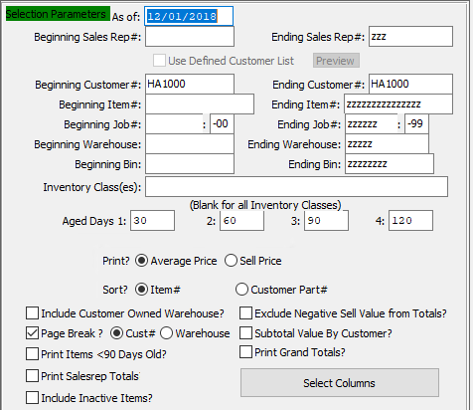

#### As Of

Enter a date for the start of this report. Any items within the selected parameters after this date will be reported.

#### Beginning Sales Rep # / Ending Sales Rep #

Enter the starting and ending sales representative number.

#### Beginning Customer # / Ending Customer #

Enter the starting and ending customer number.

#### Beginning Item # / Ending Item #

Enter the starting and ending item number.

#### Beginning Job # / Ending Job #

Enter the starting and ending job number.

#### Beginning Job #: 00 / Ending Job #: 00

Enter the starting and ending subsequent job number.

#### Beginning Warehouse / Ending Warehouse

Enter the starting and ending warehouse.

#### Beginning Bin / Ending Bin

Enter the starting and ending bin.

#### Aged Days 1:

Enter a number of days for the first pass of aged inventory.

#### Aged Days 2:

Enter a number of days for the second pass of aged inventory.

#### Aged Days 3:

Enter a number of days for the third pass of aged inventory.

#### Aged Days 4

Enter a number of days for the fourth pass of aged inventory.

#### Print? (Choice)

To choose the preferred Price Option of Average vs. Sell, please make sure the desired option choice bubble is toggled.

#### Sort? (Choice)

To choose the preferred Sorting Option of By Item Number vs. By Customer Part Number, please make sure the desired option choice bubble is toggled.

#### Include Customer Owned Warehouse? – Toggle Box

To include the quantity owned by the customer with the quantity on hand, please make sure that this toggle box is checked.

#### Page Break? – Toggle Box

To break up the pages on the printed report, make sure that the Page Break toggle box is checked. This will allow the user to choose how they wish the pages to be broken up.

#### Page Break (Choice)

To choose the preferred method of breaking up the pages on the current report of Customer Number vs. Warehouse, please make sure the desired option choice bubble is toggled.

#### Print Items < 90 Days Old? – Toggle Box

To print items that are newer than 90 days old, make sure that this toggle box is checked.

#### Print Sales Rep Totals – Toggle Box

To print totals for each Sales Representative in the report, make sure that the Print Sales Rep Totals toggle box is checked.

#### Include Inactive Items? – Toggle Box

To include inactive items in the report, make sure that the Include Inactive Items toggle box is checked.

#### Exclude Negative Sell Value from Totals? – Toggle Box

To exclude totals that have a negative sell value, make sure that this toggle box is checked.

#### Subtotal Value by Customer? – Toggle Box

To subtotal old inventory values by customer, make sure that this toggle box is checked.

#### Print Grand Totals? – Toggle Box

To print inventory grand totals on the report, make sure that the Print Grand Totals toggle box is checked.

### Select Columns

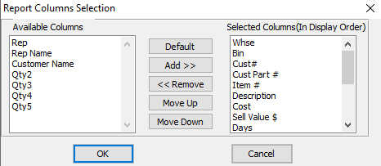

#### Available Columns

The user may choose which columns they wish to have on the report printout. As the user selects their choices, they will appear on the ‘*Selected Columns’* list.

#### Selected Columns (In Display Order)

The columns that the user has chosen from the ‘*Available Columns’* list. The order that these columns are displayed in here is the order in which they will print on the report.

#### Default

Click the ***“Default****”* button to sort the ‘*Selected Columns’* list by the default system parameters.

#### Add >>

Click on the selected item from the ‘*Available Columns’* list to highlight it, then click the ***“Add”*** button to add the selected column to the ‘*Selected Columns’* list.

#### << Remove

Click on the selected item from the ‘*Selected Columns’* list to highlight it, then click the ***“Remove”*** button to remove the selected column to the ‘*Selected Columns’* list.

#### Move Up

Within the ‘*Selected Columns’* list, the user may choose the order they wish the selected columns to print in. In order to change the order of the columns, the user can click on a selection to highlight it. By then clicking the ***“Move Up***” button, the user can change its position on the report.

#### Move Down

Within the ‘*Selected Columns’* list, the user may choose the order they wish the selected columns to print in. In order to change the order of the columns, the user can click on a selection to highlight it. By then clicking the ***“Move Down***” button, the user can change its position on the report.

### Output Destination

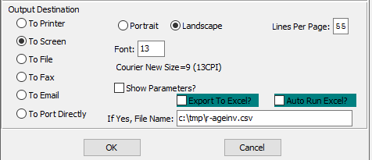

#### Destination Choice

To choose the destination where the document should be printed, please make sure that desired output destination choice bubble is toggled.

#### Layout Choice

To choose the preferred layout of Landscape vs. Portrait, please make sure the desired option choice bubbled is toggled.

#### Lines Per Page

Lines per page on the report when printing.

#### Font

Enter the font number to use with this report (Font 11 is default).

#### Show Parameters? – Toggle Box

To show parameters, make sure that the toggle box is ‘ticked’ with a checkmark.

#### Export to Excel? – Toggle Box

To export the printed file to an excel document, make sure that the Export to Excel toggle box is checked.

#### Auto Run Excel? – Toggle Box

To automatically open the new excel document, make sure that the Auto Run Excel toggle box is checked.

#### If Yes, File Name

If exporting the file to Excel, enter the desired file name.

## Next Ship Date and Value [IR#]

### Selection Parameters

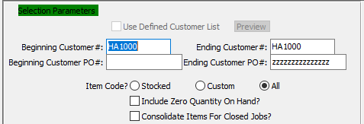

#### Beginning Customer # / Ending Customer #

Enter the starting and ending customer number.

#### Beginning Customer PO # / Ending Customer PO #

Enter the starting and ending customer purchase order number.

#### Item Code? (Choice)

To choose the preferred Item Code of Stocked vs. Customer (Or All), please make sure the desired option choice bubble is toggled.

#### Include Zero Quantity On Hand? – Toggle Box

To include all items with zero quantity balances, make sure that this toggle box is checked.

#### Consolidate Items for Closed Jobs? – Toggle Box

To consolidate items for closed jobs on the printed report, make sure that this toggle box is checked.

### Available and Selected Columns

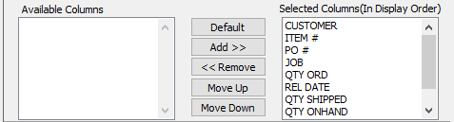

#### Available Columns

The user may choose which columns they wish to have on the report printout. As the user selects their choices, they will appear on the ‘*Selected Columns’* list.

#### Selected Columns (In Display Order)

The columns that the user has chosen from the ‘*Available Columns’* list. The order that these columns are displayed in here is the order in which they will print on the report.

#### Default

Click the ***“Default****”* button to sort the ‘*Selected Columns’* list by the default system parameters.

#### Add >>

Click on the selected item from the ‘*Available Columns’* list to highlight it, then click the ***“Add”*** button to add the selected column to the ‘*Selected Columns’* list.

#### << Remove

Click on the selected item from the ‘*Selected Columns’* list to highlight it, then click the ***“Remove”*** button to remove the selected column to the ‘*Selected Columns’* list.

#### Move Up

Within the ‘*Selected Columns’* list, the user may choose the order they wish the selected columns to print in. In order to change the order of the columns, the user can click on a selection to highlight it. By then clicking the ***“Move Up***” button, the user can change its position on the report.

#### Move Down

Within the ‘*Selected Columns’* list, the user may choose the order they wish the selected columns to print in. In order to change the order of the columns, the user can click on a selection to highlight it. By then clicking the ***“Move Down***” button, the user can change its position on the report.

### Output Destination

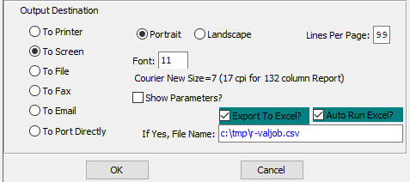

#### Destination Choice

To choose the destination where the document should be printed, please make sure that desired output destination choice bubble is toggled.

#### Layout Choice

To choose the preferred layout of Landscape vs. Portrait, please make sure the desired option choice bubbled is toggled.

#### Lines Per Page

Lines per page on the report when printing.

#### Font

Enter the font number to use with this report (Font 11 is default).

#### Show Parameters? – Toggle Box

To show parameters, make sure that the toggle box is ‘ticked’ with a checkmark.

#### Export to Excel? – Toggle Box

To export the printed file to an excel document, make sure that the Export to Excel toggle box is checked.

#### Auto Run Excel? – Toggle Box

To automatically open the new excel document, make sure that the Auto Run Excel toggle box is checked.

#### If Yes, File Name

If exporting the file to Excel, enter the desired file name.

## DL-Mat-GSA by Whs/Bin/Tag [IR$]

This report shows detail information regarding Items. The item (sorted in Item number order) information includes quantity-on-hand and selling price. The item is broken down by Warehouse, Bin, Tag, and job. Totals are shown by Item.

Finished Goods may be assigned a reorder level quantity in their inventory files. The reordering advice report will print items below the reorder quantity. In addition, the quantity available may exclude or include the quantity on order. This report may be printed by range of items, by warehouse location and product category.

### Selection Parameters

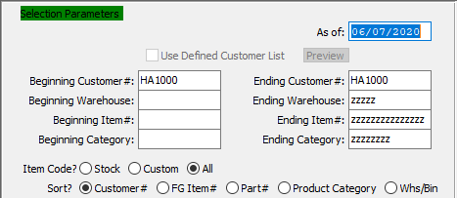

#### As Of

Enter a date for the start of this report. Any items within the selected parameters after this date will be reported.

#### Beginning Customer # / Ending Customer #

Enter the starting and ending customer number.

#### Beginning Warehouse / Ending Warehouse

Enter the starting and ending warehouse.

#### Beginning Item # / Ending Item #

Enter the starting and ending item number.

#### Beginning Category / Ending Category

Enter the starting and ending category.

#### Item Code? (Choice)

To choose the preferred Item Code of Stock vs. Custom (Or All), please make sure the desired option choice bubble is toggled.

#### Sort? (Choice)

To choose the preferred Sort Method, please make sure the desired option choice bubble is toggled.

### Available and Selected Columns

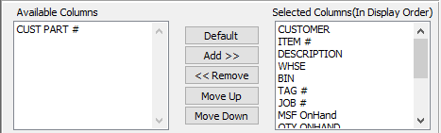

#### Available Columns

The user may choose which columns they wish to have on the report printout. As the user selects their choices, they will appear on the ‘*Selected Columns’* list.

#### Selected Columns (In Display Order)

The columns that the user has chosen from the ‘*Available Columns’* list. The order that these columns are displayed in here is the order in which they will print on the report.

#### Default

Click the ***“Default****”* button to sort the ‘*Selected Columns’* list by the default system parameters.

#### Add >>

Click on the selected item from the ‘*Available Columns’* list to highlight it, then click the ***“Add”*** button to add the selected column to the ‘*Selected Columns’* list.

#### << Remove

Click on the selected item from the ‘*Selected Columns’* list to highlight it, then click the ***“Remove”*** button to remove the selected column to the ‘*Selected Columns’* list.

#### Move Up

Within the ‘*Selected Columns’* list, the user may choose the order they wish the selected columns to print in. In order to change the order of the columns, the user can click on a selection to highlight it. By then clicking the ***“Move Up***” button, the user can change its position on the report.

#### Move Down

Within the ‘*Selected Columns’* list, the user may choose the order they wish the selected columns to print in. In order to change the order of the columns, the user can click on a selection to highlight it. By then clicking the ***“Move Down***” button, the user can change its position on the report.

### Output Destination

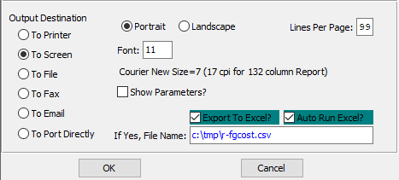

#### Destination Choice

To choose the destination where the document should be printed, please make sure that desired output destination choice bubble is toggled.

#### Layout Choice

To choose the preferred layout of Landscape vs. Portrait, please make sure the desired option choice bubbled is toggled.

#### Lines Per Page

Lines per page on the report when printing.

#### Font

Enter the font number to use with this report (Font 11 is default).

#### Show Parameters? – Toggle Box

To show parameters, make sure that the toggle box is ‘ticked’ with a checkmark.

#### Export to Excel? – Toggle Box

To export the printed file to an excel document, make sure that the Export to Excel toggle box is checked.

#### Auto Run Excel? – Toggle Box

To automatically open the new excel document, make sure that the Auto Run Excel toggle box is checked.

#### If Yes, File Name

If exporting the file to Excel, enter the desired file name.

## FG Item Value/Cost Summary [IR%]

### Selection Parameters

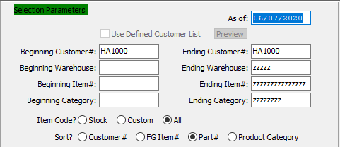

#### As Of

Enter a date for the start of this report. Any items within the selected parameters after this date will be reported.

#### Beginning Customer # / Ending Customer #

Enter the starting and ending customer number.

#### Beginning Warehouse / Ending Warehouse

Enter the starting and ending warehouse.

#### Beginning Item # / Ending Item #

Enter the starting and ending item number.

#### Beginning Category / Ending Category

Enter the starting and ending category.

#### Item Code? (Choice)

To choose the preferred Item Code of Stock vs. Custom (Or All), please make sure the desired option choice bubble is toggled.

#### Sort? (Choice)

To choose the preferred Sort Method, please make sure the desired option choice bubble is toggled.

### Available and Selected Columns

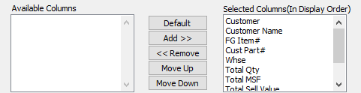

#### Available Columns

The user may choose which columns they wish to have on the report printout. As the user selects their choices, they will appear on the ‘*Selected Columns’* list.

#### Selected Columns (In Display Order)

The columns that the user has chosen from the ‘*Available Columns’* list. The order that these columns are displayed in here is the order in which they will print on the report.

#### Default

Click the ***“Default****”* button to sort the ‘*Selected Columns’* list by the default system parameters.

#### Add >>

Click on the selected item from the ‘*Available Columns’* list to highlight it, then click the ***“Add”*** button to add the selected column to the ‘*Selected Columns’* list.

#### << Remove

Click on the selected item from the ‘*Selected Columns’* list to highlight it, then click the ***“Remove”*** button to remove the selected column to the ‘*Selected Columns’* list.

#### Move Up

Within the ‘*Selected Columns’* list, the user may choose the order they wish the selected columns to print in. In order to change the order of the columns, the user can click on a selection to highlight it. By then clicking the ***“Move Up***” button, the user can change its position on the report.

#### Move Down

Within the ‘*Selected Columns’* list, the user may choose the order they wish the selected columns to print in. In order to change the order of the columns, the user can click on a selection to highlight it. By then clicking the ***“Move Down***” button, the user can change its position on the report.

### Output Destination

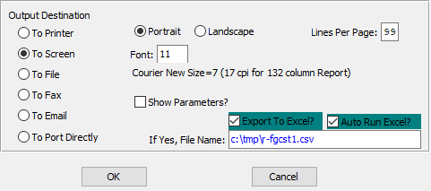

#### Destination Choice

To choose the destination where the document should be printed, please make sure that desired output destination choice bubble is toggled.

#### Layout Choice

To choose the preferred layout of Landscape vs. Portrait, please make sure the desired option choice bubbled is toggled.

#### Lines Per Page

Lines per page on the report when printing.

#### Font

Enter the font number to use with this report (Font 11 is default).

#### Show Parameters? – Toggle Box

To show parameters, make sure that the toggle box is ‘ticked’ with a checkmark.

#### Export to Excel? – Toggle Box

To export the printed file to an excel document, make sure that the Export to Excel toggle box is checked.

#### Auto Run Excel? – Toggle Box

To automatically open the new excel document, make sure that the Auto Run Excel toggle box is checked.

#### If Yes, File Name

If exporting the file to Excel, enter the desired file name.

# **List More Reports [IL]**

## QTY Totals by Cust/Item [IL1]

### Selection Parameters

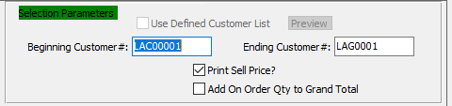

#### Beginning Customer # / Ending Customer #

Enter the starting and ending customer number.

#### Print Sell Price? – Toggle Box

To print the selling price for each item, make sure that the Print Sell Price toggle box is checked.

#### Add On Order Qty to Grand Total – Toggle Box

To add the order quantity of each item to the grand total on the report, make sure that this toggle box is checked.

### Available and Selected Columns

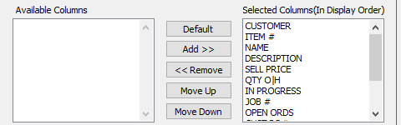

#### Available Columns

The user may choose which columns they wish to have on the report printout. As the user selects their choices, they will appear on the ‘*Selected Columns’* list.

#### Selected Columns (In Display Order)

The columns that the user has chosen from the ‘*Available Columns’* list. The order that these columns are displayed in here is the order in which they will print on the report.

#### Default

Click the ***“Default****”* button to sort the ‘*Selected Columns’* list by the default system parameters.

#### Add >>

Click on the selected item from the ‘*Available Columns’* list to highlight it, then click the ***“Add”*** button to add the selected column to the ‘*Selected Columns’* list.

#### << Remove

Click on the selected item from the ‘*Selected Columns’* list to highlight it, then click the ***“Remove”*** button to remove the selected column to the ‘*Selected Columns’* list.

#### Move Up

Within the ‘*Selected Columns’* list, the user may choose the order they wish the selected columns to print in. In order to change the order of the columns, the user can click on a selection to highlight it. By then clicking the ***“Move Up***” button, the user can change its position on the report.

#### Move Down

Within the ‘*Selected Columns’* list, the user may choose the order they wish the selected columns to print in. In order to change the order of the columns, the user can click on a selection to highlight it. By then clicking the ***“Move Down***” button, the user can change its position on the report.

### Output Destination

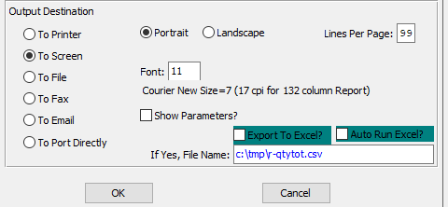

#### Destination Choice

To choose the destination where the document should be printed, please make sure that desired output destination choice bubble is toggled.

#### Layout Choice

To choose the preferred layout of Landscape vs. Portrait, please make sure the desired option choice bubbled is toggled.

#### Lines Per Page

Lines per page on the report when printing.

#### Font

Enter the font number to use with this report (Font 11 is default).

#### Show Parameters? – Toggle Box

To show parameters, make sure that the toggle box is ‘ticked’ with a checkmark.

#### Export to Excel? – Toggle Box

To export the printed file to an excel document, make sure that the Export to Excel toggle box is checked.

#### Auto Run Excel? – Toggle Box

To automatically open the new excel document, make sure that the Auto Run Excel toggle box is checked.

#### If Yes, File Name

If exporting the file to Excel, enter the desired file name.

## Unshipped FG Summary [IL2]

### Selection Parameters

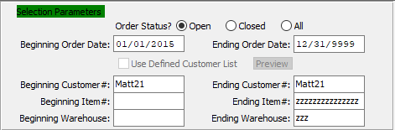

#### Order Status (Choice)

To choose the preferred Order Status of Open vs. Closed (Or All), please make sure the desired option choice bubble is toggled.

#### Beginning Order Date / Ending Order Date

Enter the starting and ending order date.

#### Beginning Customer # / Ending Customer #

Enter the starting and ending customer number.

#### Beginning Item # / Ending Item #

Enter the starting and ending item number.

#### Beginning Warehouse / Ending Warehouse

Enter the starting and ending warehouse.

### Available and Selected Columns

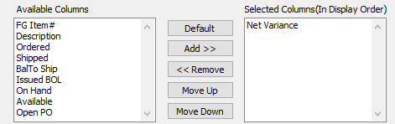

#### Available Columns

The user may choose which columns they wish to have on the report printout. As the user selects their choices, they will appear on the ‘*Selected Columns’* list.

#### Selected Columns (In Display Order)

The columns that the user has chosen from the ‘*Available Columns’* list. The order that these columns are displayed in here is the order in which they will print on the report.

#### Default

Click the ***“Default****”* button to sort the ‘*Selected Columns’* list by the default system parameters.

#### Add >>

Click on the selected item from the ‘*Available Columns’* list to highlight it, then click the ***“Add”*** button to add the selected column to the ‘*Selected Columns’* list.

#### << Remove

Click on the selected item from the ‘*Selected Columns’* list to highlight it, then click the ***“Remove”*** button to remove the selected column to the ‘*Selected Columns’* list.

#### Move Up

Within the ‘*Selected Columns’* list, the user may choose the order they wish the selected columns to print in. In order to change the order of the columns, the user can click on a selection to highlight it. By then clicking the ***“Move Up***” button, the user can change its position on the report.

#### Move Down

Within the ‘*Selected Columns’* list, the user may choose the order they wish the selected columns to print in. In order to change the order of the columns, the user can click on a selection to highlight it. By then clicking the ***“Move Down***” button, the user can change its position on the report.

### Output Destination

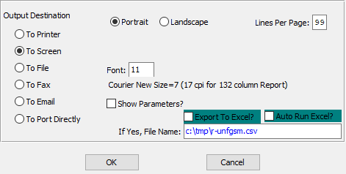

#### Destination Choice

To choose the destination where the document should be printed, please make sure that desired output destination choice bubble is toggled.

#### Layout Choice

To choose the preferred layout of Landscape vs. Portrait, please make sure the desired option choice bubbled is toggled.

#### Show Parameters? – Toggle Box

To show parameters, make sure that the toggle box is ‘ticked’ with a checkmark.

#### Export to Excel? – Toggle Box

To export the printed file to an excel document, make sure that the Export to Excel toggle box is checked.

#### Auto Run Excel? – Toggle Box

To automatically open the new excel document, make sure that the Auto Run Excel toggle box is checked.

#### If Yes, File Name

If exporting the file to Excel, enter the desired file name.

## Unshipped FG Detail [IL3]

### Selection Parameters

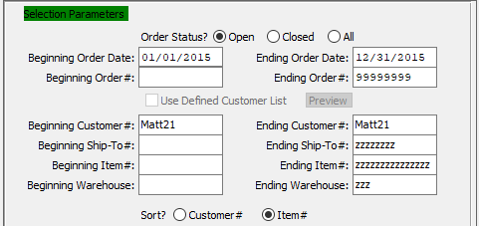

#### Order Status (Choice)

To choose the preferred Order Status of Open vs. Closed (Or All), please make sure the desired option choice bubble is toggled.

#### Beginning Order Date / Ending Order Date

Enter the starting and ending order date.

#### Beginning Order # / Ending Order #

Enter the starting and ending order number.

#### Beginning Customer # / Ending Customer #

Enter the starting and ending customer number.

#### Beginning Ship-To # / Ending Ship-To #

Enter the starting and ending ship to number.

#### Beginning Item # / Ending Item #

Enter the starting and ending item number.

#### Beginning Warehouse / Ending Warehouse

Enter the starting and ending warehouse.

#### Sort? (Choice)

To choose the preferred Sort Method of Customer Number vs. Item Number, please make sure the desired option choice bubble is toggled.

### Available and Selected Columns

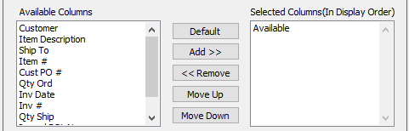

#### Available Columns

The user may choose which columns they wish to have on the report printout. As the user selects their choices, they will appear on the ‘*Selected Columns’* list.

#### Selected Columns (In Display Order)

The columns that the user has chosen from the ‘*Available Columns’* list. The order that these columns are displayed in here is the order in which they will print on the report.

#### Default

Click the ***“Default****”* button to sort the ‘*Selected Columns’* list by the default system parameters.

#### Add >>

Click on the selected item from the ‘*Available Columns’* list to highlight it, then click the ***“Add”*** button to add the selected column to the ‘*Selected Columns’* list.

#### << Remove

Click on the selected item from the ‘*Selected Columns’* list to highlight it, then click the ***“Remove”*** button to remove the selected column to the ‘*Selected Columns’* list.

#### Move Up

Within the ‘*Selected Columns’* list, the user may choose the order they wish the selected columns to print in. In order to change the order of the columns, the user can click on a selection to highlight it. By then clicking the ***“Move Up***” button, the user can change its position on the report.

#### Move Down

Within the ‘*Selected Columns’* list, the user may choose the order they wish the selected columns to print in. In order to change the order of the columns, the user can click on a selection to highlight it. By then clicking the ***“Move Down***” button, the user can change its position on the report.

### Output Destination

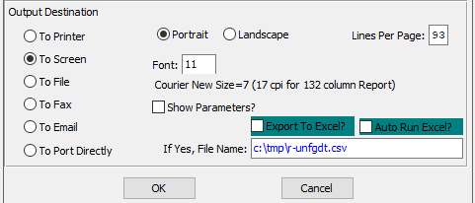

#### Destination Choice

To choose the destination where the document should be printed, please make sure that desired output destination choice bubble is toggled.

#### Layout Choice

To choose the preferred layout of Landscape vs. Portrait, please make sure the desired option choice bubbled is toggled.

#### Lines Per Page

Lines per page on the report when printing.

#### Font

Enter the font number to use with this report (Font 11 is default).

#### Show Parameters? – Toggle Box

To show parameters, make sure that the toggle box is ‘ticked’ with a checkmark.

#### Export to Excel? – Toggle Box

To export the printed file to an excel document, make sure that the Export to Excel toggle box is checked.

#### Auto Run Excel? – Toggle Box

To automatically open the new excel document, make sure that the Auto Run Excel toggle box is checked.

#### If Yes, File Name

If exporting the file to Excel, enter the desired file name.

## Scheduled Ship vs. QOH [IL4]

### Selection Parameters

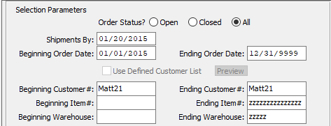

#### Order Status (Choice)

To choose the preferred Order Status of Open vs. Closed (Or All), please make sure the desired option choice bubble is toggled.

#### Shipments By

The date entered here will be the last date of the report. Any shipments scheduled after that date will be left off of the report.

#### Beginning Order Date / Ending Order Date

Enter the starting and ending order date.

#### Beginning Customer # / Ending Customer #

Enter the starting and ending customer number.

#### Beginning Item # / Ending Item #

Enter the starting and ending item number.

#### Beginning Warehouse / Ending Warehouse

Enter the starting and ending warehouse.

### Available and Selected Columns

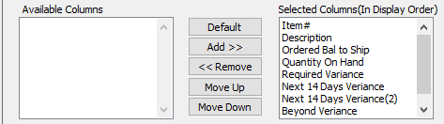

#### Available Columns

The user may choose which columns they wish to have on the report printout. As the user selects their choices, they will appear on the ‘*Selected Columns’* list.

#### Selected Columns (In Display Order)

The columns that the user has chosen from the ‘*Available Columns’* list. The order that these columns are displayed in here is the order in which they will print on the report.

#### Default

Click the ***“Default****”* button to sort the ‘*Selected Columns’* list by the default system parameters.

#### Add >>

Click on the selected item from the ‘*Available Columns’* list to highlight it, then click the ***“Add”*** button to add the selected column to the ‘*Selected Columns’* list.

#### << Remove

Click on the selected item from the ‘*Selected Columns’* list to highlight it, then click the ***“Remove”*** button to remove the selected column to the ‘*Selected Columns’* list.

#### Move Up

Within the ‘*Selected Columns’* list, the user may choose the order they wish the selected columns to print in. In order to change the order of the columns, the user can click on a selection to highlight it. By then clicking the ***“Move Up***” button, the user can change its position on the report.

#### Move Down

Within the ‘*Selected Columns’* list, the user may choose the order they wish the selected columns to print in. In order to change the order of the columns, the user can click on a selection to highlight it. By then clicking the ***“Move Down***” button, the user can change its position on the report.

### Output Destination

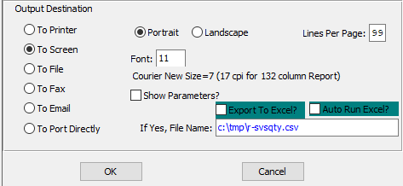

#### Destination Choice

To choose the destination where the document should be printed, please make sure that desired output destination choice bubble is toggled.

#### Layout Choice

To choose the preferred layout of Landscape vs. Portrait, please make sure the desired option choice bubbled is toggled.

#### Lines Per Page

Lines per page on the report when printing.

#### Font

Enter the font number to use with this report (Font 11 is default).

#### Show Parameters? – Toggle Box

To show parameters, make sure that the toggle box is ‘ticked’ with a checkmark.

#### Export to Excel? – Toggle Box

To export the printed file to an excel document, make sure that the Export to Excel toggle box is checked.

#### Auto Run Excel? – Toggle Box

To automatically open the new excel document, make sure that the Auto Run Excel toggle box is checked.

#### If Yes, File Name

If exporting the file to Excel, enter the desired file name.

## Inventory Balances [IL5]

### Selection Parameters

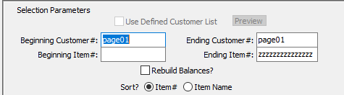

#### Beginning Customer # / Ending Customer #

Enter the starting and ending customer number.

#### Beginning Item # / Ending Item #

Enter the starting and ending item number.

#### Rebuild Balances? – Toggle Box

To rebuild inventory balances after printing the current report, make sure that the Reprint Balances toggle box is checked.

#### Sort? (Choice)

To choose the preferred Sort Method of Item Number vs. Item Name, please make sure the desired option choice bubble is toggled.

### Available and Selected Columns

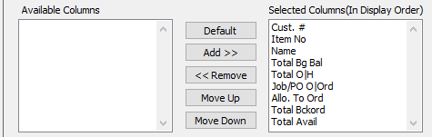

#### Available Columns

The user may choose which columns they wish to have on the report printout. As the user selects their choices, they will appear on the ‘*Selected Columns’* list.

#### Selected Columns (In Display Order)

The columns that the user has chosen from the ‘*Available Columns’* list. The order that these columns are displayed in here is the order in which they will print on the report.

#### Default

Click the ***“Default****”* button to sort the ‘*Selected Columns’* list by the default system parameters.

#### Add >>

Click on the selected item from the ‘*Available Columns’* list to highlight it, then click the ***“Add”*** button to add the selected column to the ‘*Selected Columns’* list.

#### << Remove

Click on the selected item from the ‘*Selected Columns’* list to highlight it, then click the ***“Remove”*** button to remove the selected column to the ‘*Selected Columns’* list.

#### Move Up

Within the ‘*Selected Columns’* list, the user may choose the order they wish the selected columns to print in. In order to change the order of the columns, the user can click on a selection to highlight it. By then clicking the ***“Move Up***” button, the user can change its position on the report.

#### Move Down

Within the ‘*Selected Columns’* list, the user may choose the order they wish the selected columns to print in. In order to change the order of the columns, the user can click on a selection to highlight it. By then clicking the ***“Move Down***” button, the user can change its position on the report.

### Output Destination

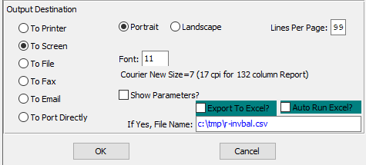

#### Destination Choice

To choose the destination where the document should be printed, please make sure that desired output destination choice bubble is toggled.

#### Layout Choice

To choose the preferred layout of Landscape vs. Portrait, please make sure the desired option choice bubbled is toggled.

#### Lines Per Page

Lines per page on the report when printing.

#### Font

Enter the font number to use with this report (Font 11 is default).

#### Show Parameters? – Toggle Box

To show parameters, make sure that the toggle box is ‘ticked’ with a checkmark.

#### Export to Excel? – Toggle Box

To export the printed file to an excel document, make sure that the Export to Excel toggle box is checked.

#### Auto Run Excel? – Toggle Box

To automatically open the new excel document, make sure that the Auto Run Excel toggle box is checked.

#### If Yes, File Name

If exporting the file to Excel, enter the desired file name.

## FG Posting Report by Date [IL6]

### Selection Parameters

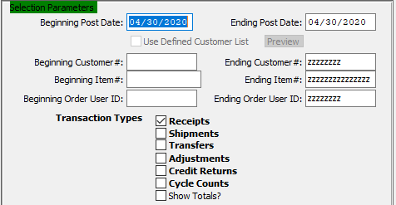

#### Beginning Post Date / Ending Post Date

Enter the starting and ending post date.

#### Beginning Customer # / Ending Customer #

Enter the starting and ending customer number.

#### Beginning Item # / Ending Item #

Enter the starting and ending item number.

#### Beginning Order User ID / Ending Order User ID

Enter the starting and ending order user ID.

#### Transaction Type – Receipts – Toggle Box

To include Receipts in the report, make sure that the Receipts toggle box is checked.

#### Transaction Type – Shipments – Toggle Box

To include Shipments in the report, make sure that the Shipments toggle box is checked.

#### Transaction Type – Transfers – Toggle Box

To include Transfers in the report, make sure that the Transfers toggle box is checked.

#### Transaction Type – Adjustments – Toggle Box

To include Adjustments in the report, make sure that the Adjustments toggle box is checked.

#### Transaction Type – Credit Returns – Toggle Box

To include Credit Returns in the report, make sure that the Credit Returns toggle box is checked.

#### Transaction Type – Cycle Counts – Toggle Box

To include Cycle Counts in the report, make sure that the Cycle Counts toggle box is checked.

#### Show Totals? – Toggle Box

To show totals for each of the selected transaction types on the report, make sure that the Show Totals toggle box is checked.

### Available and Selected Columns

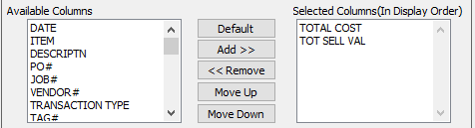

#### Available Columns

The user may choose which columns they wish to have on the report printout. As the user selects their choices, they will appear on the ‘*Selected Columns’* list.

#### Selected Columns (In Display Order)

The columns that the user has chosen from the ‘*Available Columns’* list. The order that these columns are displayed in here is the order in which they will print on the report.

#### Default

Click the ***“Default****”* button to sort the ‘*Selected Columns’* list by the default system parameters.

#### Add >>

Click on the selected item from the ‘*Available Columns’* list to highlight it, then click the ***“Add”*** button to add the selected column to the ‘*Selected Columns’* list.

#### << Remove

Click on the selected item from the ‘*Selected Columns’* list to highlight it, then click the ***“Remove”*** button to remove the selected column to the ‘*Selected Columns’* list.

#### Move Up

Within the ‘*Selected Columns’* list, the user may choose the order they wish the selected columns to print in. In order to change the order of the columns, the user can click on a selection to highlight it. By then clicking the ***“Move Up***” button, the user can change its position on the report.

#### Move Down

Within the ‘*Selected Columns’* list, the user may choose the order they wish the selected columns to print in. In order to change the order of the columns, the user can click on a selection to highlight it. By then clicking the ***“Move Down***” button, the user can change its position on the report.

### Output Destination

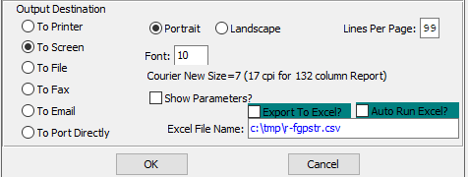

#### Destination Choice

To choose the destination where the document should be printed, please make sure that desired output destination choice bubble is toggled.

#### Layout Choice

To choose the preferred layout of Landscape vs. Portrait, please make sure the desired option choice bubbled is toggled.

#### Lines Per Page

Lines per page on the report when printing.

#### Font

Enter the font number to use with this report (Font 11 is default).

#### Show Parameters? – Toggle Box

To show parameters, make sure that the toggle box is ‘ticked’ with a checkmark.

#### Export to Excel? – Toggle Box

To export the printed file to an excel document, make sure that the Export to Excel toggle box is checked.

#### Auto Run Excel? – Toggle Box

To automatically open the new excel document, make sure that the Auto Run Excel toggle box is checked.

#### If Yes, File Name

If exporting the file to Excel, enter the desired file name.

## FG Daily Activity [IL7]

### Selection Parameters

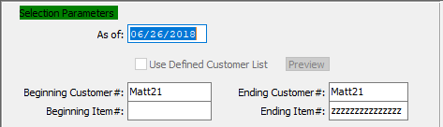

#### As Of

Enter a date for the start of this report. Any items within the selected parameters after this date will be reported.

#### Beginning Customer # / Ending Customer #

Enter the starting and ending customer number.

#### Beginning Item # / Ending Item #

Enter the starting and ending item number.

### Available and Selected Columns

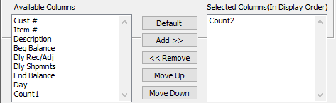

#### Available Columns

The user may choose which columns they wish to have on the report printout. As the user selects their choices, they will appear on the ‘*Selected Columns’* list.

#### Selected Columns (In Display Order)

The columns that the user has chosen from the ‘*Available Columns’* list. The order that these columns are displayed in here is the order in which they will print on the report.

#### Default

Click the ***“Default****”* button to sort the ‘*Selected Columns’* list by the default system parameters.

#### Add >>

Click on the selected item from the ‘*Available Columns’* list to highlight it, then click the ***“Add”*** button to add the selected column to the ‘*Selected Columns’* list.

#### << Remove

Click on the selected item from the ‘*Selected Columns’* list to highlight it, then click the ***“Remove”*** button to remove the selected column to the ‘*Selected Columns’* list.

#### Move Up

Within the ‘*Selected Columns’* list, the user may choose the order they wish the selected columns to print in. In order to change the order of the columns, the user can click on a selection to highlight it. By then clicking the ***“Move Up***” button, the user can change its position on the report.

#### Move Down

Within the ‘*Selected Columns’* list, the user may choose the order they wish the selected columns to print in. In order to change the order of the columns, the user can click on a selection to highlight it. By then clicking the ***“Move Down***” button, the user can change its position on the report.

### Output Destination

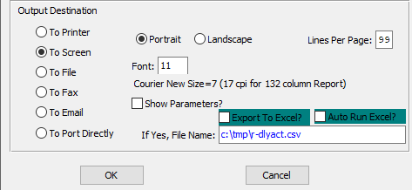

#### Destination Choice

To choose the destination where the document should be printed, please make sure that desired output destination choice bubble is toggled.

#### Layout Choice

To choose the preferred layout of Landscape vs. Portrait, please make sure the desired option choice bubbled is toggled.

#### Lines Per Page

Lines per page on the report when printing.

#### Font

Enter the font number to use with this report (Font 11 is default).

#### Show Parameters? – Toggle Box

To show parameters, make sure that the toggle box is ‘ticked’ with a checkmark.

#### Export to Excel? – Toggle Box

To export the printed file to an excel document, make sure that the Export to Excel toggle box is checked.

#### Auto Run Excel? – Toggle Box

To automatically open the new excel document, make sure that the Auto Run Excel toggle box is checked.

#### If Yes, File Name

If exporting the file to Excel, enter the desired file name.

## Inventory Status by Job [IL8]

### Selection Parameters

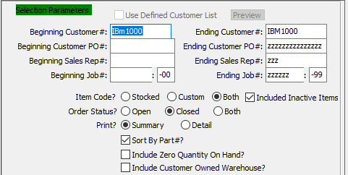

#### Beginning Customer # / Ending Customer #

Enter the starting and ending customer number.

#### Beginning Customer PO # / Ending Customer PO #

Enter the starting and ending purchase order number.

#### Beginning Sales Rep # / Ending Sales Rep #

Enter the starting and ending sales representative number.

#### Beginning Job # / Ending Job #

Enter the starting and ending job number.

#### Beginning Job #: 00 / Ending Job #: 00

Enter the starting and ending subsequent job number.

#### Item Code? (Choice)

To choose the preferred Item Code of Stocked vs. Custom (Or Both), please make sure the desired option choice bubble is toggled.

#### Include Inactive Items? – Toggle Box

To include inactive items in the report, make sure that the Include Inactive Items toggle box is checked.

#### Order Status? (Choice)

To choose the preferred Order Status of Open vs. Closed (Both), please make sure the desired option choice bubble is toggled.

#### Print? (Choice)

To choose the preferred Print Option of Summary vs. Detail, please make sure the desired option choice bubble is toggled.

#### Sort by Part #? – Toggle Box

To sort the report by the part numbers, make sure that the Sort By Part # toggle box is checked.

#### Include Zero Quantity On Hand? – Toggle Box

To include all items with zero quantity balances, make sure that this toggle box is checked.

#### Include Customer Owned Warehouse? – Toggle Box

To include the quantity owned by the customer with the quantity on hand, please make sure that this toggle box is checked.

### Available and Selected Columns

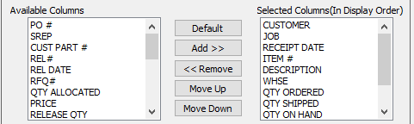

#### Available Columns

The user may choose which columns they wish to have on the report printout. As the user selects their choices, they will appear on the ‘*Selected Columns’* list.

#### Selected Columns (In Display Order)

The columns that the user has chosen from the ‘*Available Columns’* list. The order that these columns are displayed in here is the order in which they will print on the report.

#### Default

Click the ***“Default****”* button to sort the ‘*Selected Columns’* list by the default system parameters.

#### Add >>

Click on the selected item from the ‘*Available Columns’* list to highlight it, then click the ***“Add”*** button to add the selected column to the ‘*Selected Columns’* list.

#### << Remove

Click on the selected item from the ‘*Selected Columns’* list to highlight it, then click the ***“Remove”*** button to remove the selected column to the ‘*Selected Columns’* list.

#### Move Up

Within the ‘*Selected Columns’* list, the user may choose the order they wish the selected columns to print in. In order to change the order of the columns, the user can click on a selection to highlight it. By then clicking the ***“Move Up***” button, the user can change its position on the report.

#### Move Down

Within the ‘*Selected Columns’* list, the user may choose the order they wish the selected columns to print in. In order to change the order of the columns, the user can click on a selection to highlight it. By then clicking the ***“Move Down***” button, the user can change its position on the report.

### Output Destination

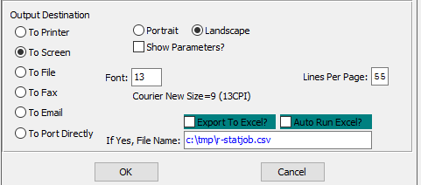

#### Destination Choice

To choose the destination where the document should be printed, please make sure that desired output destination choice bubble is toggled.

#### Layout Choice

To choose the preferred layout of Landscape vs. Portrait, please make sure the desired option choice bubbled is toggled.

#### Lines Per Page

Lines per page on the report when printing.

#### Font

Enter the font number to use with this report (Font 11 is default).

#### Show Parameters? – Toggle Box

To show parameters, make sure that the toggle box is ‘ticked’ with a checkmark.

#### Export to Excel? – Toggle Box

To export the printed file to an excel document, make sure that the Export to Excel toggle box is checked.

#### Auto Run Excel? – Toggle Box

To automatically open the new excel document, make sure that the Auto Run Excel toggle box is checked.

#### If Yes, File Name

If exporting the file to Excel, enter the desired file name.

## Reorder Advice by Ship-To [IL9]

The system bases the upon the quantity on hand, the reorder level, and whether or not the *F/G* item is lot controlled. The quantity-on-hand (plus the quantity-on-order [optionally]) is less than the reorder point, and the item is not lot controlled then reordering advice for the item will print.

### Selection Parameters

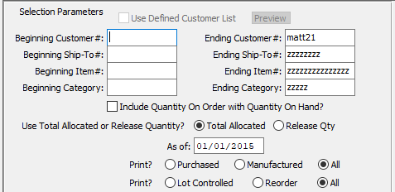

#### Beginning Customer # / Ending Customer #

Enter the starting and ending customer number.

#### Beginning Ship-To # / Ending Ship-To #

Enter the starting and ending ship to number.

#### Beginning Item # / Ending Item #

Enter the starting and ending item number.

#### Beginning Category / Ending Category

Enter the starting and ending category.

#### Include Quantity On Order with Quantity On Hand? – Toggle Box

Please make sure that this toggle box is checked in order to include the quantity on order from Purchasing or Shop Orders to be added to the on-hand quantity. If the cumulative quantity total is less than the reorder level quantity, then the item will print on the reorder advice report so that the product may be manufactured or purchased.

#### Use Total Allocated or Release Quantity? (Choice)

To choose the preferred Quantity of Total Allocated vs. Release, please make sure the desired option choice bubble is toggled.

#### As Of

Enter a date for the start of this report. Any items within the selected parameters after this date will be reported.

#### Print? (Item Type)

To choose the preferred Print Method of Purchased vs. Manufactured (Or All), please make sure the desired option choice bubble is toggled.

#### Print? (Controlled vs Reorder)

To choose the preferred Print Method of Lot Controlled vs. Reorder (Or All), please make sure the desired option choice bubble is toggled.

### Available and Selected Columns

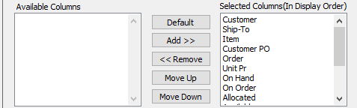

#### Available Columns

The user may choose which columns they wish to have on the report printout. As the user selects their choices, they will appear on the ‘*Selected Columns’* list.

#### Selected Columns (In Display Order)

The columns that the user has chosen from the ‘*Available Columns’* list. The order that these columns are displayed in here is the order in which they will print on the report.

#### Default

Click the ***“Default****”* button to sort the ‘*Selected Columns’* list by the default system parameters.

#### Add >>

Click on the selected item from the ‘*Available Columns’* list to highlight it, then click the ***“Add”*** button to add the selected column to the ‘*Selected Columns’* list.

#### << Remove

Click on the selected item from the ‘*Selected Columns’* list to highlight it, then click the ***“Remove”*** button to remove the selected column to the ‘*Selected Columns’* list.

#### Move Up

Within the ‘*Selected Columns’* list, the user may choose the order they wish the selected columns to print in. In order to change the order of the columns, the user can click on a selection to highlight it. By then clicking the ***“Move Up***” button, the user can change its position on the report.

#### Move Down

Within the ‘*Selected Columns’* list, the user may choose the order they wish the selected columns to print in. In order to change the order of the columns, the user can click on a selection to highlight it. By then clicking the ***“Move Down***” button, the user can change its position on the report.

### Output Destination

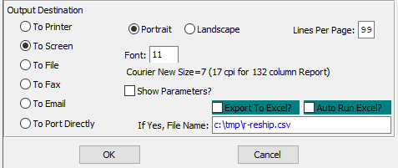

#### Destination Choice

To choose the destination where the document should be printed, please make sure that desired output destination choice bubble is toggled.

#### Layout Choice

To choose the preferred layout of Landscape vs. Portrait, please make sure the desired option choice bubbled is toggled.

#### Lines Per Page

Lines per page on the report when printing.

#### Font

Enter the font number to use with this report (Font 11 is default).

#### Show Parameters? – Toggle Box

To show parameters, make sure that the toggle box is ‘ticked’ with a checkmark.

#### Export to Excel? – Toggle Box

To export the printed file to an excel document, make sure that the Export to Excel toggle box is checked.

#### Auto Run Excel? – Toggle Box

To automatically open the new excel document, make sure that the Auto Run Excel toggle box is checked.

#### If Yes, File Name

If exporting the file to Excel, enter the desired file name.

## Shipment by Customer Part [IL)]

### Selection Parameters

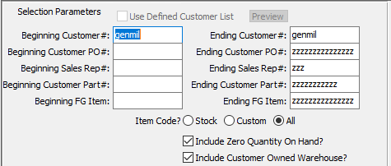

#### Beginning Customer # / Ending Customer #

Enter the starting and ending customer number.

#### Beginning Customer PO # / Ending Customer PO #

Enter the starting and ending customer purchase order number.

#### Beginning Sales Rep # / Ending Sales Rep #

Enter the starting and ending sales representative number.

#### Beginning Customer Part # / Ending Customer Part #

Enter the starting and ending customer part number.

#### Beginning FG Item / Ending FG Item

Enter the starting and ending finished good item.

#### Item Code? (Choice)

To choose the preferred Item Code of Stock vs. Custom (Or All), please make sure the desired option choice bubble is toggled.

#### Include Zero Quantity On Hand? – Toggle Box

To include all items with zero quantity balances, make sure that this toggle box is checked.

#### Include Customer Owned Warehouse? – Toggle Box

To include the quantity owned by the customer with the quantity on hand, please make sure that this toggle box is checked.

### Available and Selected Columns

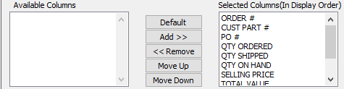

#### Available Columns

The user may choose which columns they wish to have on the report printout. As the user selects their choices, they will appear on the ‘*Selected Columns’* list.

#### Selected Columns (In Display Order)

The columns that the user has chosen from the ‘*Available Columns’* list. The order that these columns are displayed in here is the order in which they will print on the report.

#### Default

Click the ***“Default****”* button to sort the ‘*Selected Columns’* list by the default system parameters.

#### Add >>

Click on the selected item from the ‘*Available Columns’* list to highlight it, then click the ***“Add”*** button to add the selected column to the ‘*Selected Columns’* list.

#### << Remove

Click on the selected item from the ‘*Selected Columns’* list to highlight it, then click the ***“Remove”*** button to remove the selected column to the ‘*Selected Columns’* list.

#### Move Up

Within the ‘*Selected Columns’* list, the user may choose the order they wish the selected columns to print in. In order to change the order of the columns, the user can click on a selection to highlight it. By then clicking the ***“Move Up***” button, the user can change its position on the report.

#### Move Down

Within the ‘*Selected Columns’* list, the user may choose the order they wish the selected columns to print in. In order to change the order of the columns, the user can click on a selection to highlight it. By then clicking the ***“Move Down***” button, the user can change its position on the report.

### Output Destination

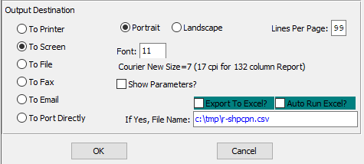

#### Destination Choice

To choose the destination where the document should be printed, please make sure that desired output destination choice bubble is toggled.

#### Layout Choice

To choose the preferred layout of Landscape vs. Portrait, please make sure the desired option choice bubbled is toggled.

#### Lines Per Page

Lines per page on the report when printing.

#### Font

Enter the font number to use with this report (Font 11 is default).

#### Show Parameters? – Toggle Box

To show parameters, make sure that the toggle box is ‘ticked’ with a checkmark.

#### Export to Excel? – Toggle Box

To export the printed file to an excel document, make sure that the Export to Excel toggle box is checked.

#### Auto Run Excel? – Toggle Box

To automatically open the new excel document, make sure that the Auto Run Excel toggle box is checked.

#### If Yes, File Name

If exporting the file to Excel, enter the desired file name.

## FG Packing Detail [IL!]

### Selection Parameters

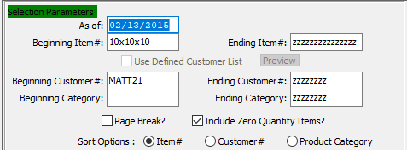

#### As Of

Enter a date for the start of this report. Any items within the selected parameters after this date will be reported.

#### Beginning Item # / Ending Item #

Enter the starting and ending item number.

#### Beginning Customer # / Ending Customer #

Enter the starting and ending customer number.

#### Beginning Category / Ending Category

Enter the starting and ending category.

#### Page Break? – Toggle Box

To break up the pages in the printed report, make sure that the Page Break toggle box is checked.

#### Include Zero Quantity Items? -Toggle Box

To include all items with zero quantity balances, make sure that this toggle box is checked.

#### Sort Options (Choice)

To choose the preferred Sort Option of Item Number vs. Customer Number vs. Product Category, please make sure the desired option choice bubble is toggled.

### Available and Selected Columns

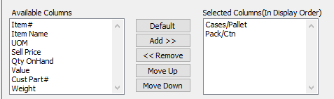

#### Available Columns

The user may choose which columns they wish to have on the report printout. As the user selects their choices, they will appear on the ‘*Selected Columns’* list.

#### Selected Columns (In Display Order)

The columns that the user has chosen from the ‘*Available Columns’* list. The order that these columns are displayed in here is the order in which they will print on the report.

#### Default

Click the ***“Default****”* button to sort the ‘*Selected Columns’* list by the default system parameters.

#### Add >>

Click on the selected item from the ‘*Available Columns’* list to highlight it, then click the ***“Add”*** button to add the selected column to the ‘*Selected Columns’* list.

#### << Remove

Click on the selected item from the ‘*Selected Columns’* list to highlight it, then click the ***“Remove”*** button to remove the selected column to the ‘*Selected Columns’* list.

#### Move Up

Within the ‘*Selected Columns’* list, the user may choose the order they wish the selected columns to print in. In order to change the order of the columns, the user can click on a selection to highlight it. By then clicking the ***“Move Up***” button, the user can change its position on the report.

#### Move Down

Within the ‘*Selected Columns’* list, the user may choose the order they wish the selected columns to print in. In order to change the order of the columns, the user can click on a selection to highlight it. By then clicking the ***“Move Down***” button, the user can change its position on the report.

### Output Destination

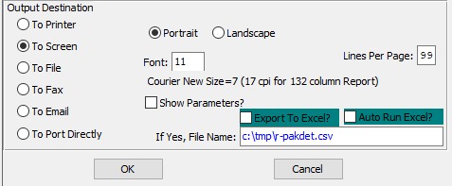

#### Destination Choice

To choose the destination where the document should be printed, please make sure that desired output destination choice bubble is toggled.

#### Layout Choice

To choose the preferred layout of Landscape vs. Portrait, please make sure the desired option choice bubbled is toggled.

#### Lines Per Page

Lines per page on the report when printing.

#### Font

Enter the font number to use with this report (Font 11 is default).

#### Show Parameters? – Toggle Box

To show parameters, make sure that the toggle box is ‘ticked’ with a checkmark.

#### Export to Excel? – Toggle Box

To export the printed file to an excel document, make sure that the Export to Excel toggle box is checked.

#### Auto Run Excel? – Toggle Box

To automatically open the new excel document, make sure that the Auto Run Excel toggle box is checked.

#### If Yes, File Name

If exporting the file to Excel, enter the desired file name.

## Customer Inventory [IL@]

### Selection Parameters

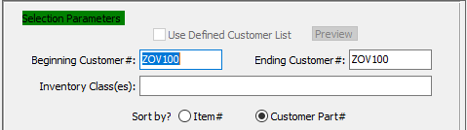

#### Beginning Customer # / Ending Customer #

Enter the starting and ending customer number.

#### Sort By (Choice)

To choose the preferred Sort Method of Item Number vs. Customer Part Number, please make sure the desired option choice bubble is toggled.

### Available and Selected Columns

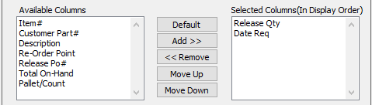

#### Available Columns

The user may choose which columns they wish to have on the report printout. As the user selects their choices, they will appear on the ‘*Selected Columns’* list.

#### Selected Columns (In Display Order)

The columns that the user has chosen from the ‘*Available Columns’* list. The order that these columns are displayed in here is the order in which they will print on the report.

#### Default

Click the ***“Default****”* button to sort the ‘*Selected Columns’* list by the default system parameters.

#### Add >>

Click on the selected item from the ‘*Available Columns’* list to highlight it, then click the ***“Add”*** button to add the selected column to the ‘*Selected Columns’* list.

#### << Remove

Click on the selected item from the ‘*Selected Columns’* list to highlight it, then click the ***“Remove”*** button to remove the selected column to the ‘*Selected Columns’* list.

#### Move Up

Within the ‘*Selected Columns’* list, the user may choose the order they wish the selected columns to print in. In order to change the order of the columns, the user can click on a selection to highlight it. By then clicking the ***“Move Up***” button, the user can change its position on the report.

#### Move Down

Within the ‘*Selected Columns’* list, the user may choose the order they wish the selected columns to print in. In order to change the order of the columns, the user can click on a selection to highlight it. By then clicking the ***“Move Down***” button, the user can change its position on the report.

### Output Destination

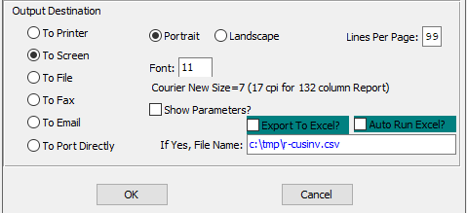

#### Destination Choice

To choose the destination where the document should be printed, please make sure that desired output destination choice bubble is toggled.

#### Layout Choice

To choose the preferred layout of Landscape vs. Portrait, please make sure the desired option choice bubbled is toggled.

#### Lines Per Page

Lines per page on the report when printing.

#### Font

Enter the font number to use with this report (Font 11 is default).

#### Show Parameters? – Toggle Box

To show parameters, make sure that the toggle box is ‘ticked’ with a checkmark.

#### Export to Excel? – Toggle Box

To export the printed file to an excel document, make sure that the Export to Excel toggle box is checked.

#### Auto Run Excel? – Toggle Box

To automatically open the new excel document, make sure that the Auto Run Excel toggle box is checked.

#### If Yes, File Name

If exporting the file to Excel, enter the desired file name.

## Sales Venue by Salesman by Customer [IL#]

### Selection Parameters

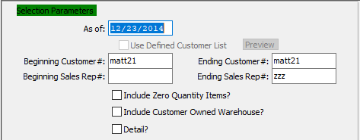

#### As Of

Enter a date for the start of this report. Any items within the selected parameters after this date will be reported.

#### Beginning Customer # / Ending Customer #

Enter the starting and ending customer number.

#### Beginning Sales Rep # / Ending Sales Rep #

Enter the starting and ending sales representative number.

#### Include Zero Quantity Items? – Toggle Box

To include all items with zero quantity balances, make sure that this toggle box is checked.

#### Include Customer Owned Warehouse? – Toggle Box

To include the quantity owned by the customer with the quantity on hand, please make sure that this toggle box is checked.

#### Detail? – Toggle Box

To print a detailed report with all customer and sales representative information, make sure that the Detail toggle box is checked.

### Available and Selected Columns

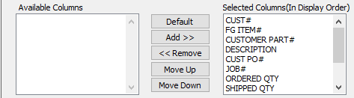

#### Available Columns

The user may choose which columns they wish to have on the report printout. As the user selects their choices, they will appear on the ‘*Selected Columns’* list.

#### Selected Columns (In Display Order)

The columns that the user has chosen from the ‘*Available Columns’* list. The order that these columns are displayed in here is the order in which they will print on the report.

#### Default

Click the ***“Default****”* button to sort the ‘*Selected Columns’* list by the default system parameters.

#### Add >>

Click on the selected item from the ‘*Available Columns’* list to highlight it, then click the ***“Add”*** button to add the selected column to the ‘*Selected Columns’* list.

#### << Remove

Click on the selected item from the ‘*Selected Columns’* list to highlight it, then click the ***“Remove”*** button to remove the selected column to the ‘*Selected Columns’* list.

#### Move Up

Within the ‘*Selected Columns’* list, the user may choose the order they wish the selected columns to print in. In order to change the order of the columns, the user can click on a selection to highlight it. By then clicking the ***“Move Up***” button, the user can change its position on the report.

#### Move Down

Within the ‘*Selected Columns’* list, the user may choose the order they wish the selected columns to print in. In order to change the order of the columns, the user can click on a selection to highlight it. By then clicking the ***“Move Down***” button, the user can change its position on the report.

### Output Destination

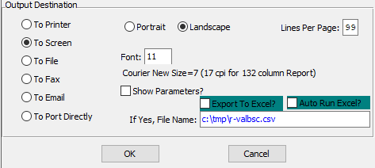

#### Destination Choice

To choose the destination where the document should be printed, please make sure that desired output destination choice bubble is toggled.

#### Layout Choice

To choose the preferred layout of Landscape vs. Portrait, please make sure the desired option choice bubbled is toggled.

#### Lines Per Page

Lines per page on the report when printing.

#### Font

Enter the font number to use with this report (Font 11 is default).

#### Show Parameters? – Toggle Box

To show parameters, make sure that the toggle box is ‘ticked’ with a checkmark.

#### Export to Excel? – Toggle Box

To export the printed file to an excel document, make sure that the Export to Excel toggle box is checked.

#### Auto Run Excel? – Toggle Box

To automatically open the new excel document, make sure that the Auto Run Excel toggle box is checked.

#### If Yes, File Name

If exporting the file to Excel, enter the desired file name.

## Warehouse Item Audit List [IL$]

### Inventory by Warehouse

The finished goods inventory table allows defining reorder levels by warehouse. The reorder advise report has a toggle box to calculated inventory requirements by warehouse. If this toggle box is not checked, the report may show the inventory levels are adequate when in fact, a specific warehouse may be below levels sufficient to satisfy local customer’s demands.

The key to reordering by warehouse is to set reorder levels by warehouse for each item. The Advantzware software will update each warehouse when adding orders, updating release quantities and finished goods movements. The Inventory table now store quantities on hand, on order, allocated and available for each warehouse.

In order to allocate inventory quantities by warehouse, the customer service representative must indicate what warehouse will deliver the product. The ***“Ship-To”*** code added on the release will import the warehouse defined in the customers ship-to file for automatic allocation by warehouse. However, the SHIPTO may be changed or multiple shipping locations may be added to the release screen, thereby updating the specific warehouses allocated quantity.

The finished goods Bins/Jobs table will show a quantity on hand grand total of ALL warehouse or allow the user to select a specific warehouse to display the pallet tags on hand for each job.

### Selection Parameters

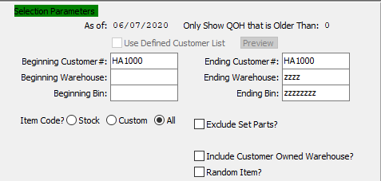

#### Beginning Customer # / Ending Customer #

Enter the starting and ending customer number.

#### Beginning Warehouse / Ending Warehouse

Enter the starting and ending warehouse.

#### Beginning Bin / Ending Bin

Enter the starting and ending bin.

#### Item Code? (Choice)

To choose the preferred Item Code of Stock vs. Custom (Or All), please make sure the desired option choice bubble is toggled.

#### Exclude Set Parts? – Toggle Box

To exclude set parts from the audit report, make sure that the Exclude Set Parts toggle box is checked.

#### Include Customer Owned Warehouse? – Toggle Box

To include the quantity owned by the customer with the quantity on hand, please make sure that this toggle box is checked.

#### Random Item? – Toggle Box

To include random items that do not have a set bin, make sure that the Random Item toggle box is checked.

### Available and Selected Columns

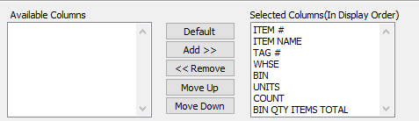

#### Available Columns

The user may choose which columns they wish to have on the report printout. As the user selects their choices, they will appear on the ‘*Selected Columns’* list.

#### Selected Columns (In Display Order)

The columns that the user has chosen from the ‘*Available Columns’* list. The order that these columns are displayed in here is the order in which they will print on the report.

#### Default

Click the ***“Default****”* button to sort the ‘*Selected Columns’* list by the default system parameters.

#### Add >>

Click on the selected item from the ‘*Available Columns’* list to highlight it, then click the ***“Add”*** button to add the selected column to the ‘*Selected Columns’* list.

#### << Remove

Click on the selected item from the ‘*Selected Columns’* list to highlight it, then click the ***“Remove”*** button to remove the selected column to the ‘*Selected Columns’* list.

#### Move Up

Within the ‘*Selected Columns’* list, the user may choose the order they wish the selected columns to print in. In order to change the order of the columns, the user can click on a selection to highlight it. By then clicking the ***“Move Up***” button, the user can change its position on the report.

#### Move Down

Within the ‘*Selected Columns’* list, the user may choose the order they wish the selected columns to print in. In order to change the order of the columns, the user can click on a selection to highlight it. By then clicking the ***“Move Down***” button, the user can change its position on the report.

### Output Destination

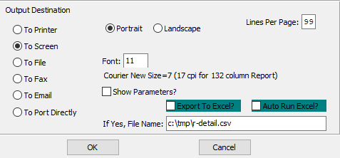

#### Destination Choice

To choose the destination where the document should be printed, please make sure that desired output destination choice bubble is toggled.

#### Layout Choice

To choose the preferred layout of Landscape vs. Portrait, please make sure the desired option choice bubbled is toggled.

#### Lines Per Page

Lines per page on the report when printing.

#### Font

Enter the font number to use with this report (Font 11 is default).

#### Show Parameters? – Toggle Box

To show parameters, make sure that the toggle box is ‘ticked’ with a checkmark.

#### Export to Excel? – Toggle Box

To export the printed file to an excel document, make sure that the Export to Excel toggle box is checked.

#### Auto Run Excel? – Toggle Box

To automatically open the new excel document, make sure that the Auto Run Excel toggle box is checked.

#### If Yes, File Name

If exporting the file to Excel, enter the desired file name.

## Aged Inventory w/ WIP [IL%]

### Selection Parameters

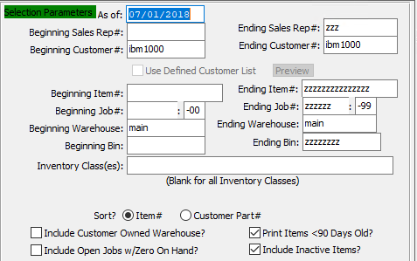

#### As Of

Enter a date for the start of this report. Any items within the selected parameters after this date will be reported.

#### Beginning Sales Rep # / Ending Sales Rep #

Enter the starting and ending sales representative number.

#### Beginning Customer # / Ending Customer #

Enter the starting and ending customer number.

#### Beginning Item # / Ending Item #

Enter the starting and ending item number.

#### Beginning Job # / Ending Job #

Enter the starting and ending job number.

#### Beginning Job #: 00 / Ending Job #: 00

Enter the starting and ending subsequent job number.

#### Beginning Warehouse / Ending Warehouse

Enter the starting and ending warehouse.

#### Beginning Bin / Ending Bin

Enter the starting and ending bin.

#### Sort? (Choice)

To choose the preferred Sort Method of Item Number vs. Customer Part Number, please make sure the desired option choice bubble is toggled.

#### Include Customer Owned Warehouse? – Toggle Box

To include the quantity owned by the customer with the quantity on hand, please make sure that this toggle box is checked.

#### Include Open Jobs w/ Zero On Hand? – Toggle Box

To include open jobs that are waiting for items to get back in stock, make sure that this toggle box is checked.

#### Print Items < 90 Days Old? – Toggle Box

To print items that are newer than 90 days old, make sure that this toggle box is checked.

#### Include Inactive Items? – Toggle Box

To include inactive items in the report, make sure that the Include Inactive Items toggle box is checked.

### Available and Selected Columns

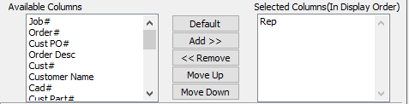

#### Available Columns

The user may choose which columns they wish to have on the report printout. As the user selects their choices, they will appear on the ‘*Selected Columns’* list.

#### Selected Columns (In Display Order)

The columns that the user has chosen from the ‘*Available Columns’* list. The order that these columns are displayed in here is the order in which they will print on the report.

#### Default

Click the ***“Default****”* button to sort the ‘*Selected Columns’* list by the default system parameters.

#### Add >>

Click on the selected item from the ‘*Available Columns’* list to highlight it, then click the ***“Add”*** button to add the selected column to the ‘*Selected Columns’* list.

#### << Remove

Click on the selected item from the ‘*Selected Columns’* list to highlight it, then click the ***“Remove”*** button to remove the selected column to the ‘*Selected Columns’* list.

#### Move Up

Within the ‘*Selected Columns’* list, the user may choose the order they wish the selected columns to print in. In order to change the order of the columns, the user can click on a selection to highlight it. By then clicking the ***“Move Up***” button, the user can change its position on the report.

#### Move Down

Within the ‘*Selected Columns’* list, the user may choose the order they wish the selected columns to print in. In order to change the order of the columns, the user can click on a selection to highlight it. By then clicking the ***“Move Down***” button, the user can change its position on the report.

### Output Destination

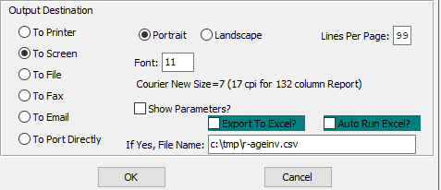

#### Destination Choice

To choose the destination where the document should be printed, please make sure that desired output destination choice bubble is toggled.

#### Layout Choice

To choose the preferred layout of Landscape vs. Portrait, please make sure the desired option choice bubbled is toggled.

#### Lines Per Page

Lines per page on the report when printing.

#### Font

Enter the font number to use with this report (Font 11 is default).

#### Show Parameters? – Toggle Box

To show parameters, make sure that the toggle box is ‘ticked’ with a checkmark.

#### Export to Excel? – Toggle Box

To export the printed file to an excel document, make sure that the Export to Excel toggle box is checked.

#### Auto Run Excel? – Toggle Box

To automatically open the new excel document, make sure that the Auto Run Excel toggle box is checked.

#### If Yes, File Name

If exporting the file to Excel, enter the desired file name.

## FG Executive Summary [IL^]

### Selection Parameters

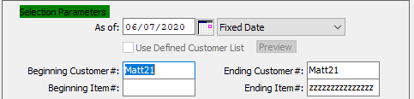

#### As Of

Enter a date for the start of this report. Any items within the selected parameters after this date will be reported.

#### Date Type

The user may enter the type of date they wish to include in the report. They may choose from this drop-down menu.

#### Beginning Customer # / Ending Customer #

Enter the starting and ending customer number.

#### Beginning Item # / Ending Item #

Enter the starting and ending item number.

### Available and Selected Columns

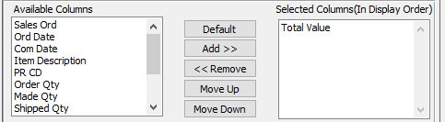

#### Available Columns

The user may choose which columns they wish to have on the report printout. As the user selects their choices, they will appear on the ‘*Selected Columns’* list.

#### Selected Columns (In Display Order)

The columns that the user has chosen from the ‘*Available Columns’* list. The order that these columns are displayed in here is the order in which they will print on the report.

#### Default

Click the ***“Default****”* button to sort the ‘*Selected Columns’* list by the default system parameters.

#### Add >>

Click on the selected item from the ‘*Available Columns’* list to highlight it, then click the ***“Add”*** button to add the selected column to the ‘*Selected Columns’* list.

#### << Remove

Click on the selected item from the ‘*Selected Columns’* list to highlight it, then click the ***“Remove”*** button to remove the selected column to the ‘*Selected Columns’* list.

#### Move Up

Within the ‘*Selected Columns’* list, the user may choose the order they wish the selected columns to print in. In order to change the order of the columns, the user can click on a selection to highlight it. By then clicking the ***“Move Up***” button, the user can change its position on the report.

#### Move Down

Within the ‘*Selected Columns’* list, the user may choose the order they wish the selected columns to print in. In order to change the order of the columns, the user can click on a selection to highlight it. By then clicking the ***“Move Down***” button, the user can change its position on the report.

### Output Destination

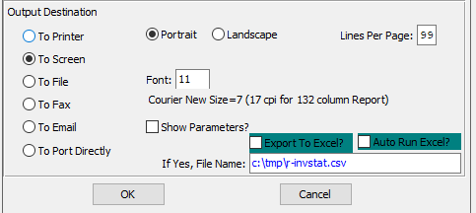

#### Destination Choice

To choose the destination where the document should be printed, please make sure that desired output destination choice bubble is toggled.

#### Layout Choice

To choose the preferred layout of Landscape vs. Portrait, please make sure the desired option choice bubbled is toggled.

#### Show Parameters? – Toggle Box

To show parameters, make sure that the toggle box is ‘ticked’ with a checkmark.

#### Export to Excel? – Toggle Box

To export the printed file to an excel document, make sure that the Export to Excel toggle box is checked.

#### Auto Run Excel? – Toggle Box

To automatically open the new excel document, make sure that the Auto Run Excel toggle box is checked.

#### If Yes, File Name

If exporting the file to Excel, enter the desired file name.

# **File Maintenance for Items [IF]**

## Finished Good Item [IF1]

### Overview

The item file maintains all data for each finished goods item sold to customers. Adding, deleting, changing and viewing information is performed with the function keys on the menu bar at the bottom of the screen. The find key provides the capability to search for an item by item name, customer, customer part number, purchase order number, die number, etc. simply by pressing ***“F”*** (Find).

Special attention should be used when creating the item name. For custom boxes, the item name will automatically transfer from the estimate item name entered. The item name description is used for many alpha-Alphanumeric searches throughout the system. For this reason, the description entered should be consistent.

For example, ice cream boxes could start as Ice Cream Box, Vanilla, or Vanilla Ice Cream Box. To search for all ice cream boxes, the description must start with Ice Cream, otherwise: Vanilla, Chocolate and Strawberry would not be listed together.

Please Note: For stock boxes, the item name must be manually entered.

For Stock boxes or custom boxes that are produced based on a minimum stocking level, the reorder fields provide automatic reordering advised reporting. When the quantity available (on hand + on order less allocated) falls below the reorder level, that item is listed on the reorder advise report recommending either a manufacturing shop order or a purchase order to be placed. Upon issuance, the system checks minimum and maximum order quantities to prevent uneconomical production or purchasing levels.

### Browse Items

The browser screen shows all the existing item numbers, names, CAD numbers, estimate numbers, item codes, cat, SPC number and style in the system starting with the most recent and descending to the oldest. To view the first/last, press the ***“End”*** key or ***“Home”*** key or click the icon with the circling arrows to sort ascending, then descending.

Please Note: The ability to edit bins is now controlled by permission settings for the program master 'FgiJob'.

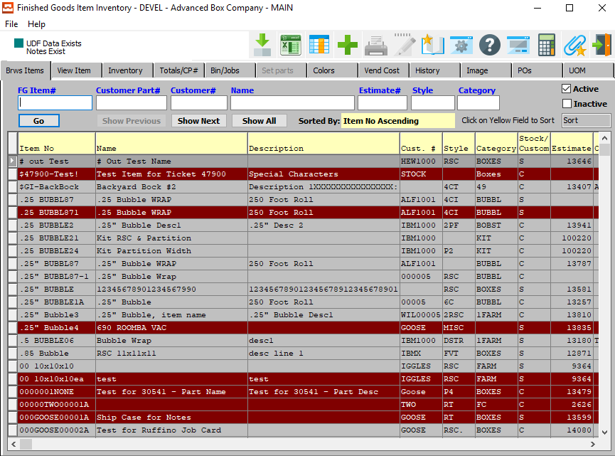

To search, press the tab key until the cursor is positioned on the desired field. Type a few characters that determine where you want the search to begin, then press either ***“F1”*** or ***“Enter”***.

For example, to show all items for Smith company, press the Tab key until the cursor is blinking on the customer field, type Smith and press ***“F1”***. All items for Smith company are displayed in alphabetical order. To select a particular item, press your ***arrow*** keys until the desired item is highlighted, then press ***“Enter”***.

The items record may now be viewed, changed or deleted by pressing ***"C"*** (Change) or ***"D"*** (Delete). The ***“Enter”*** key will move the cursor from field to field, however the ***“F1”*** key will move the cursor from one block of data to the next. The ***"N"*** (Next) and ***"P"*** (Previous) keys will access the next and previous items in alphabetical order based on the item code. The ***"T"*** (Totals) key will display year to date and period to date inventory quantities and the ***"B"*** (Bin) key will show all on hand quantities by warehouse, bin and tag/pallet number.

#### ADD

Click the ***“Green + Icon”*** at the top of the page to add a new item.

### Browse Item Field Definitions

#### FG Item #

Enter the FG item number or you may use the ***“F1”*** look-up. A partial description may be typed into any field or data may be entered into multiple fields followed by pressing the ***“Go”*** button to sort the fields by the criteria that was entered. Once the data is presented on the screen, the YELLOW column heading may be clicked to sort that specific column in ascending or descending order.

#### Customer Part #

Enter the customer part number. A partial description may be typed into any field or data may be entered into multiple fields followed by pressing the ***“Go”*** button to sort the fields by the criteria that was entered. Once the data is presented on the screen, the YELLOW column heading may be clicked to sort that specific column in ascending or descending order.

#### Customer #

Enter customer number or you may use the ***“F1”*** look-up. A partial description may be typed into any field or data may be entered into multiple fields followed by pressing the ***“Go”*** button to sort the fields by the criteria that was entered. Once the data is presented on the screen the YELLOW column heading may be clicked to sort that specific column in ascending or descending order.

#### Name

Enter the FG name that you want to search for.

#### Estimate #

Enter the estimate number or you may use the ***“F1”*** look-up. A partial description may be typed into any field or data may be entered into multiple fields followed by pressing the ***“Go”*** button to sort the fields by the criteria that was entered. Once the data is presented on the screen, the YELLOW column heading may be clicked to sort that specific column in ascending or descending order.

#### Active? – Toggle Box

To include active items, make sure that the Active toggle box is checked.

#### Inactive? – Toggle Box

To include inactive items, make sure that the Inactive toggle box is checked.

### View Item

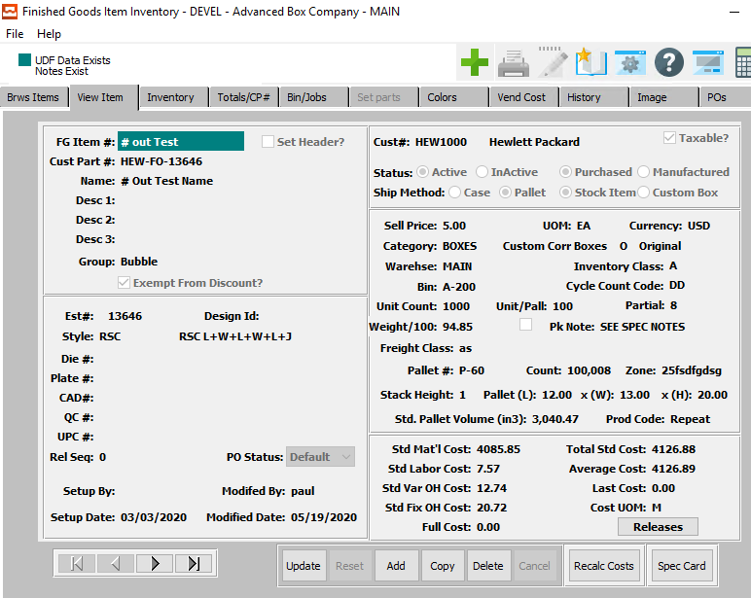

#### UPDATE

Click the ***“Update”*** button to update the currently selected item.

#### ADD

Click the ***“Add”*** button to add a new item. Alternatively, click the ***“Green + Icon”*** at the top of the page.

#### COPY

Click the ***“Copy”*** button to copy information from the currently selected item.

#### DELETE

Click the ***“Delete”*** button to delete the currently selected item.

#### RECALC COSTS

Press the ***“Recalc. Costs”*** button to recalculate all costs for the current item after making updates it it.

#### SPEC CARD

Click the ***“Spec Card”*** button to print off a specification card detailing the current item.

#### NEXT

Press ***"N"*** (Next) to find next item to view or modify. Alternatively, press the ***“Right Arrow”*** on the screen.

#### PREVIOUS

Press ***"P"*** (Previous) to find previous item to view or modify. Alternatively, press the ***“Left Arrow”*** on the screen.

### Add/Update Item

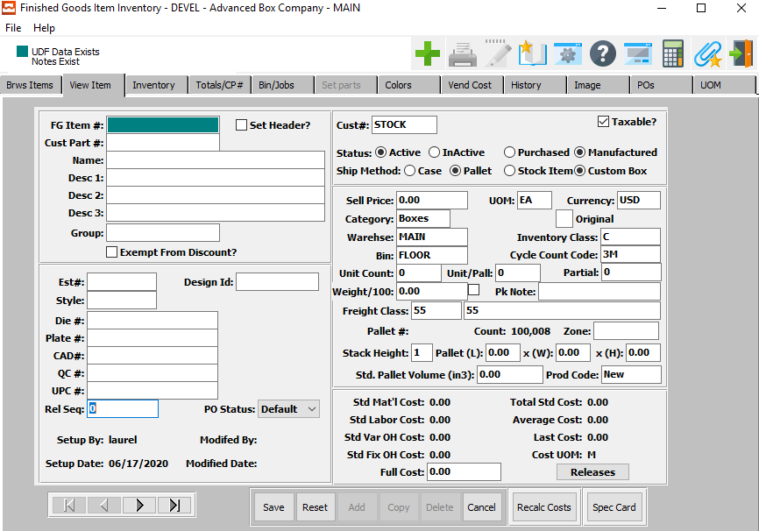

#### SAVE

Click the “***Save***” button to save the current item.

#### RESET

Click the “***Reset***” button to reset all changes to the item.

#### CANCEL

Click the “***Cancel***” button to cancel the item without saving changes.

#### NEXT

Press ***"N"*** (Next) to find next item to view or modify. Alternatively, press the ***“Right Arrow”*** on the screen.

#### PREVIOUS

Press ***"P"*** (Previous) to find previous item to view or modify. Alternatively, press the ***“Left Arrow”*** on the screen.

#### RECALC COSTS

Press the ***“Recalc. Costs”*** button to recalculate all costs for the current item after making updates it it.

#### SPEC CARD

Click the ***“Spec Card”*** button to print off a specification card detailing the current item.

### Add/Update Item Field Definitions

#### FG Item #

The Item code must be unique within each company. The Item Number code is key to all Finished Goods transactions and links the product on the estimate to a finished goods item. If the estimator enters or creates a finished goods number that does not exist, the system will prompt to create the item, whereby critical data such as item description, style, dimensions, colors, customer, cad number, etc. are downloaded to the item file.

If the estimator enters a finished goods item that already exists, then the item specifications will transfer to the new estimate from the existing estimate. The system can automatically create the item code via the cost estimate. However, this should be created manually for purchased stock items that are sold to multiple customers.

The network administration, control parameter N-K-1 FGITEM has numerous options for creating the fifteen-character item code, which includes matching the customer part#, or a manual entry or a sequential number combined with the product line/category and customer code. The benefit of the sequential number is that multiple part items have identical character except the last 3, which keeps the items together on reports and inquiries. The finished good's item number is used for numerous sales, inventory and production reports throughout the system.

Please Note: Once the FG Item code has been created, it can only be changed by the N-Q-3 utility, which will update all database files including the all history tables.

#### Customer Part #

This is the code that the customer references this item, whereas the finished goods item code is the box plants specific identifier. Most purchase orders sent by the client will display their part number and this may be required on business forms such as the quote, bill of lading and invoice.

The customer part number transfers to the finished good item record from cost estimating when entering an order for an estimate. This field is also used for alpha-numeric searches and inquiries throughout the system.

#### Name

The item name defaults from the Finished Goods file.

#### Description

This Item Description line repeats twice. The descriptions transfer from the estimate for custom boxes. However, they must be entered for stock boxes. Only the first line transfers to the order, job ticket, purchase order and the other reports.

When adding customer orders from an estimate, the description fields will transfer to the order entry line as well as to the finished good's item record. The description fields can be programmed to also print on various business forms such as the quotation, order acknowledgment, release ticket, job ticket, bill of lading, invoice as well as reports throughout the system.

Please Note: Once the FG Item code has been created, the best practice to update the Item Description is to update the item name in the I-F-1 Finished Goods file, whereby the system synchronizes the description with the order and the estimate.

#### Exempt from Discount? – Toggle Box

To exempt the current item from all applicable discounts, make sure that the Exempt from Discount toggle box is checked.

#### Estimate #

This is the estimate number transferred from cost estimating when entering an order for a custom box; it must be entered when creating stock boxes. For stock Boxes, optionally, press “***F1”*** to search, or the ***“Page Up”*** / ***“Page Down”*** keys to scroll through the Estimate file. Press the “***Enter***” key to accept the Estimate displayed on the screen. The system uses this field for alpha-Alphanumeric searches and inquiries.

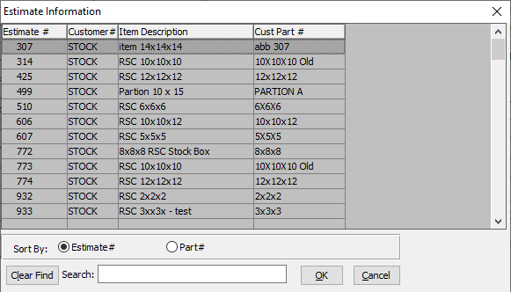

This list can be sorted by Estimate Number or Part Number. Alternatively, the user may search for a number that they wish to use in order to narrow down their selection.

As soon as the user makes their selection, or finishes manually entering a valid Estimate, many subsequent fields will automatically fill with necessary information.

#### Plate #

This is the plate number transferred from cost estimating when an order is entered for a custom box, however it must be entered for stock boxes. This field is also used for alpha-Alphanumeric searches and inquiries throughout the system.

#### CAD #

This is the Cad-Cam or Sample number transferred from cost estimating when entering an order for a custom box; it must be entered for stock boxes. This field is also used for alpha-Alphanumeric searches and inquiries throughout the system.

#### Style

Enter a valid style number from the style file. Optionally, press “***F1”*** to search, or the ***“Page Up”*** / ***“Page Down”*** keys to scroll through the Style file. Press the “***Enter***” key to accept the Style displayed on the screen. This Style transfers from the estimate for custom boxes, however the user must enter the style for stock boxes.

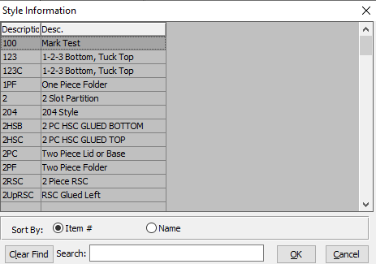

This list can be sorted by Item Number or Item Name. Alternatively, the user may search for what they wish to use in order to narrow down their selection.

#### Die #

This is the die number transferred from cost estimating when entering an order for a custom box; it must be entered for stock boxes. This field is used for alpha-Alphanumeric searches and inquiries throughout the system.

#### QC #

This is the quality control or statistical process control number transferred from cost estimating when entering an order for a custom box; it must be entered for stock boxes. This field is also used for alpha-Alphanumeric searches and inquiries throughout the system.

#### UPC #

This is the universal product code (UPC) number transferred from cost estimating when entering an order for a custom box; it must be entered for stock boxes. This field is also used for alpha-Alphanumeric searches and inquiries throughout the system.

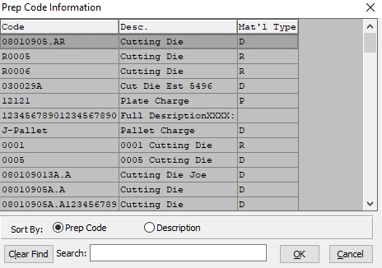

This list can be sorted by Prep Code or Description. Alternatively, the user may search for what they wish to use in order to narrow down their selection.

#### PO Status

This is to prevent the creation of a purchase order for any Finished Goods item. The use for this would be phasing out a certain item, or just preventing that item from being purchased without changing the item PO Status.

Select an option of the PO Status to indicate the type of purchase orders that can be done for an item with the following options:

|  |  |
| --- | --- |
| Default | This would allow the item to be controlled using the N-K-1 OEAutoFG values that drive automatic Po creation in order entry. Creation of the purchase order during order entry for purchased FARM Out Items would proceed with the existing logic. |
| Locked | This would prevent the item from being ordered on a purchase order to the vendor either manually or via order entry via the N-K-1 OEAutoFG parameter logic. If the item is entered on a purchase order line, a message will be presented to the user 'This item is locked for ordering until it is removed from Locked Purchasing status' and the line item will be cancelled from the order. |
| No Auto | This would require a manual creation of a Vendor purchase order via P-U-1 for the item and would not allow the item to be ordered automatically regardless of the settings for automated PO creation via the parameter named N-K-1 OEAutoFG. |

This type of purchase order will need approval before it can be printed or sent to a vendor. Security by User Group or by User ID can be added to dictate access to the ***“Hold”*** / ***“Release”*** button.

#### Setup By

The username of the original user that created this item.

#### Setup Date

The original date of the creation of this item.

#### Modified By

The username of the last user that update information for this item.

#### Modified Date

The last date that a user updated information for this item.

#### Customer #

For purchased items, the customer code should be set to the Box plant customer code which has a status of X. The customer code will transfer from the estimate. The estimator must enter the customer code or search for a customer by pressing ***“F1”*** key.

To limit the search, type the first few letters of the customer code, then press ***“F1”***. The customer search browser will appear, then type additional letters to further limit the search or double click one of the customers listed on the customer browser.

To add a new customer, just enter the code and press enter, our system will then ask you to create this customer. Once entered, the customer name, address, city, state, zip and salesman will transfer to the estimate and then to the quote file.

To estimate prospective customers, the customer code TEMP, which is abbreviated for temporary, may be used to create estimates without creating customers in the accounts receivable file. It is recommended to create a new ship to code for each new temporary customer, which will provide a database of prospective customers that may be used for marketing purposes.

The TEMP customer allows modification to the company name and address. Orders cannot be placed for the TEMP customer. The estimator must first replace the TEMP code with a valid customer code. When an order is entered for an estimate, the customer information will transfer to the finished goods items record so that customer inventory reporting and sales analysis are available.

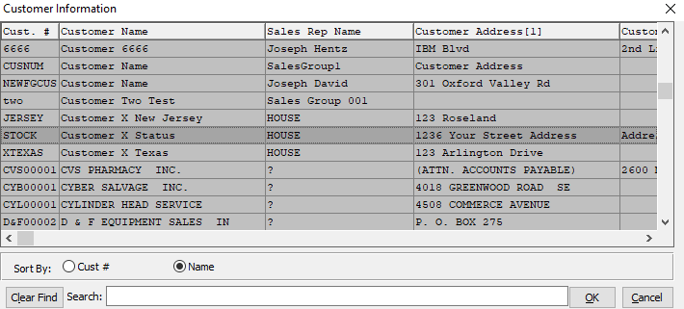

This list can be sorted by Customer Number or Customer Name. Alternatively, the user may search for what they wish to use in order to narrow down their selection.

#### Taxable? – Toggle Box

If this item is eligible for taxes, make sure that the Taxable toggle box is checked.

#### Order Status (Choice)

To choose the preferred order status of Active vs. Inactive, please make sure the desired option choice bubble is toggled.

#### Item Status (Choice)

To choose the preferred item status of Purchased vs. Manufactured, please make sure the desired option choice bubble is toggled.

#### Ship Method (Choice)

To choose the preferred ship method of Case vs. Pallet, please make sure the desired option choice bubble is toggled.

#### Order Status (Choice)

To choose the preferred item status of Stock Item vs. Custom, please make sure the desired option choice bubble is toggled.

#### Sell Price

Enter the price per the selling unit of measure. This transfers from the order for custom boxes; the user must enter the selling price for stock boxes.

#### UOM

The sell price unit of measure defaults to M for per thousand, however this may be modified. Each unit of measure will yield a different total selling price.

Valid Units of Measure are:

|  |  |
| --- | --- |
| C | Per Hundred |
| CS | Per Case |
| EA | Per Each |
| L | Per Lot |
| M | Per Thousand |

#### Currency

Enter the currency code.

#### Category

Finished Goods Categories are created under the I-F-3 menu to create group of similar products. Most common groups are boxes, kits, foam, tape, supplies, parts, etc. Press the F1 key to search for an existing category for this product. Sales commissions by sales representative may be defined by customer and product category. Many inventory reports, sales reports, production reports and general ledger reporting may be filtered by the product category. The 1st letter of the product category can be used as 1st letter of the finished goods item code if that option is selected in the N-K-1 FGItem parameter. The product category will transfer to the finished goods item record when the item is created. There can be one or more product categories assigned to a product line in the job cost file for automatic general ledger creation of standard costs for cost of goods sold, work in process, finished goods, actual costs and efficiency variances.

Enter a valid category from the Product Category file. Optionally, press “***F1”*** to search, or the ***“Page Up”*** / ***“Page Down”*** keys to scroll through the Product Category file. Press the “***Enter***” key to accept the Product Category displayed on the screen. This transfers from the estimate for custom boxes; it must be entered for stock boxes. Many inventory, sales and job costing reports are available by product category.

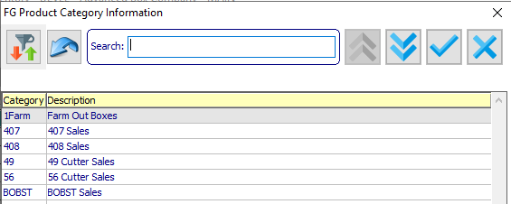

#### Order Status

Enter the code for the order status type. Alternatively, the user may press the ***“F1”*** key to select a code from a list of available Order Types.

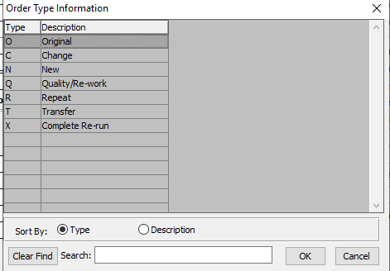

This list can be sorted by Type Code or Description. Alternatively, the user may search for what they wish to use in order to narrow down their selection.

#### Warehouse

To list the exact tag, bin and warehouse on the Release ticket, the warehouse location may be entered, otherwise leave blank. The location may be searched by pressing the [F1] key or Page Up/Page Down keys.

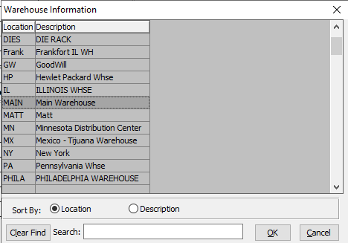

This list can be sorted by Warehouse Location or Warehouse Description. Alternatively, the user may search for what they wish to use in order to narrow down their selection.

#### Bin

Enter valid Bin from Bin file. Optionally, Press the [F1] key to search through, or the page up/down keys to scroll through the Bin file. Press the [Enter] key to accept the Bin displayed on the screen.

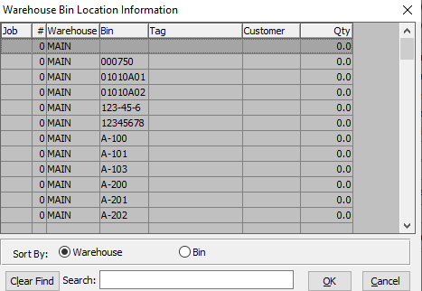

This list can be sorted by Warehouse or Bin. Alternatively, the user may search for what they wish to use in order to narrow down their selection.

#### Inventory Class

Enter user defined code for customizing reports. Alternatively, the user may press the ***“F1”*** key to select a finished good class from a list of available Classes.

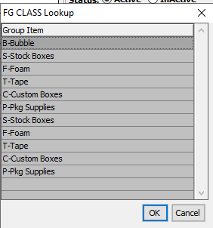

#### Cycle Count Code

Enter a user defined code for grouping categories of Finished Goods. A worksheet will print sorted by cycle count code for taking a physical inventory. Utilizing this method allows counting inventory by logical categories. Alternatively, the user may press the ***“F1”*** key to select a code from a list of available Finished Good Cycle Count Codes.

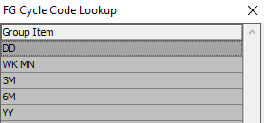

#### Unit Count

This refers to the case count, bundle count or pallet count depending on the finished goods item.

For folding carton boxes this would represent the quantity of boxes packed in a corrugated case also known as the case count. The case count transfers from the estimate when entering a customer order for a custom box.

For corrugated boxes most customers ship the entire pallet, therefore the count for manufactured corrugated boxes would represent the pallet or bale count also known as the unit count.

For distribution items that are purchased and resold such as bubble wrap, tape, peanut, foam, stock boxes, etc., this would be the unit count of how this is shipped. This would be manual entered for stock boxes.

Please Note: the number of pallets needed for freight calculation purposes will take the quantity divided by the count to yield the number of units to ship. The number of units are then divided by the units/pallet (i.e. cases per pallet).

#### Unit/Pallet

Enter the quantity of cases per pallet. On number of cases are computed, the number of cases per pallet are calculated number of cases per pallet.

#### Partial

Enter a partial quantity for the item.

#### Weight/100

Once all the items are entered by tag number, the weight per tag or total weight and freight charge per hundred weight may be entered. This will also transfer to the invoice.

#### Pack Note

Enter special notes regarding packing instructions. Packaging notes may be used to prompt for the color of the label to be applied to a corrugated case when ordering case labels via O-U-10 hot keys.

#### Freight Class

Enter the freight class. Alternatively, the user may press the ***“F1”*** key to select a class from a list of available Freight Classes.

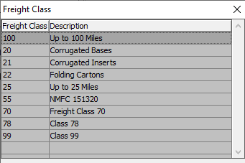

#### Zone

Enter the Delivery Zone. Alternatively, the user may press the ***“F1”*** key to select a zone from a list of available Delivery Zones.

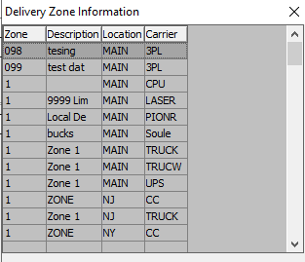

#### Stack Height

This is the number of pallets stack on top of one another.

#### Pallet (Length)

Enter the length of a single pallet.

#### Pallet (Width)

Enter the width of a single pallet.

#### Pallet (Height)

Enter the height of a single pallet.

#### Standard Pallet Volume

Enter the standard pallet volume here.

#### Product Code

Enter a user defined production code used to group items for customizing your own production reports. Alternatively, the user may press the ***“F1”*** key to select a code from a list of available Finished Good Production Codes..

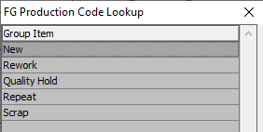

#### Full Cost

This is the cumulative standard cost of goods for all items invoiced through customer billing. The system maintains costs of goods sold, in the inventory module, for the current period, for the year-to-date, for last year. This field is a supplement to the normal finished goods costs field.

This is best used for purchased items to add extra costs for freight and shipping and handling above the actual cost from the vendor. The O-R-6 commission report has a Toggle Box called use FULL COST? To be used in place of the finished goods cost. The order will show the Full Cost as well as the job cost or vendors purchase cost. The Invoice will post both costs to the Accounts Receivable History File.

### Print Spec Card

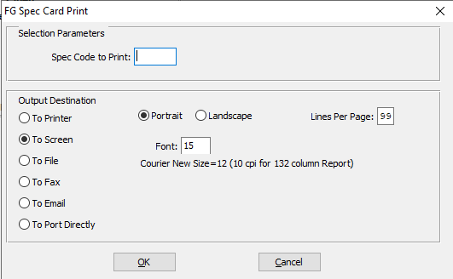

#### Spec Code to Print

Enter a specification code to print the card for.

#### Destination Choice

To choose the destination where the document should be printed, please make sure that desired output destination choice bubble is toggled.

#### Layout Choice

To choose the preferred layout of Landscape vs. Portrait, please make sure the desired option choice bubbled is toggled.

#### Lines Per Page

Lines per page on the report when printing.

#### Font

Enter the font number to use with this report (Font 11 is default).

### Inventory Overview

The Inventory Tab of the item file displays the summary balances for all warehouses. The All Warehouse is a grand total of all balances for all warehouses. The DROP DOWN arrow provides an option to view inventory quantities for each warehouse.

Customer order entry increases the quantity allocated for all warehouses, however, the release quantity and SHIP FROM warehouse in the RELEASE tab increases the quantity allocated by warehouse. Creating or updated Jobs or adding purchase orders for a finished good will increase the ON ORDER level for that warehouse whereas Inventory Receipts will increase on hand and reduce on order quantity by location. Likewise, shipments via bill of ladings will subtract on hand by the exact warehouse the goods were shipped and reduce quantity allocated for that warehouse.

Each finished goods item can have a reorder level based on all warehouse locations as well as specific reorder levels and lead times for each warehouse. This provides the ability to print reorder advise reporting by warehouse, whereby the California warehouse may have a reorder level of 5000 whereas the New York location may have a reorder level of 25,000 and the software will only show the items to replenish by warehouse that fall below that level.

For Stock boxes or custom boxes that are produced based on a minimum stocking level, the reorder fields are used for reordering advised reporting. When the quantity available (on hand + on order less allocated) falls below the reorder level, that item is listed on the reorder advise report recommending either a manufacturing shop order or a purchase order to be placed. Upon issuance, the system prints both minimum and maximum order quantities to prevent uneconomical production or purchasing levels.

@@

Vendor Codes are better to be added to the VEND COST tab. The Purchased or Manufactured toggle box dictates items as manufactured in house or purchased for resale which is used to categorize items or reporting. The Stocked toggle box is used to dictate items that are controlled via a pretextual inventory control whereas Non-Stocked items would be have this toggle box unchecked indicating the plant does not desire to keep an on-hand balance. Various reports allow inclusion of stocked vs non stocked items to limit the items reported.

Sets may be either unassembled or assembled or assembled with Parts. An Assembled set is a set that is built from each component. When receiving to an assembled set, the system will look at the quantities in each component and then verify the set header can be received. Finished Goods receipts for Assembled Sets will require component part receipts on hand and posted first.

Assembled Set receipts posting would then increase the set receipt quantity and simultaneously reduce the parts inventory. Assembled Sets w/Parts receipts will not require the components to be on hand. SET receipts that are assembled with Parts will create the component receipts will be increased and simultaneously decreased by the components required for each set.

Unassembled Sets are receipts should not or need not be added, but if they are, they will add a positive and negative quantity for each component part and increase set quantity on hand inventory. Normally, the unassembled set item is not shipped as only the components are shipped. Once all items are shipped the software will automatically invoice for the total sets shipped.

Shipments via bill of lading work differently for assembled vs unassembled. Assembled sets will only set quantity on hand for Assembled Sets whereas shipments for Unassembled Sets will reduce both the set and the component inventory.

### Inventory Screen

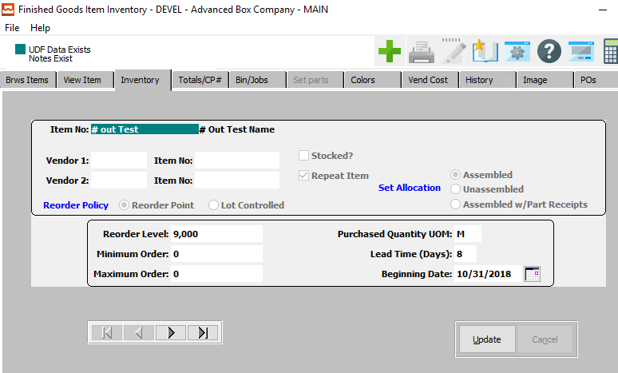

#### UPDATE

Click the ***“Update”*** button to update the currently selected inventory.

#### NEXT

Press ***"N"*** (Next) to find next inventory to view or modify. Alternatively, press the ***“Right Arrow”*** on the screen.

#### PREVIOUS

Press ***"P"*** (Previous) to find previous inventory to view or modify. Alternatively, press the ***“Left Arrow”*** on the screen.

### Update Inventory

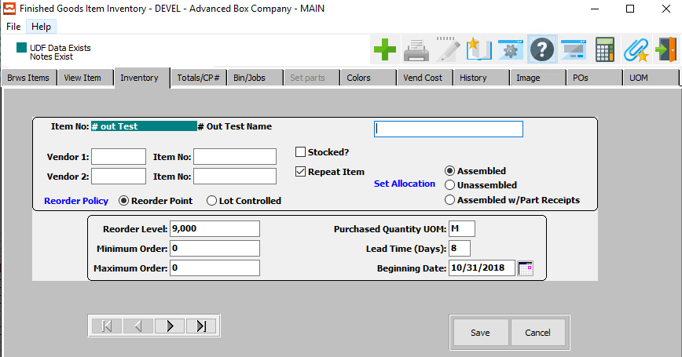

#### SAVE

Click the “***Save***” button to save the current inventory.

#### CANCEL

Click the “***Cancel***” button to cancel the inventory without saving changes.

#### NEXT

Press ***"N"*** (Next) to find next inventory to view or modify. Alternatively, press the ***“Right Arrow”*** on the screen.

#### PREVIOUS

Press ***"P"*** (Previous) to find previous inventory to view or modify. Alternatively, press the ***“Left Arrow”*** on the screen.

### Update Inventory Field Definitions

#### Item Description

Enter the description in this field.

#### Vendor 1

Enter the primary vendor number from the accounts payable vendor file for the item, if purchased rather than manufactured. Optionally, press “***F1”*** to search, or the ***“Page Up”*** / ***“Page Down”*** keys to scroll through the Vendor file. Press the “***Enter***” key to accept the Vendor displayed on the screen.

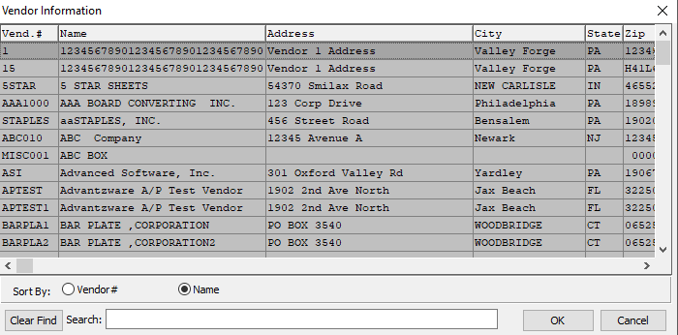

This list can be sorted by Vendor Number or Vendor Name. Alternatively, the user may search for what they wish to use in order to narrow down their selection.

#### Item Number (Vendor 1)

Enter vendor number one's part number for this item.

#### Vendor 2

Enter the secondary vendor number from the accounts payable vendor file for the item, if purchased rather than manufactured. Optionally, press “***F1”*** to search, or the ***“Page Up”*** / ***“Page Down”*** keys to scroll through the Vendor file. Press the “***Enter***” key to accept the Vendor displayed on the screen.



This list can be sorted by Vendor Number or Vendor Name. Alternatively, the user may search for what they wish to use in order to narrow down their selection.

#### Item Number (Vendor 2)

Enter vendor number two’s part number for this item.

#### Stocked? – Toggle Box

To mark this item as in-stock, make sure that the Stocked toggle box is checked.

#### Repeat Item – Toggle Box

To mark this as a repeated item, make sure that the Repeat Item toggle box is checked.

#### Reorder Policy (Choice)

To choose the preferred Reorder Policy of Reorder Point vs. Lot Controlled, please make sure the desired option choice bubble is toggled.

#### Set Allocation (Choice)

To choose the preferred Allocation of Assembled vs. Unassembled vs. Assembled with Part Receipts, please make sure the desired option choice bubble is toggled.

#### Reorder Level

Enter the quantity level based on selling unit of measure when we must place an order for additional items. When the quantity available (quantity on hand plus, optionally, quantity on order) falls below the reorder level, this item will appear on the reorder advice report to trigger either a shop order for manufactured items, or a purchase order for purchased items.

#### Minimum Order

Enter a minimum quantity to purchase, or to produce, in order to obtain a reasonable price. An attempt to place a purchase order, or shop order, for a smaller quantity would display a warning message.

#### Maximum Order

Enter the maximum quantity to limit excessive inventory on hand (a maximum quantity to purchase or to produce). An attempt to place a purchase order, or factory/shop orders, for larger quantity would display a warning message.

#### Purchased Quantity UOM

The sell price unit of measure defaults to M for per thousand, however this may be modified. Each unit of measure will yield a different total selling price.

Valid Units of Measure are:

|  |  |
| --- | --- |
| C | Per Hundred |
| CS | Per Case |
| EA | Per Each |
| L | Per Lot |
| M | Per Thousand |

#### Lead Time (Days)

Enter the number of days from time of purchase order to delivery of the product, from the vendor.

#### Beginning Date

The date of the physical count transaction.

### Totals/CP#

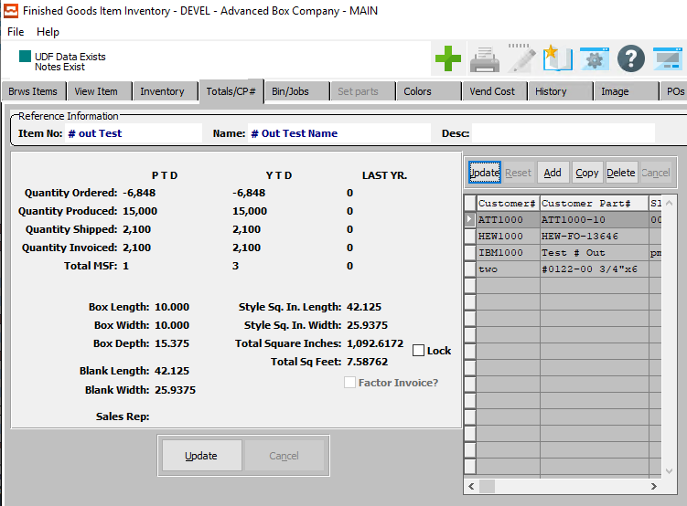

#### UPDATE

Click the ***“Update”*** button to update the currently selected total.

#### ADD

Click the ***“Add”*** button to add a new total. Alternatively, click the ***“Green + Icon”*** at the top of the page.

#### COPY

Click the ***“Copy”*** button to copy information from the currently selected total.

#### DELETE

Click the ***“Delete”*** button to delete the currently selected total.

### Update Totals/CP #

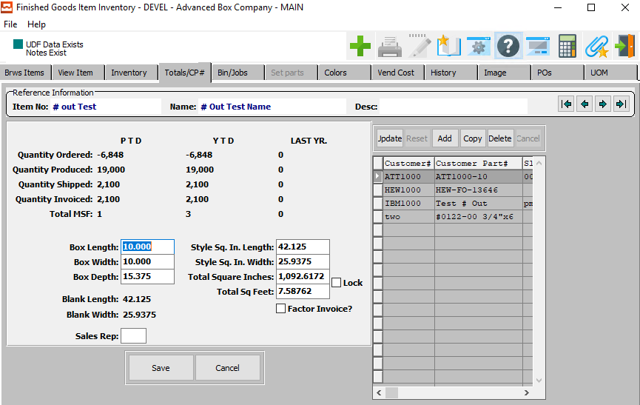

#### SAVE

Click the “***Save***” button to save the current total/CP #.

#### CANCEL

Click the “***Cancel***” button to cancel the total/CP # without saving changes.

### Update Totals/CP # Field Definitions

#### Box Length

Enter the box length.

#### Box Width

Enter the box width.

#### Box Depth

Enter the box depth.

#### Style Square Inch Length

Enter the blank length.

#### Style Square Inch Width

Enter the blank width.

#### Total Square Inches

Enter the total square inches.

#### Lock – Toggle Box

To lock the measurements so that they cannot be edited during further updates, make sure that the Lock toggle box is checked.

#### Total Square Feet

Enter the total square feet.

#### Factor Invoice? – Toggle Box

To factor this invoice, make sure that the Factor Invoice toggle box is checked.

#### Sales Rep

Enter the Sales Rep Number. Alternatively, the user may press the ***“F1”*** key to select a number from a list of available Sales Representatives.

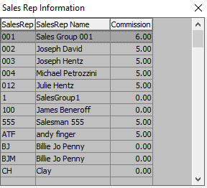

### Bin/Jobs

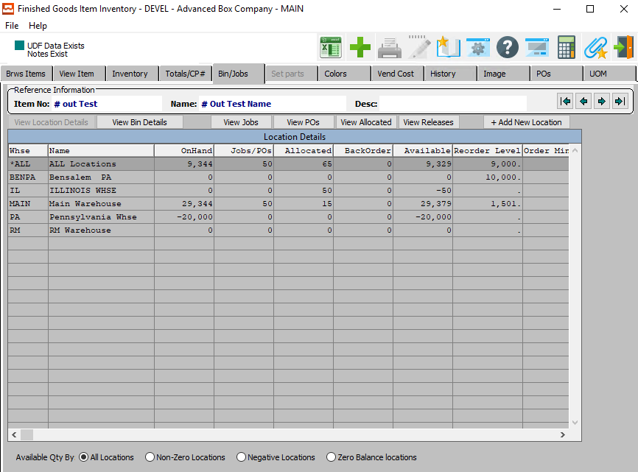

#### Bin File

The Finished Goods Bin File shows records by warehouse, bin location, and tag number for the Finished Goods item detailing the quantity for each location.

#### Job File

The Finished Goods job file stores the transactions from receipts to inventory by the job number, warehouse, bin location, tag number and provides the quantity per case, total quantity, and cost per thousand for each transaction received into inventory.

#### VIEW BIN DETAILS

Click the ***“View Bin Details”*** button to view details about the currently selected Bin or Job.

### Colors

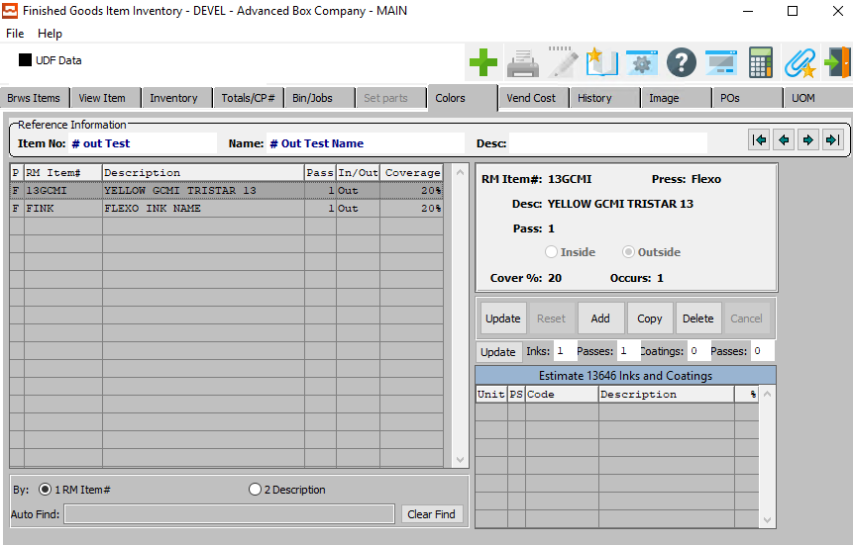

#### UPDATE

Click the ***“Update”*** button to update the currently selected color.

#### ADD

Click the ***“Add”*** button to add a new color. Alternatively, click the ***“Green + Icon”*** at the top of the page.

#### COPY

Click the ***“Copy”*** button to copy information from the currently selected color.

#### DELETE

Click the ***“Delete”*** button to delete the currently selected color.

### Add/Update Color

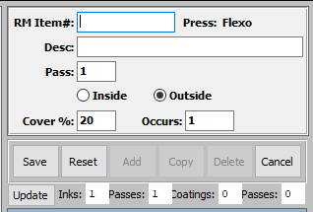

#### SAVE

Click the “***Save***” button to save the current color.

#### RESET

Click the “***Reset***” button to reset all changes to the color.

#### CANCEL

Click the “***Cancel***” button to cancel the color without saving changes.

#### UPDATE

Click the ***“Update”*** button to update the currently selected color.

### Add/Update Color Field Definition

#### RM Item #

Enter valid item number from Finished Goods file. Press F5 to search. Optionally, Press the ***“F1”*** key to search through, or the ***“Page Up” / “Page Down”*** to scroll through the Item file. Press the ***“Enter”*** key to accept the Item displayed on the screen. When choosing an item number, the customer number associated with the item (in the item file) is displayed on the screen.

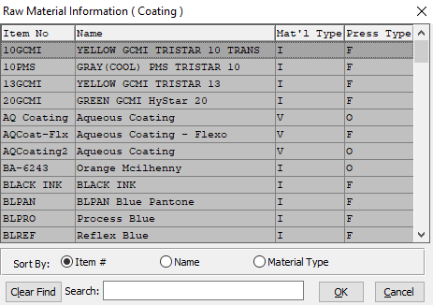

This list can be sorted by Item Number, Item Name, or Material Type. Alternatively, the user may search for what they wish to use in order to narrow down their selection.

As soon as the user makes their selection, or finishes manually entering a valid Raw Material Item Number, many subsequent fields will automatically fill with necessary information.

#### Description

The Raw Material Item description will automatically fill in once the user has entered or chosen a valid raw material number.

#### Pass

Enter the number of passes of the color press.

#### Inside/Outside (Choice)

To choose the preferred Location of Inside vs. Outside, please make sure the desired option choice bubble is toggled.

### Vend Cost

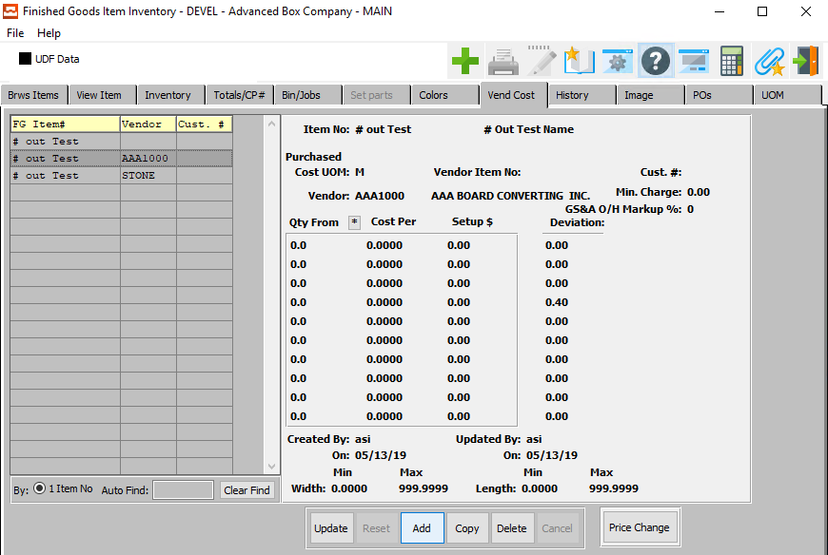

#### UPDATE

Click the ***“Update”*** button to update the currently selected vendor cost.

#### ADD

Click the ***“Add”*** button to add a new vendor cost. Alternatively, click the ***“Green + Icon”*** at the top of the page.

#### COPY

Click the ***“Copy”*** button to copy information from the currently selected vendor cost.

#### DELETE

Click the ***“Delete”*** button to delete the currently selected vendor cost.

### Add/Update Vend Cost

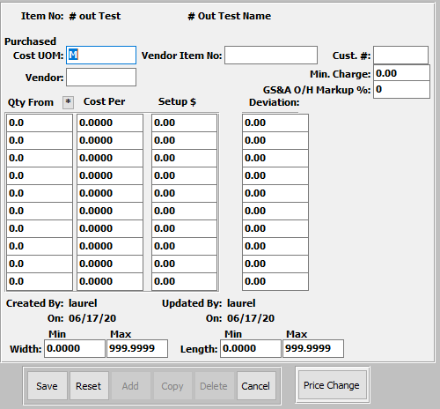

#### SAVE

Click the “***Save***” button to save the current vendor cost.

#### RESET

Click the “***Reset***” button to reset all changes to the vendor cost.

#### CANCEL

Click the “***Cancel***” button to cancel the vendor cost without saving changes.

### History

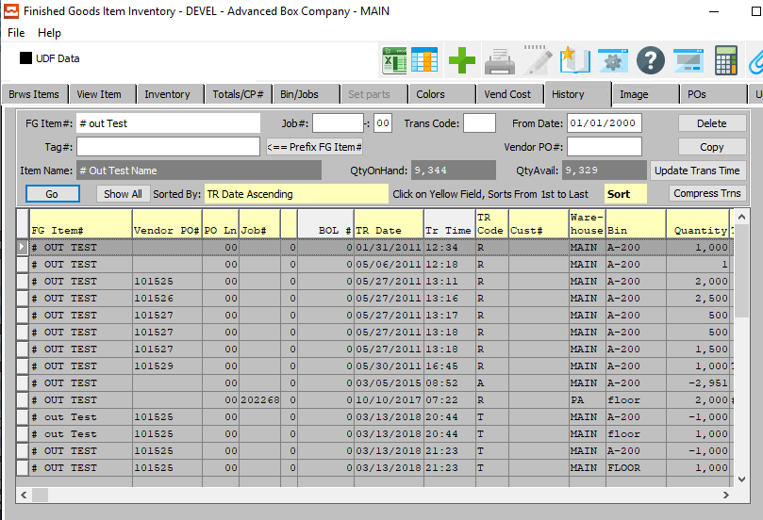

#### ADD

Click the ***“Green + Icon”*** at the top of the page to add a new history.

#### COPY

Click the ***“Copy”*** button to copy information from the currently selected history.

#### DELETE

Click the ***“Delete”*** button to delete the currently selected history.

### History Field Definitions

#### Tag #

Enter the tag number to search for. Alternatively, the user may press the ***“F1”*** key to select a number from a list of available Tag Numbers.

#### Job #

Enter the job number to search for. Alternatively, the user may press the ***“F1”*** key to select a number from a list of available Job numbers.

#### Job #: 00

Enter the subsequent job number to search for.

#### Trans Code

Enter the transaction code to search for. Alternatively, the user may press the ***“F1”*** key to select a code from a list of available Transaction Codes.

#### From Date

Enter the date to begin the search from.

#### Vendor PO #

Enter the vendor purchase order number to search for. Alternatively, the user may press the ***“F1”*** key to select a number from a list of available Vendor POs.

### Image

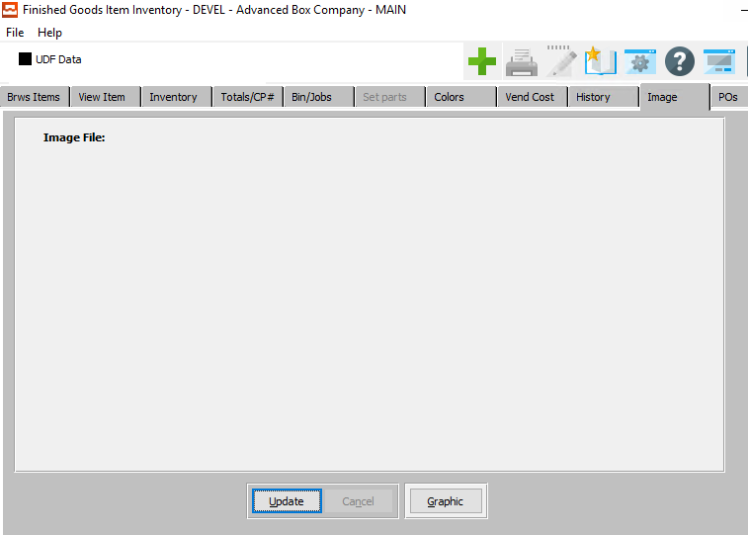

#### UPDATE

Click the ***“Update”*** button to update the currently selected image file.

### Update Image File

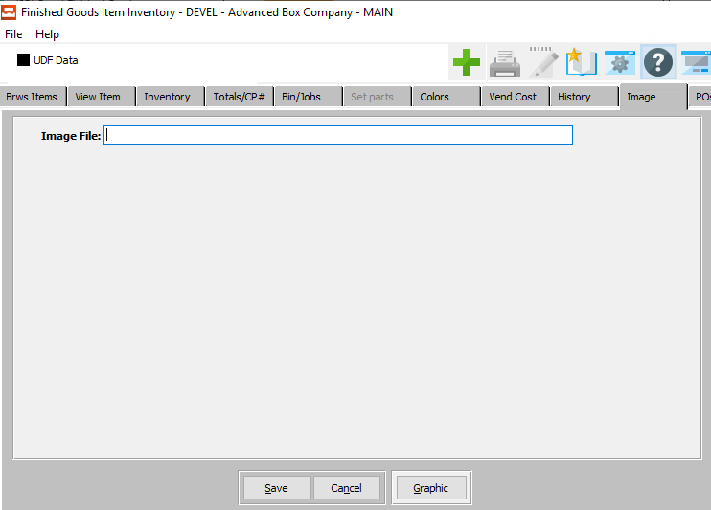

#### SAVE

Click the “***Save***” button to save the current image file.

#### CANCEL

Click the “***Cancel***” button to cancel the image file without saving changes.

#### Image File

Enter the file path of the desired image file. Alternatively, the user may press the ***“F1”*** button to choose a document from the Windows File Explorer.

### POs

The Pos tab allows the user to browse through all of the current open Purchase Orders for the currently selected item.

### UOM

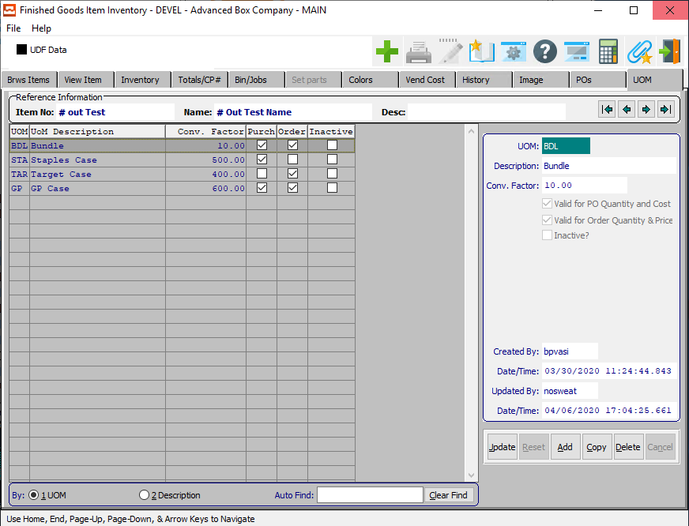

#### UPDATE

Click the ***“Update”*** button to update the currently selected Unit of Measure.

#### ADD

Click the ***“Add”*** button to add a new Unit of Measure. Alternatively, click the ***“Green + Icon”*** at the top of the page.

#### COPY

Click the ***“Copy”*** button to copy information from the currently selected Unit of Measure.

#### DELETE

Click the ***“Delete”*** button to delete the currently selected Unit of Measure.

### Add/Update UOM

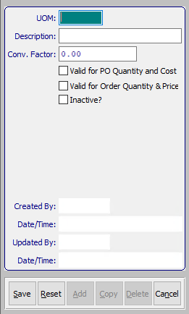

#### SAVE

Click the “***Save***” button to save the current unit of measure.

#### RESET

Click the “***Reset***” button to reset all changes to the unit of measure.

#### CANCEL

Click the “***Cancel***” button to cancel the unit of measure without saving changes.

### Add/Update UOM Field Definitions

#### UOM

The sell price unit of measure defaults to M for per thousand, however this may be modified. Each unit of measure will yield a different total selling price.

Valid Units of Measure are:

|  |  |
| --- | --- |
| C | Per Hundred |
| CS | Per Case |
| EA | Per Each |
| L | Per Lot |
| M | Per Thousand |

#### Description

Enter a user defined description for the product category.

#### Conversion Factor

Enter the conversion factor decimal number to update the unit of measure by.

#### Valid for PO Quantity and Cost – Toggle Box

To mark this unit of measure as valid for purchase order quantity and cost., make sure that this toggle box is checked.

#### Valid for Order Quantity & Price – Toggle Box

To mark this unit of measure as valid for order quantity and price, make sure that this toggle box is checked.

#### Inactive? – Toggle Box

To retire a unit of measure from being used by the system, make sure that the Inactive toggle box is checked.

#### Created By

The username of the original user that created this unit of measure.

#### Date/Time (Created)

The original date and time that this unit of measure was created.

#### Updated By

The username of the last user that updated information for this unit of measure.

#### Date/Time (Updated)

The last date and time that this unit of measure was updated.

## Finished Goods Control [IF2]

The Inventory Control file sets company-wide defaults for utilizing the Finished Goods inventory system. User defined features particular to your company may be defined in this file. For example, you have the option to value inventory at either last cost, average cost or standard cost.

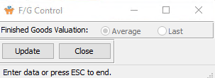

#### CLOSE

Click the ***“Close”*** button to close the Finished Goods Control popup screen.

#### UPDATE

Click the ***“Update”*** button to update the currently selected finished goods control.

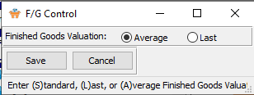

#### SAVE

Click the “***Save***” button to save the current finished goods control.

#### CANCEL

Click the “***Cancel***” button to cancel the finished goods control without saving changes.

#### Finished Goods Valuation

Enter the method to value Finished Goods Inventory. The valid entries are ***“L”*** (Last Cost) and ***“A”***) (Average) cost. The inventory valuation method should not be changed after any transactions have been posted. Check with your accountant, or financial advisor before proceeding.

## Finished Goods Categories [IF3]

The product category file defines groups of finished goods items. Many inventory, sales, and job costing reports are available by product category. The 'General Ledger accounts key' defines general ledger accounts for each product category. Once defined, production posting will automatically record debits and credits for actual costs, work in process, cost of goods sold and job costing variances by product category.

### Browse Category

The product category file defines groups of finished goods items. Many inventory, sales, and job costing reports are available by product category. The 'General Ledger accounts key' defines general ledger accounts for each product category. Once defined, production posting will automatically record debits and credits for actual costs, work in process, cost of goods sold and job costing variances by product category.

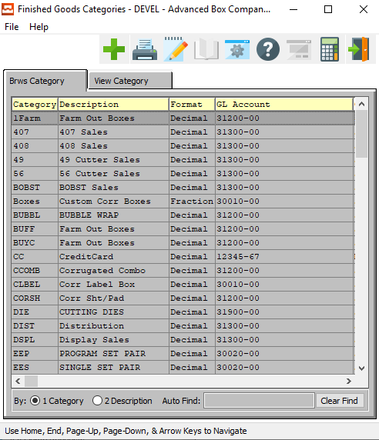

#### ADD

Click the ***“Green + Icon”*** at the top of the page to add a new Finished Good category.

### View Category

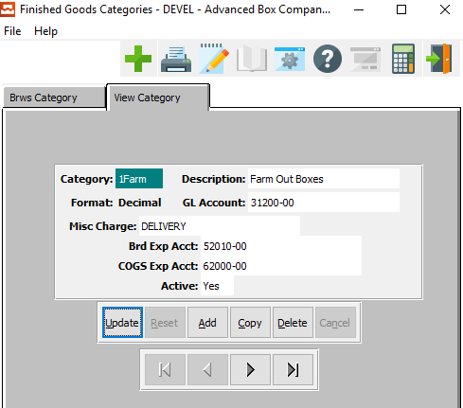

#### UPDATE

Click the ***“Update”*** button to update the currently selected Finished Good Category.

#### ADD

Click the ***“Add”*** button to add a new Finished Good Category. Alternatively, click the ***“Green + Icon”*** at the top of the page.

#### COPY

Click the ***“Copy”*** button to copy information from the currently selected Finished Good Category.

#### DELETE

Click the ***“Delete”*** button to delete the currently selected Finished Good Category.

#### NEXT

Press ***"N"*** (Next) to find next Finished Good Category to view or modify. Alternatively, press the ***“Right Arrow”*** on the screen.

#### PREVIOUS

Press ***"P"*** (Previous) to find previous Finished Good Category to view or modify. Alternatively, press the ***“Left Arrow”*** on the screen.

### Add/Update Finished Good Category

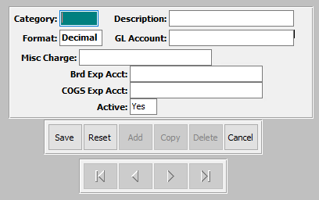

#### SAVE

Click the “***Save***” button to save the current finished good category.

#### RESET

Click the “***Reset***” button to reset all changes to the finished good category.

#### CANCEL

Click the “***Cancel***” button to cancel the finished good category without saving changes.

### Add/Update Finished Good Category Field Definitions

#### Category

Enter a user defined product category. This file contains categories defined by each company. The description is defined in the file so that only the code is entered in the Finished Goods file. Many inventory and job costing reports are available by product category.

#### Description

Enter a user defined description for the product category.

#### GL Account

Enter the General Ledger Expense Account number associated with this Product Category.

#### Misc. Charge

Enter the Miscellaneous Charge Code. Alternatively, the user may press the ***“F1”*** key to select a code from a list of available Misc. Charges.

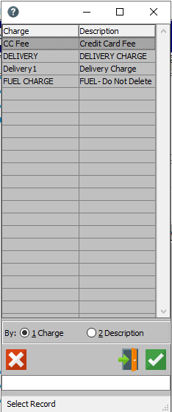

#### Board Exp. Account

Enter the Account Number. Alternatively, the user may press the ***“F1”*** key to select a number from a list of available General Ledger Accounts.

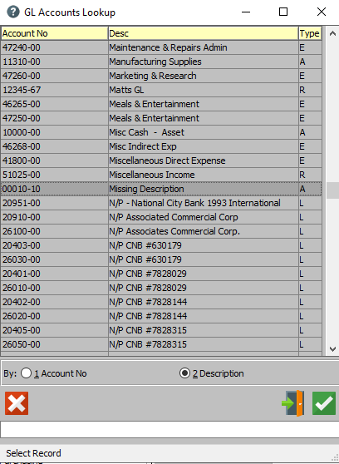

This list can be sorted by Account Number or Description. Alternatively, the user may search for what they wish to use in order to narrow down their selection.

## Warehouse / Bin Locations [IF4]

Multiple locations (a.k.a. plants or warehouses) may be defined for each company. Once defined, the location code is used to receive, transfer, ship, adjust and delete items by warehouse. Many reports optionally sort by warehouse/plant location. You may want to define a location called 'in transit', or outside vendor, in order to track (the location of) inventory outside the plant.

### Browse Location

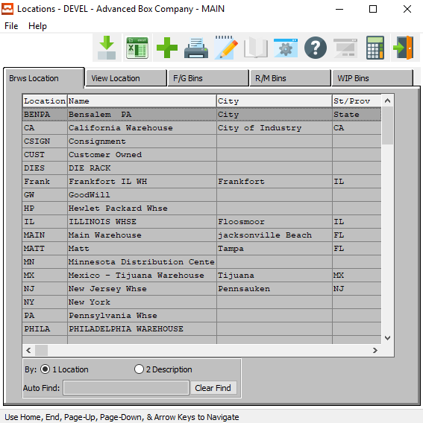

#### ADD

Click the ***“Green + Icon”*** at the top of the page to add a new Warehouse/Bin Location.

### View Location

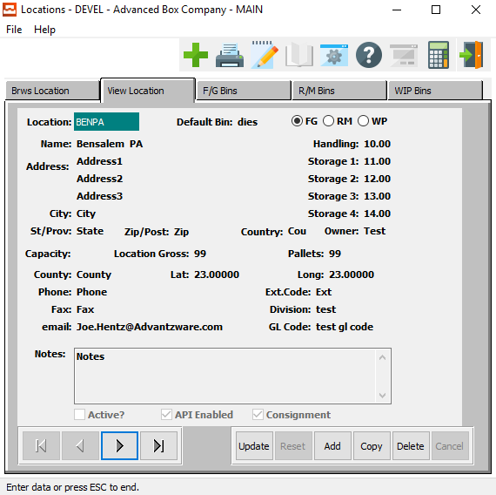

#### UPDATE

Click the ***“Update”*** button to update the currently selected Warehouse/Bin Location.

#### ADD

Click the ***“Add”*** button to add a new Warehouse/Bin Location. Alternatively, click the ***“Green + Icon”*** at the top of the page.

#### COPY

Click the ***“Copy”*** button to copy information from the currently selected Warehouse/Bin Location.

#### DELETE

Click the ***“Delete”*** button to delete the currently selected Warehouse/Bin Location.

#### NEXT

Press ***"N"*** (Next) to find next Warehouse/Bin Location to view or modify. Alternatively, press the ***“Right Arrow”*** on the screen.

#### PREVIOUS

Press ***"P"*** (Previous) to find previous Warehouse/Bin Location to view or modify. Alternatively, press the ***“Left Arrow”*** on the screen.

### Add/Update Warehouse/Bin Location

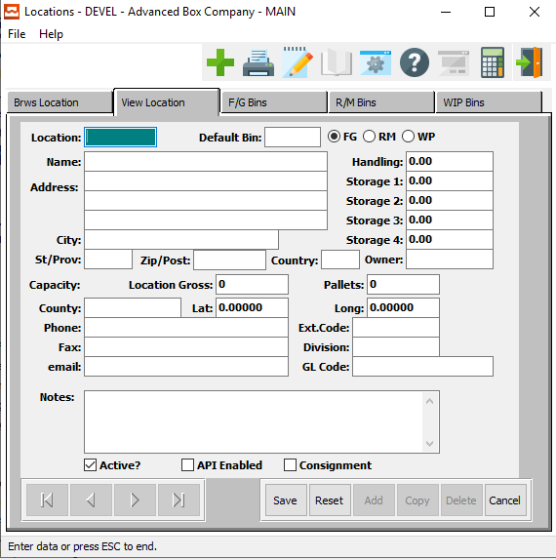

#### SAVE

Click the “***Save***” button to save the current location.

#### RESET

Click the “***Reset***” button to reset all changes to the location.

#### CANCEL

Click the “***Cancel***” button to cancel the location without saving changes.

### Add/Update Warehouse/Bin Location Field Definitions

#### Location

Enter the Plant, or the Warehouse, code so that we can track (control) inventory for this location.

#### Default Bin

Enter the default bin code for this item. Alternatively, the user may press the ***“F1”*** key to select a bin from a list of available Warehouse Bin Location Codes.

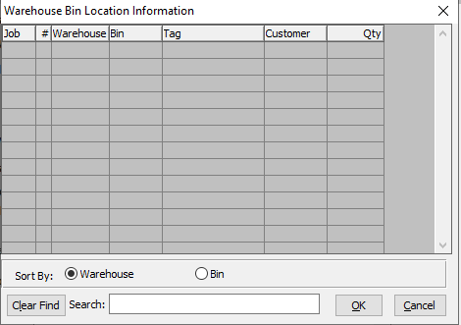

This list can be sorted by Warehouse or Bin. Alternatively, the user may search for what they wish to use in order to narrow down their selection.

#### Item Type (Choice)

To choose the preferred Item Type of Finished Goods vs. Raw Material vs. Work in Process, please make sure the desired option choice bubble is toggled.

#### Name

Enter the description for this warehouse.

#### Address

Enter the street address for this warehouse.

#### City

Enter the city for this warehouse.

#### State/Province

Enter the state or province for this warehouse.

#### Zip/Postal Code

Enter the zip or postal code for this warehouse.

#### Country

Enter the country for this warehouse.

#### Owner

Enter the Vendor Owner of the facility.

#### Handling

This is cost per pallet for the forklift driver to move the pallet from the receiving dock to the warehouse and back to the shipping dock. The total number of pallets required for the estimated quantity will be multiplied by the handling cost per pallet.

#### Storage 1-4

The warehouse file has the cost per pallet for handing the pallets as well as the storage cost per pallet for warehousing based on the stacking height configuration. The assumption is that a normal pallet will require (48 x 45) square inches, however, when stacking the pallets, the storage cost per pallet will be reduced. Please note, for finished items that are larger than the physical pallet, the pallet multiplier will increase the storage cost per pallet for the item’s overhand dimensions.

|  |  |
| --- | --- |
| Storage 1 | This is the storage cost per pallet when the stacking height is just 1 pallet in the warehouse storage location. |
| Storage 2 | This is the storage cost per pallet when the stacking height is 2 pallets in the same warehouse storage location. |
| Storage 3 | This is the storage cost per pallet when the stacking height is 3 pallets in the same warehouse storage location. |
| Storage 4 | This is the storage cost per pallet when the stacking height is 4 pallets in the same warehouse storage location. |

#### Location Gross

This is the total number of Square Feet reserved for this warehouse location. This field can be compared to the total amount of square feet on hand inventory for that warehouse location to determine how much space is available for future inventory.

#### Pallets

This is the total number of pallets reserved for this warehouse location. This field can be compared to the total amount of pallets on hand inventory for that warehouse location to determine how much space is available for future inventory.

#### Phone

Enter the phone number of the customer.

#### Extension Code

Enter the extension code for the direct contact at this location.

#### Fax

Enter the fax number of the customer.

#### Email

Enter the email address of the customer.

#### Latitude

Enter the exact latitude for this location.

#### Longitude

Enter the exact longitude for this location.

#### Division

Enter the Plant or Division.

#### GL Code

Enter the General Ledger code for this warehouse.

#### Notes

The user may enter any notes they wish about this particular warehouse.

#### Active? – Toggle Box

To mark this bin or warehouse as active, make sure that the Active toggle box is checked.

#### API Enabled – Toggle Box

To mark this location as API Enabled, make sure that the API Enabled toggle box is checked.

#### Consignment – Toggle Box

To mark this as a consignment bin, make sure that the Consignment toggle box is checked.

### F/G/ Bins

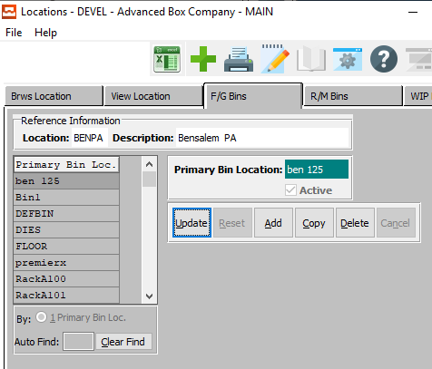

#### UPDATE

Click the ***“Update”*** button to update the currently selected Finished Good Bin.

#### ADD

Click the ***“Add”*** button to add a new Finished Good Bin. Alternatively, click the ***“Green + Icon”*** at the top of the page.

#### COPY

Click the ***“Copy”*** button to copy information from the currently selected Finished Good Bin.

#### DELETE

Click the ***“Delete”*** button to delete the currently selected Finished Good Bin.

### Add/Update Finished Good Bin

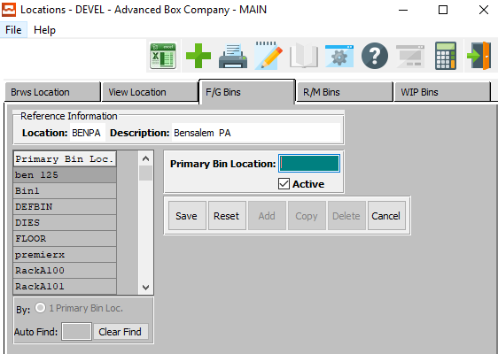

#### SAVE

Click the “***Save***” button to save the current finished good bin.

#### RESET

Click the “***Reset***” button to reset all changes to the finished good bin.

#### CANCEL

Click the “***Cancel***” button to cancel the finished good bin without saving changes.

#### Primary Bin Location

Enter a unique Bin code (by company warehouse). In other words, in a warehouse, a bin must have a unique code, in the same company. The same bin number can be used, in the warehouse, only if the company code is different. The same bin number may also be used, in the comp if the warehouse code is different. At least one bin must be created.

For example, you may create a bin called Plant. However, to better control inventory by tag/ticket number, you could create multiple bins by aisle, rack, shelf, etc.

#### Active – Toggle Box

To mark this bin location as active, make sure that the Active toggle box is checked.

### R/M/ Bins

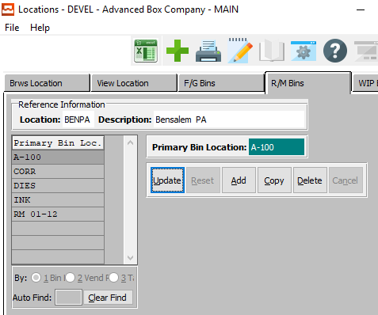

#### UPDATE

Click the ***“Update”*** button to update the currently selected Raw Material Bin.

#### ADD

Click the ***“Add”*** button to add a new Raw Material Bin. Alternatively, click the ***“Green + Icon”*** at the top of the page.

#### COPY

Click the ***“Copy”*** button to copy information from the currently selected Raw Material Bin.

#### DELETE

Click the ***“Delete”*** button to delete the currently selected Raw Material Bin.

### Add/Update Raw Material Bin

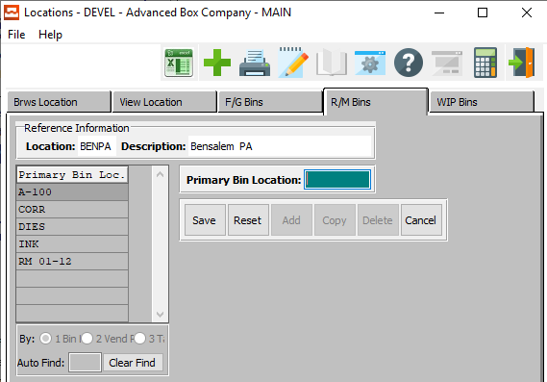

#### SAVE

Click the “***Save***” button to save the current raw material bin.

#### RESET

Click the “***Reset***” button to reset all changes to the raw material bin.

#### CANCEL

Click the “***Cancel***” button to cancel the raw material bin without saving changes.

#### Primary Bin Location

Enter a unique Bin code (by company warehouse). In other words, in a warehouse, a bin must have a unique code, in the same company. The same bin number can be used, in the warehouse, only if the company code is different. The same bin number may also be used, in the comp if the warehouse code is different. At least one bin must be created.

For example, you may create a bin called Plant. However, to better control inventory by tag/ticket number, you could create multiple bins by aisle, rack, shelf, etc.

### WIP Bins

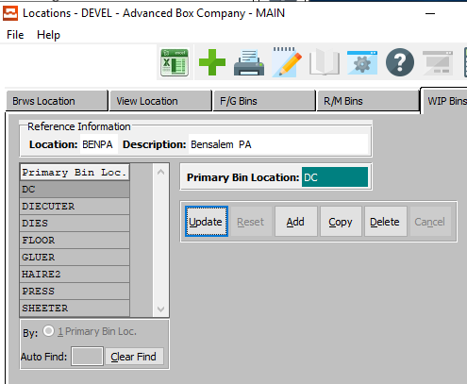

#### UPDATE

Click the ***“Update”*** button to update the currently selected Work in Process Bins.

#### ADD

Click the ***“Add”*** button to add a new Work in Process Bins. Alternatively, click the ***“Green + Icon”*** at the top of the page.

#### COPY

Click the ***“Copy”*** button to copy information from the currently selected Work in Process Bins.

#### DELETE

Click the ***“Delete”*** button to delete the currently selected Work in Process Bins.

### Add/Update Work in Process Bins

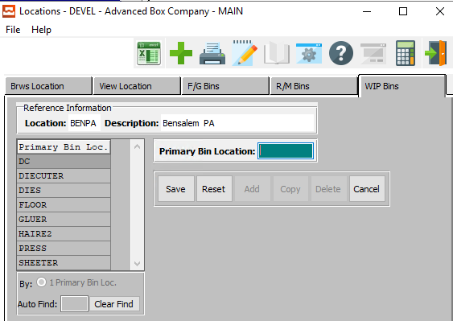

#### SAVE

Click the “***Save***” button to save the current work in process bin.

#### RESET

Click the “***Reset***” button to reset all changes to the work in process bin.

#### CANCEL

Click the “***Cancel***” button to cancel the work in process bin without saving changes.

#### Primary Bin Location

Enter a unique Bin code (by company warehouse). In other words, in a warehouse, a bin must have a unique code, in the same company. The same bin number can be used, in the warehouse, only if the company code is different. The same bin number may also be used, in the comp if the warehouse code is different. At least one bin must be created.

For example, you may create a bin called Plant. However, to better control inventory by tag/ticket number, you could create multiple bins by aisle, rack, shelf, etc.

## Set Maintenance [IF5]

### Browse Items

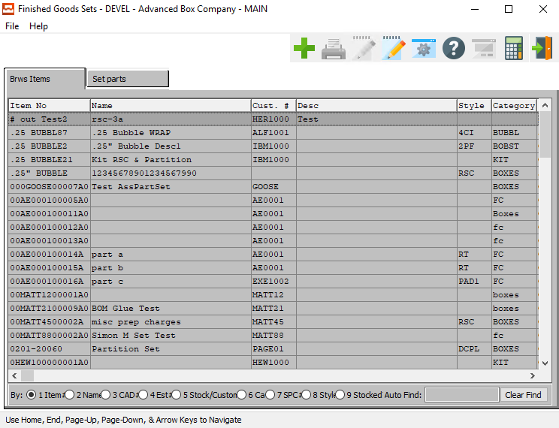

#### ADD

Click the ***“Green + Icon”*** at the top of the page to add a new Item.

### Set Parts

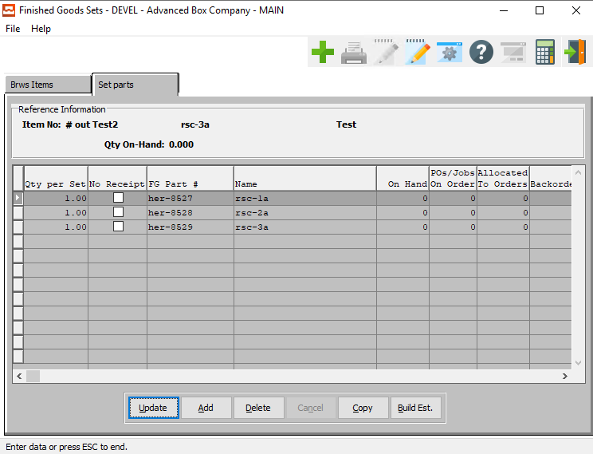

#### UPDATE

Click the ***“Update”*** button to update the currently selected set part.

#### ADD

Click the ***“Add”*** button to add a new set part. Alternatively, click the ***“Green + Icon”*** at the top of the page.

#### COPY

Click the ***“Copy”*** button to copy information from the currently selected set part.

#### DELETE

Click the ***“Delete”*** button to delete the currently selected set part.

#### BUILD EST.

Click the ***“Build Est.***” button to build an estimate for the currently selected Set Part. If an estimate already exists, the user will be asked if they wish to delete the current estimate and build a new one.

### Add/Update Set Part

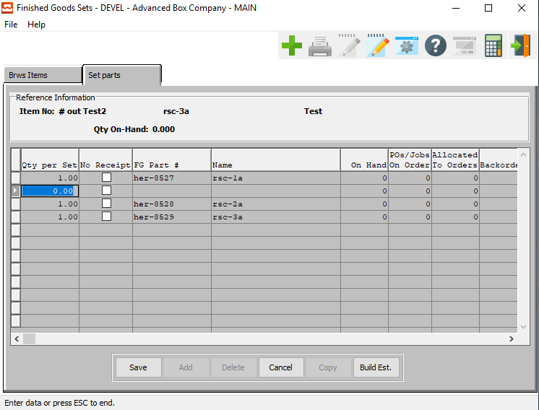

#### SAVE

Click the “***Save***” button to save the current set part.

#### CANCEL

Click the “***Cancel***” button to cancel the set part without saving changes.

#### BUILD EST.

Click the ***“Build Est.***” button to build an estimate for the currently selected Set Part. If an estimate already exists, the user will be asked if they wish to delete the current estimate and build a new one.

### Add/Update Set Part Field Definitions

#### Qty Per Set

Enter the quantity per set of the this set part.

#### No Receipt

If this set part does not have a receipt, make sure that the No Receipt toggle box is checked.

#### FG Part #

This is the item number for either the Lid or the Bottom. Enter the item number. Alternatively, the user may press the ***“F1”*** key to select a number from a list of available Finished Goods.

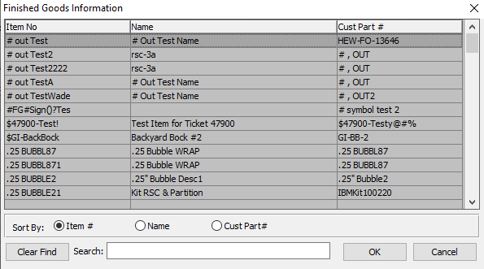

This list can be sorted by Item Number, Name, or Customer Part Number. Alternatively, the user may search for what they wish to use in order to narrow down their selection.

As soon as the user makes their selection, or finishes manually entering a valid Part Number, many subsequent fields will automatically fill with necessary information.

#### Name

This description name transfers from the estimate for custom boxes, however it must be entered for stock boxes. This line transfers to the job ticket, purchase order, and numerous other reports. The system also uses the Item Name for alphanumeric searches.

#### On Hand

The number on hand field automatically fills as soon as the user enters or chooses a valid Part number.

#### Post Jobs on Order

The number of purchase orders or jobs that have this part on order.

#### Allocated to Orders

The number of these parts that have been allocated to orders.

#### Backorder

This box will indicate if this part is on backorder due to being out of stock.

#### Available

This box will indicate if this part still have inventory available for new orders.

## Global FG Price Change [IF6]

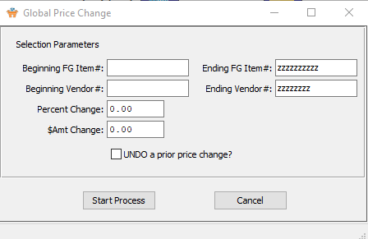

#### Beginning FG # / Ending FG #

Enter the starting and ending finished good number.

#### Beginning Vendor # / Ending Vendor #

Enter the starting and ending vendor number.

#### Percent Change

If changing the prices by a certain percentage of the current price, enter that percent here.

#### # Amount Change

If change the price by a dollar amount, enter that amount here.

#### Undo a Prior Price Change? – Toggle Box

If the price for the current item has been changed before, and user wishes to undo that change, make sure that this toggle box is checked.

## Freight Class [IF7]

### Browse Freight Class

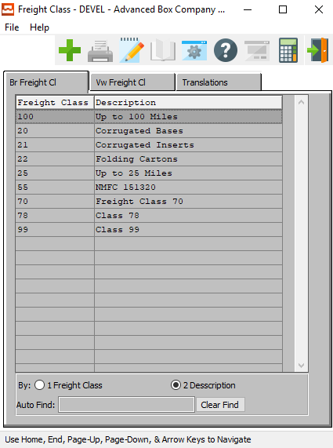

#### ADD

Click the ***“Green + Icon”*** at the top of the page to add a new Freight Class.

### View Freight Class

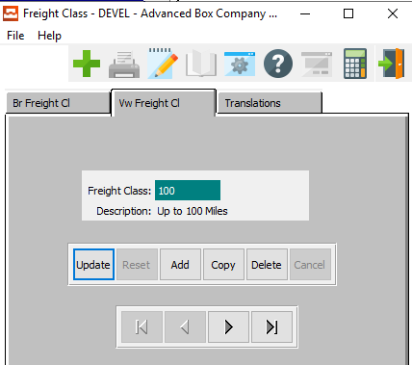

#### UPDATE

Click the ***“Update”*** button to update the currently selected freight class.

#### ADD

Click the ***“Add”*** button to add a new freight class. Alternatively, click the ***“Green + Icon”*** at the top of the page.

#### COPY

Click the ***“Copy”*** button to copy information from the currently selected freight class.

#### DELETE

Click the ***“Delete”*** button to delete the currently selected freight class.

#### NEXT

Press ***"N"*** (Next) to find next freight class to view or modify. Alternatively, press the ***“Right Arrow”*** on the screen.

#### PREVIOUS

Press ***"P"*** (Previous) to find previous freight class to view or modify. Alternatively, press the ***“Left Arrow”*** on the screen.

### Add Freight Class

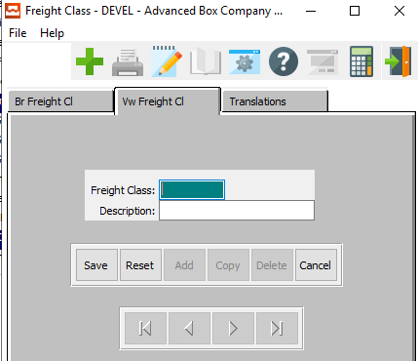

#### SAVE

Click the “***Save***” button to save the current freight class.

#### RESET

Click the “***Reset***” button to reset all changes to the freight class.

#### CANCEL

Click the “***Cancel***” button to cancel the freight class without saving changes.

### Add Freight Class Field Definitions

#### Freight Class

The user may enter their own code for this field class.

#### Description

The user may enter a description for this field class.

### Translations

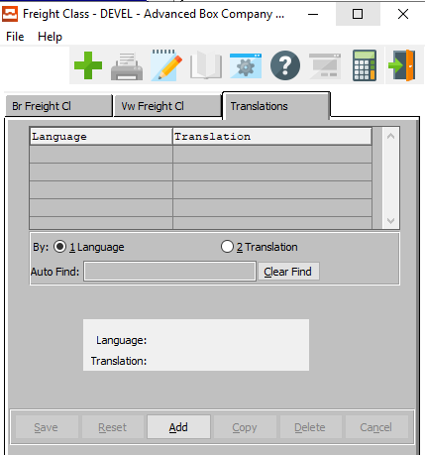

#### ADD

Click the ***“Add”*** button to add a new translation. Alternatively, click the ***“Green + Icon”*** at the top of the page.

### Add Translation

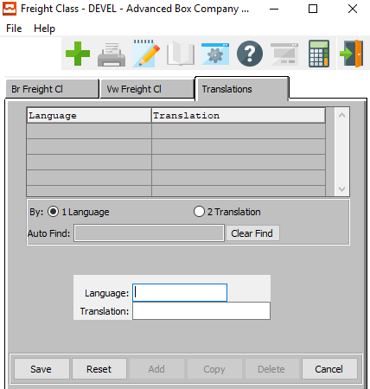

#### SAVE

Click the “***Save***” button to save the current translation.

#### RESET

Click the “***Reset***” button to reset all changes to the translation.

#### CANCEL

Click the “***Cancel***” button to cancel the translation without saving changes.

### Add Translation Field Definitions

#### Language

The user may add their own code for a specific language.

#### Translation

The user may add their description for the translation here.

## Adjustment Reason Code [IF8]

### Browse Reason

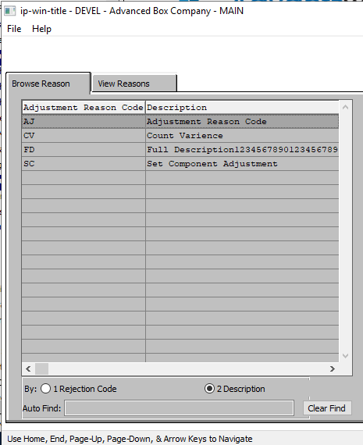

### View Reasons

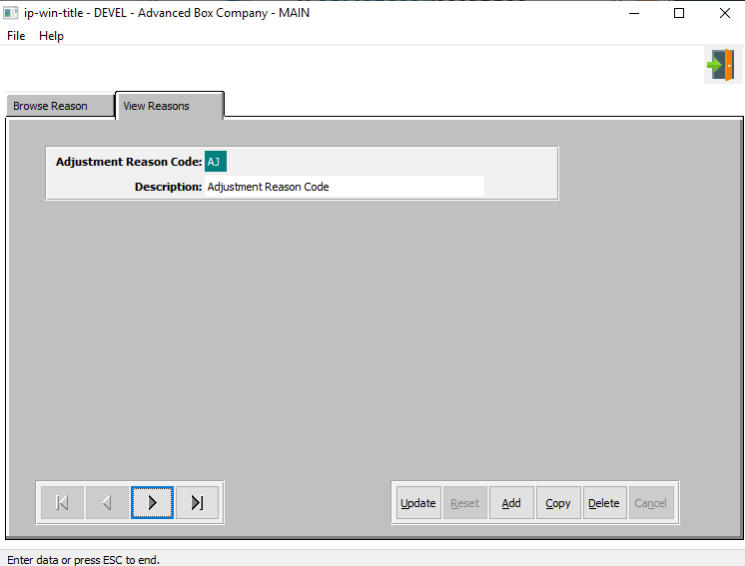

#### UPDATE

Click the ***“Update”*** button to update the currently selected reason.

#### ADD

Click the ***“Add”*** button to add a new reason. Alternatively, click the ***“Green + Icon”*** at the top of the page.

#### COPY

Click the ***“Copy”*** button to copy information from the currently selected reason.

#### DELETE

Click the ***“Delete”*** button to delete the currently selected reason.

#### NEXT

Press ***"N"*** (Next) to find next reason to view or modify. Alternatively, press the ***“Right Arrow”*** on the screen.

#### PREVIOUS

Press ***"P"*** (Previous) to find previous reason to view or modify. Alternatively, press the ***“Left Arrow”*** on the screen.

#### EXIT

Click the ***“Exit Door Icon”*** to exit the Adjustment Reason popup screen.

### Add/Update Reason

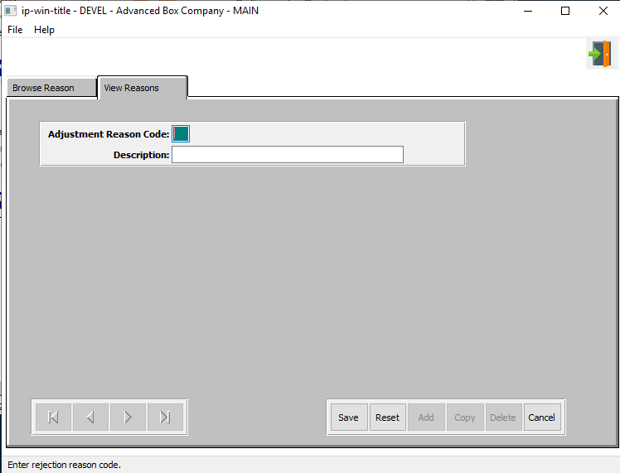

#### SAVE

Click the “***Save***” button to save the current reason.

#### RESET

Click the “***Reset***” button to reset all changes to the reason.

#### CANCEL

Click the “***Cancel***” button to cancel the reason without saving changes.

#### EXIT

Click the ***“Exit Door Icon”*** to exit the Adjustment Reason popup screen.

### Add/Update Reason Field Definitions

#### Adjustment Reason Code

The user may add their own two-letter code for their adjustment reason.

#### Description

The user may add their own description for this adjustment reason.

## Inventory Status [IF9]

### Browse

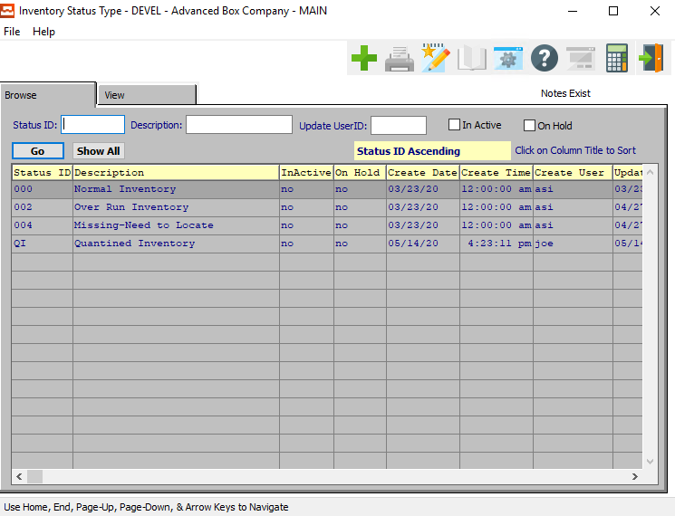

#### ADD

Click the ***“Green + Icon”*** at the top of the page to add a new inventory status.

#### Status ID

Enter the Status Id to search for. Alternatively, the user may press the ***“F1”*** key to select an ID from a list of available Status IDs.

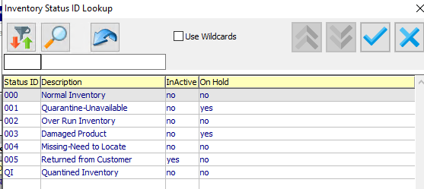

#### Description

The Status description field will automatically fill in once the user has entered or chosen a valid Status ID.

#### Update User ID

Enter the User ID Code. Alternatively, the user may press the ***“F1”*** key to select a code from a list of available Users.

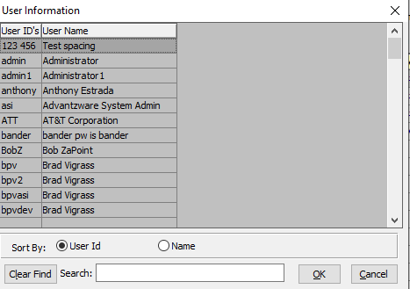

This list can be sorted by User ID or Username. Alternatively, the user may search for what they wish to use in order to narrow down their selection.

#### Inactive – Toggle Box

To include inactive inventory statuses in the browse list, make sure that the Inactive toggle box is checked.

#### On Hold – Toggle Box

To include inventory statuses that are on hold in the browse list, make sure that the On Hold toggle box is checked.

### View

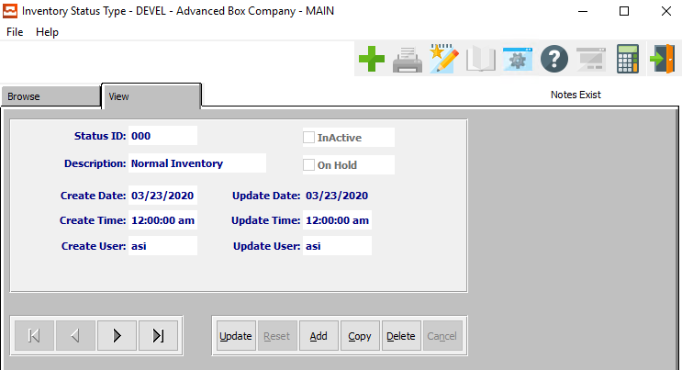

#### UPDATE

Click the ***“Update”*** button to update the currently selected inventory status.

#### ADD

Click the ***“Add”*** button to add a new inventory status. Alternatively, click the ***“Green + Icon”*** at the top of the page.

#### COPY

Click the ***“Copy”*** button to copy information from the currently selected inventory status.

#### DELETE

Click the ***“Delete”*** button to delete the currently selected inventory status.

#### NEXT

Press ***"N"*** (Next) to find next inventory status to view or modify. Alternatively, press the ***“Right Arrow”*** on the screen.

#### PREVIOUS

Press ***"P"*** (Previous) to find previous inventory status to view or modify. Alternatively, press the ***“Left Arrow”*** on the screen.

### Add/Update Inventory Status

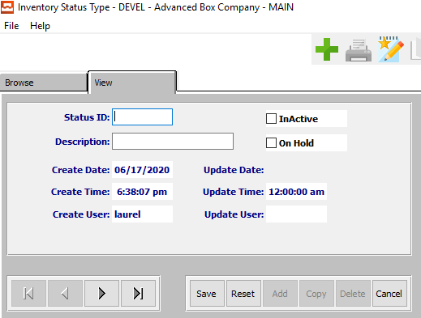

#### SAVE

Click the “***Save***” button to save the current inventory status.

#### RESET

Click the “***Reset***” button to reset all changes to the inventory status.

#### CANCEL

Click the “***Cancel***” button to cancel inventory status XXX without saving changes.

#### NEXT

Press ***"N"*** (Next) to find next inventory status to view or modify. Alternatively, press the ***“Right Arrow”*** on the screen.

#### PREVIOUS

Press ***"P"*** (Previous) to find previous inventory status to view or modify. Alternatively, press the ***“Left Arrow”*** on the screen.

### Add/Update Inventory Status Field Definitions

#### Status ID

Enter a status ID code for this inventory. The user may define their own.

#### Description

Enter a short description for this inventory. The user may enter their own.

#### Inactive – Toggle Box

To set this inventory status as inactive, make sure that the Inactive toggle box is checked.

#### On Hold – Toggle Box

To set this inventory status as On Hold, make sure that the On Hold toggle box is checked.

#### Create Date

This is the date that this inventory status was originally created. It is not modifiable.

#### Create Time

This is the exact time that this inventory status was originally created. It is not modifiable.

#### Create User

This is the username of the user that this inventory status was originally created by. It is not modifiable.

#### Update Date

This is the date that this inventory status was last updated. It is not modifiable.

#### Update Time

This is the exact time that this inventory status was last modified. It is not modifiable.

#### Update User

This is the username of the user that this inventory status was last updated by. It is not modifiable.